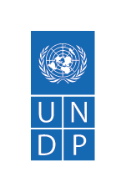
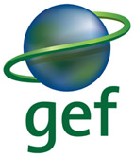

Project title: Umbrella Programme to Support NBSAP Update and the 7th National Reports
Country(ies): Global (see bottom of table for list of 69 participating countries) | Implementing Partner (GEF Executing Entity): UNDP |  |  | Execution Modality: Direct Implementation Modality (Global DIM)
Contributing Outcome (UNSDCF/CPD, RPD, GPD): N/A (project is multi-country)
UNDP Social and Environmental Screening Category: Moderate |  |  | UNDP Gender Marker: GEN 2
Quantum Award ID: not required at submission stage. This must be created after CEO endorsement/Approval. |  |  | Quantum Project ID: This must be created after CEO Endorsement/Approval. It can only be approved after Prodoc Signature.
UNDP PIMS ID number: 9678 |  |  | GEF Project ID number: 11286
LPAC meeting date: November, 2023
Last possible date to submit to GEF: N/A, this project is being submitted as a non-expedited enabling activity
Latest possible CEO endorsement date: N/A, this project is being submitted as a non-expedited enabling activity
Project duration in months: 42 months
Planned start date: 1 February 2024 |  |  | Planned completion date: 30 July 2027
Expected date of Mid-Term Review (MTR) submission to the GEF: N/A |  |  | Expected date of Terminal evaluation (TE) submission to the GEF: 30 January 2028
Expected Operational Closure Date: 30 April 2028 |  |  | Expected Financial Closure Date: 30 October 2028
Brief project description: This Global Programme will support countries in revising and updating their National Biodiversity Strategies and Action Plans (NBSAPs) in order to align with the recently agreed upon Kunming-Montreal Global Biodiversity Framework, and enable effective implementation of the Convention on Biological Diversity (CBD) and the Kunming Montreal Global Biodiversity Framework at the national level. In addition, this grant supports countries in preparing and submitting their 7th National Report on the implementation of the Convention on Biological Diversity and the Kunming-Montreal Global Biodiversity Framework.
This Global Programme will be responsive to CBD guidance on developing NBSAPs and completing the 7th National Report, including recent COP15 outcomes and decisions. It will also build upon existing work through the Global Biodiversity Framework Early Action Support (GBF-EAS) that is ongoing, as well as support to countries to develop biodiversity finance plans, through the recently approved “Umbrella Programme to Support Development of Biodiversity Finance Plans”. The project implementation units of all three initiatives will coordinate to ensure that resources from both projects are used effectively and efficiently towards the update or revision of the National Biodiversity Strategies and Action Plans and the preparation of the 7th National Reports in the targeted countries.
Financing Plan
GEF Trust Fund grant (GEF-8 set aside for enabling activities) |  |  | 35,600,000
UNDP TRAC resources |  |  | N/A
Confirmed cash co-financing to be administered by UNDP |  |  | N/A
- Total Budget administered by UNDP |  |  | 35,600,000
- Total confirmed co-financing to this project not administered by UNDP |  |  | N/A
- Grand-Total Project Financing (1)+(2) |  |  | 35,600,000
Signatures:
Signature: print name below |  | Agreed by UNDP (Executive Coordinator – Environmental Finance) |  | Date/Month/Year: within 6 months of GEF CEO endorsement
Signature: print name below |  | Agreed by Implementing Partner (Director, Nature Hub) |  | Date/Month/Year: within 6 months of GEF CEO endorsement
Signature: print name below |  | Agreed by UNDP |  | Date/Month/Year: within 6 months of GEF CEO endorsement
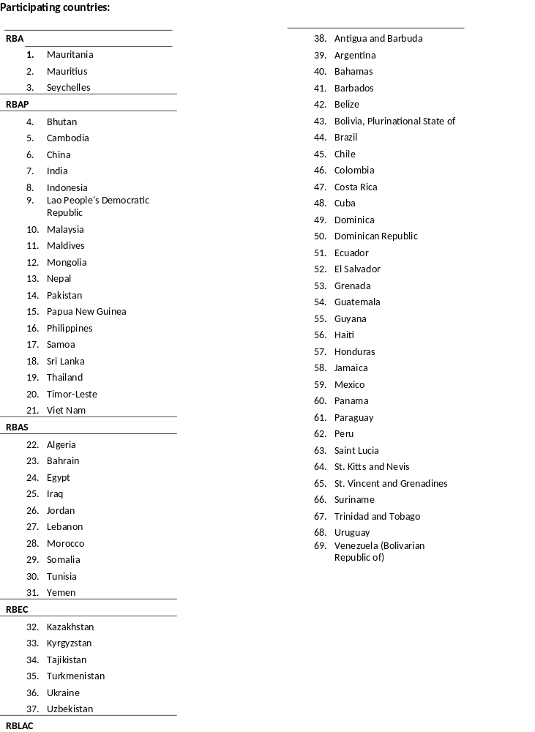

- Table of Contents
I. Table of Contents 4
Acronyms 5
II. Development Challenges 6
III Strategy 8
IV Results and Partnerships 14
V. Project Management 24
VII Monitoring and Evaluation (M&E) Plan 31
Minimum project monitoring and reporting requirements as required by the GEF: 31
Evaluation Plan 38
VIII Governance and Management Arrangements 40
Section 2: Project governance structure 41
Section 3: Segregation of duties and firewalls vis-à-vis UNDP representation on the project board: 42
Section 4: Roles and Responsibilities of the Project Organization Structure: 42
IX Financial Planning and Management 45
X Total Budget and Work Plan 48
XI Legal Context 71
XII Risk Management 71
XIII Mandatory Annexes 75
Annex 1: GEF Budget Template 76
Annex 2: GEF execution support letter: 86
Annex 3: Project map and Geospatial Coordinates of project sites 87
Annex 4: Multi Year Work Plan 27
Annex 5: UNDP Social and Environmental Screening Procedure (SESP) 29
Annex 6: UNDP Risk Register 48
Annex 7: Overview of Technical Consultancies/Subcontracts 56
Annex 8: Stakeholder Engagement Plan 67
Annex 9: Environmental Social Management Framework (ESMF) and other SES frameworks/plans 68
Annex 10: Gender Analysis and Gender Action Plan 69
Annex 11: Additional agreements 73
Annex 13: GEF CEO Endorsement/Approval 92
Annex 14: On-Granting Provisions Applicable to the Implementing Partner 93
Annex 16: GEF Core indicators 96
Annex 17: GEF Taxonomy 97
Annex 18: Results of the Partners Capacity Assessment Tool (PACT) and HACT Micro Assessment 103
Annex 19 - Umbrella Programme to Support NBSAP Update and the 7th National Reports - Country Office Annex 104

Acronyms

6NR | 6th National Report
7NR | 7th National Report
BD | Biodiversity
BIOFIN | Biodiversity Finance Initiative
BPPS | Bureau for Programme and Policy Support
CBD | Convention on Biological Diversity
CEO | Chief Executive Officer
CNA | Competent National Authority
CO | Country Office
COP | Conference of the Parties
CPD | Country Programme Document
DIM | Direct Implementation Modality
DOA | Delegation of Authority
DPC | Direct Project Cost
EA | Enabling Activity
EBD | Ecosystems and Biodiversity
EFP | Environment Focal Point
FTA | Full Time Appointment
GBF | Global Biodiversity Framework
GBF-EAS | Global Biodiversity Framework Early Action Support
GBF | Global Biodivesrity Framework
GBO | Global Biodiversity Outlook
GEF | Global Environment Facility
GEFSEC | Global Environment Facility Secretariat
GPA | Gender Plan of Action
GPD | Global Programme Document
GPMTSU | Global Project Management and Technical Support Unit
GRM | Grievance Redress Mechanism
ID | Identifier
IPLC | Indigenous People and Local Community
IPSA | International Personnel Service Agreement
LDC | Least Developed Country
LOE | Letter of Endorsement
LPAC | Local Project Appraisal Committee
MEA | Multilateral Environmental Agreement
MOOC | Massive Open Online Course
MOP | Meeting of the Parties
MPSU | Management and Programme Support Unit
MSP | Medium Size Project
N/A | Not applicable
NBSAP | National Biodiversity Strategy and Action Plan
NBT | National Biodiversity Target
VF-Hub | Vertical funds hub
NDC | Nationally Determined Contribution
NIM | National Implementation Modality
OFP | Operational Focal Point

II. Development Challenges

The National Biodiversity Strategies and Action Plans (NBSAPs) play a crucial role in addressing development challenges related to biodiversity conservation and sustainable development. These plans aim to protect and sustainably manage biodiversity and ecosystems while addressing the underlying causes and immediate threats to biodiversity loss. NBSAPs can support the development challenge, in terms of poverty reduction and addressing inequality and exclusion, and their alignment with national strategies and international conventions.

The development challenge addressed by NBSAPs is the loss of biodiversity and the degradation of ecosystems. This problem can be analyzed through a causal chain, which helps identify root causes, underlying causes, and immediate causes. The causal chain might include factors such as unsustainable land use practices, habitat destruction, pollution, climate change, overexploitation of natural resources, and lack of awareness and capacity for biodiversity conservation.

The Theory of Change for NBSAPs involves implementing targeted actions to address the immediate causes, such as establishing and managing protected areas, restoring degraded ecosystems, promoting sustainable agriculture and forestry practices, reducing pollution, and raising awareness about biodiversity conservation. By addressing these immediate causes, the underlying causes, such as unsustainable consumption and production patterns, inadequate policies and governance structures, and socio-economic factors, can be tackled. Ultimately, by addressing the root causes, such as unsustainable development pathways and a lack of integration of biodiversity considerations into sectoral policies and plans, the NBSAPs seek to achieve long-term biodiversity conservation and sustainable development.

There is substantial evidence demonstrating the magnitude of the biodiversity loss problem and its impact on different population groups. Biodiversity loss affects communities, including women, indigenous people, and marginalized groups, in several ways. For example, indigenous communities heavily rely on biodiversity for their livelihoods, cultural practices, and traditional knowledge systems. Biodiversity loss can lead to reduced access to resources, loss of cultural heritage, and increased vulnerability to poverty. Additionally, marginalized groups often depend directly on ecosystem services for their sustenance and livelihoods. Biodiversity loss can exacerbate their vulnerability by reducing the availability of resources such as food, clean water, and medicinal plants. Furthermore, biodiversity loss can disproportionately impact women, who often have a close relationship with natural resources and play a significant role in resource management and food security within communities.

Addressing biodiversity loss through NBSAPs is crucial for poverty reduction and addressing inequality and exclusion. Biodiversity is essential for maintaining ecosystem services, such as soil fertility, water purification, pollination, and climate regulation, which are fundamental for human well-being and livelihoods, particularly for vulnerable communities. By protecting and sustainably managing biodiversity, NBSAPs contribute to poverty reduction by ensuring the availability of vital resources and supporting sustainable livelihoods.

Furthermore, addressing biodiversity loss is closely linked to addressing inequality and exclusion. By recognizing the rights and knowledge systems of indigenous peoples and marginalized groups, NBSAPs can promote inclusive governance structures and participatory decision-making processes. Integrating gender considerations and empowering women within biodiversity conservation efforts can also contribute to reducing gender inequalities.

NBSAPs must be designed to be consistent with national strategies and plans, as well as international conventions and assessments. They align with various frameworks and initiatives, such as: the Nationally Determined Contributions (NDCs), National Action Plan for Adaptation (NAPA), the Minamata Convention, etc. NBSAPs can integrate climate change and adaptation measures, recognizing the interlinkages between biodiversity and climate change (NDCs); NBSAPs can align with desertification and land degradation-related goals, promoting sustainable land management and restoration of degraded ecosystems (UNCCD); and NBSAPs can address the impacts of mercury pollution on biodiversity and ecosystems (Minamata Convention). By aligning with these strategies, plans, and conventions, NBSAPs ensure coherence and maximize the synergies between biodiversity conservation, sustainable development, and poverty reduction efforts.

Following the adoption of the Kunming-Montreal Global Biodiversity Framework (GBF), each of the 196 CBD Parties must ensure its NBSAP is in alignment with the GBF. This is a necessary first step for translating the GBF into national actions that lead to the achievement of the stated targets and milestones. Achieving the 23 proposed global targets of the GBF will require sustained and concerted action by all Parties. The theory of change of the GBF “recognizes that urgent policy action globally, regionally, and nationally is required to transform economic, social and financial models so that the trends that have exacerbated biodiversity loss will stabilize in the next 10 years (by 2030) and allow for the recovery of natural ecosystems in the following 20 years, with net improvements by 2050 to achieve the Convention’s vision of ‘living in harmony with nature by 2050’. It also assumes that a whole-of-government and society approach is necessary to make the changes needed over the next 10 years as a steppingstone towards the achievement of the 2050 Vision. As such, Governments and societies need to determine priorities and allocate financial and other resources, internalize the value of nature and recognize the cost of inaction.” This project is designed to meet this challenge and support Parties in their efforts.

III Strategy

The implementation of National Biodiversity Strategies and Action Plans (NBSAPs) has been mixed globally. The Global Biodiversity Outlook 5 (GBO-5) report, published in 2020, highlights that although countries have made important progress in setting targets and developing policies, overall adequate progress has not been achieved for almost all of the Targets. Further the information from the national reports prepared by Parties to the Convention, reveal examples of progress which, if scaled up, could support the transformative changes necessary to achieve the 2050 vision of living in harmony with nature. However, despite this progress, actual implementation of NBSAPs has been slow and insufficient to address the ongoing loss of biodiversity, and many of the national targets contained in the NBSAPs did not match the scope or level of ambition of the Strategic Plan for Biodiversity 2011-2020 and the Aichi Biodiversity Targets.
The GBO-5, along with other reports, including the Global Assessment Report on Biodiversity and Ecosystem Services prepared by the Intergovernmental Science-Policy Platform on Biodiversity and Ecosystem Services, indicate that biodiversity and the services and functions it provides, continues to decline at an alarming rate, with one million species at risk of extinction.
Other reports support this trend. For example, Protected Planet, a global database of protected areas, reports that although the number of protected areas has increased in recent years, the coverage and management effectiveness of protected areas are still insufficient to prevent the loss of biodiversity. Moreover, global reports such as the Living Planet Report 2020 by WWF and the IPBES Global Assessment Report on Biodiversity and Ecosystem Services highlight the numerous drivers of biodiversity loss, including habitat loss and fragmentation, overexploitation, climate change, pollution, and invasive species. Overall, the current global status of the implementation of NBSAPs is inadequate to meet the objectives and targets of the Convention on Biological Diversity and the newly agreed Global Biodiversity Framework (GBF) respectively. Part of the reason is that most of national targets included in the NBSAPs updated or revised in line with the Strategic Plan for Biodiversity 2011-2020 were not aligned with the global targets agreed at CBD COP 10, according to relevant analyses prepared by the CBD Secretariat.
The GEF grant aims to provide technical and financial assistance to eligible countries to be able to update or revise NBSAPs, and to implement and achieve these new and challenging goals and targets of the GBF. The program will foster cooperation and coordination among different sectors and stakeholders, including, and not limited to, governments, civil society organizations, private sector, academia, and Indigenous Peoples and Local Communities (IPLCs), to ensure their effective participation in the NBSAP revision and implementation process. The ultimate goal is to support countries to take urgent action to halt and reverse biodiversity loss to put nature at the core to contribute to the achievement of the 2050 Vision for Biodiversity and the Sustainable Development Goals (SDGs).
In the baseline situation, nearly all NBSAPs were developed, revised and/or updated using the Aichi Targets as a framework. A study in 2016 analyzed over 100 NBSAPS, found the following persistent gaps across countries from the last round of NBSAPs:
- Lack of integration: Many NBSAPs have not been fully integrated into broader policy frameworks, which limits their impact on sustainable development outcomes. There is a need to integrate biodiversity considerations into economic, social, political, and environmental policies at all levels of government and society.

- Lack of political will: NBSAP development and implementation requires support from the highest level of Government.

- Non-alignment of national targets with global targets: Limited progress in the implementation of the Strategic Plan for Biodiversity 2011-2020 is partly related to the non-alignment of national targets included in a big percentage of NBSAPs with the global targets. For example, some countries did not develop national targets to implement some global targets.

- Insufficient stakeholder engagement: Meaningful stakeholder engagement is essential for the development and implementation of effective NBSAPs. However, many NBSAP processes have failed to sufficiently engage key stakeholders, including IPLCs, and the private sector.

- Weak monitoring and reporting: Monitoring and reporting mechanisms are critical for tracking progress towards NBSAP targets and ensuring transparency and responsibility. However, many NBSAPs lack effective monitoring and reporting mechanisms, which makes it difficult to assess progress and identify areas for improvement.

- Limited financing: Many NBSAPs have been underfunded, which limits their ability to achieve their intended outcomes. There is a need to increase financial resources for biodiversity conservation and to develop innovative financing mechanisms. A recent emphasis on supporting all GEF-eligible countries to develop biodiversity finance plans will likely provide some relief to this chronic challenge.

- Weak institutional frameworks: Effective implementation of NBSAPs requires strong institutional frameworks and coordination mechanisms. However, many countries lack the institutional capacity to effectively implement their NBSAPs, including the necessary legal, regulatory and policy frameworks.

- Limited mainstreaming: Many sectors and stakeholders have not fully mainstreamed biodiversity considerations into their planning and decision-making processes. There is an urgent need to raise awareness of the value of biodiversity and to integrate biodiversity considerations into all sectors of government, society, and economy.

- Insufficient capacity building: Many countries lack the technical and human capacity to effectively implement their NBSAPs. There is a need for capacity-building initiatives, including training and knowledge-sharing programs, to strengthen the capacity of governments, relevant stakeholders and IPLCs.

- Ambiguous targets: Another assessment of NBSAPs found that while the majority of NBSAPs contained targets related to the Aichi Biodiversity, however the number of NBSAPs with targets having or exceeding the scope and level of ambition of an Aichi Target was on average under a fifth. Overall, the majority of national targets and/or commitments contained in the NBSAPs were lower than the Aichi Targets or did not address all of the elements of the Aichi Target.

In addition, the Kunming Montreal Global Biodiversity Framework has several differences compared to the previous Aichi Biodiversity Targets of the Strategic Plan for Biodiversity. One major difference is that the GBF is more ambitious, and includes a broader scope of targets, including dedicated gender-responsive targets, that are interconnected with other global goals, including the Sustainable Development Goals (SDGs). The GBF comprises 23 targets, with specific objectives for each target and indicators to measure progress. The targets are organized around three themes: (1) reducing threats to biodiversity; (2) meeting people’s needs through sustainable use and benefits sharing; (3) tools and solutions for implementation and mainstreaming.
Some of the new skills and topics that countries will need to learn and include in their National Biodiversity Strategies and Action Plans to meet the 2030 biodiversity targets include:
- Mainstreaming biodiversity: Although the topic of sectoral and policy mainstreaming is not necessarily new to countries, there is increased recognition of the importance of accelerating action on biodiversity mainstreaming, and on ensuring better policy alignment and cohesion, while increasing synergies in implementation at the national level.

- Integration of biodiversity and climate change: The GBF recognizes the linkages between biodiversity and climate change and highlights the need for integrated approaches to address these interconnected issues. Countries will need to learn about and include in their NBSAPs strategies that promote nature-based solutions and address both biodiversity and climate change simultaneously.

- Integration of Indigenous and local knowledge: The GBF emphasizes the importance of recognizing and integrating Indigenous and local knowledge in biodiversity conservation and management. Countries will need to learn how to work collaboratively with indigenous peoples to co-create and implement effective NBSAPs that respect and value their knowledge systems.

- Stronger emphasis on gender: The GBF includes several references to gender-responsive plans, including both Target 22, which calls for the full, equitable, inclusive, effective and gender-responsive representation and participation in decision-making as well as access to justice; and Target 23, which calls for gender equality in implementing the GBF, including an emphasis on capacity, rights and participation.

- Integration of business and financial sectors: The GBF recognizes the important role of businesses and the financial sector in achieving biodiversity conservation and sustainable use. Countries will need to engage with and incentivize businesses and financial institutions to support biodiversity-friendly practices and investments. Target 15 in particular calls on Parties to take measures to encourage corporations to disclose risks, dependencies and impacts on biodiversity.

- Inclusive governance and meaningful stakeholder engagement: The GBF emphasizes the importance of inclusive governance and stakeholder engagement in biodiversity conservation and management using whole-of-government and whole-of-society approaches. Countries will need to learn how to engage diverse stakeholders, including, and not limited to, civil society organizations, private sector, academia, youth, and women, in the NBSAP revision and implementation process, and ensure their meaningful participation. Throughout the new framework, there are numerous references to the full and equitable engagement of IPLCs and civil society stakeholders, going well beyond previous models of engagement.

- Innovative monitoring and reporting: The GBF and its monitoring framework introduce headline and other indicators and reporting requirements to measure progress towards the targets. Countries will need to learn how to develop and enhance national monitoring and reporting systems that could, among other things, incorporate new technologies, citizen science, and other innovative approaches to ensure accurate and timely reporting on progress towards the targets.

- Better use and integration of quantitative and spatial data: The GBF introduces Target 1, which focuses on developing participatory, integrated and biodiversity-inclusive spatial land- and sea-use plans, and/or effective management processes, in order to bring biodiversity loss as close to zero as possible in areas of high ecological importance. This could require, among other elements, a level of sophistication in terms of data, software, and data processing procedures in order to optimize multiple competing land- and sea- use priorities.

- Setting and aligning national targets: Countries will need to better align their national targets with the global goals and targets, and develop strategies and actions to implement national and global targets.

- Capacity building: Because of the many new elements introduced by the Kunming Montreal Global Biodiversity Framework, there is a strong need for countries to strengthen their capacities to both develop and implement NBSAPs and the Kunming Montreal GBF.

- Developing a national biodiversity financing plan: A major component of the Kunming Montreal Global Biodiversity Plan is to include robust biodiversity finance plans for implementation of NBSAPs and the Kunming Montreal GBF. These plans should be an integral component of the updated or revised NBSAPs and subsequent iterations.

Overall, the newly adopted GBF represents a significant set of new approaches, which will require dedicated and focused efforts by countries, and strong technical assistance by supporting agencies and others, if countries are to revise and update their NBSAPs to be in full alignment with the new Kunming-Montreal Global Biodiversity Framework.

Theory of Change
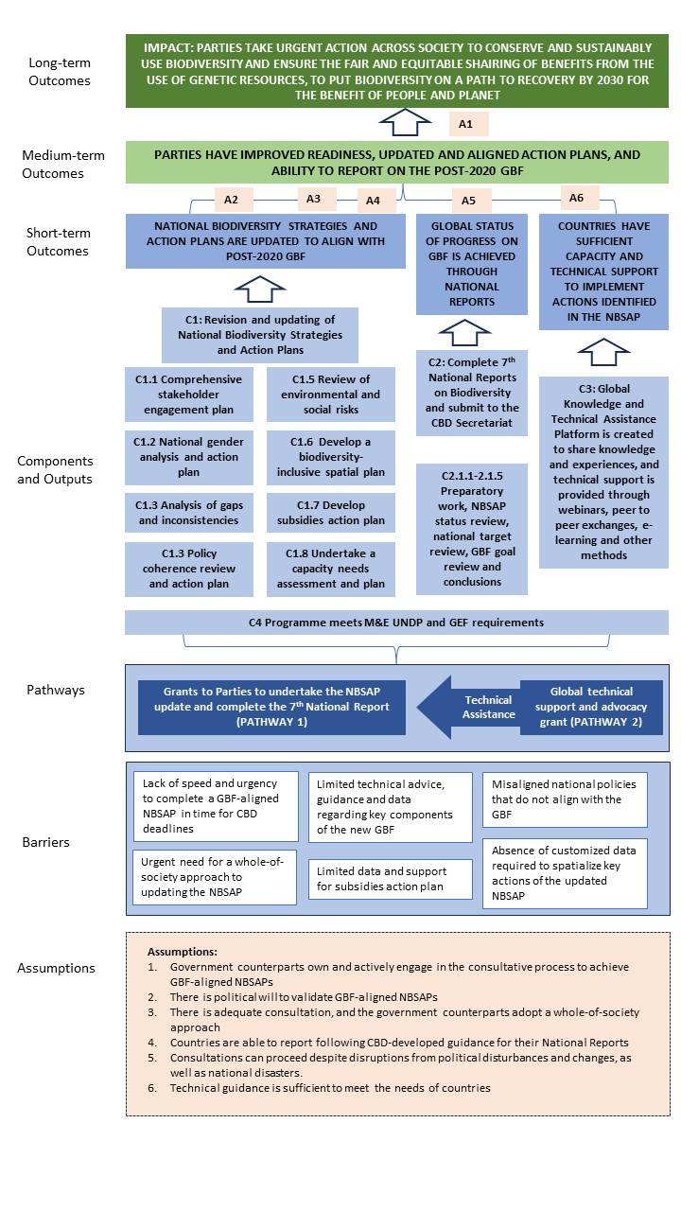

Alignment with GEF focal area and/or impact program strategies
The project directly contributes to the GEF-8 Biodiversity Programming Directions, specifically regarding The GEF’s stated support for activities included in this project in its Biodiversity Strategy: “The GEF will support…Enabling Activities, where the GEF will also support development of biodiversity policy and institutional frameworks through enabling activities. This will include revisions to the national biodiversity strategy and action plans, and national reports for CBD, the Cartagena Protocol, and the Nagoya Protocol.”
The project will also contribute towards national capacity development in line with Component 3 of the GEF 8 Strategy through its national institutional analyses, including policy coherence, gender and spatial analyses; global technical assistance for national biodiversity strategies and action planning; global technical support for national reporting, and support to existing global knowledge platforms on topics related to NBSAPs and national reporting, including e-learning tutorials, massive open online courses, webinars, guidance documents, publications and communications materials.
Incremental/additional cost reasoning and expected contributions from the baseline
Without external assistance and technical guidance, many countries are unable to commit the necessary funds, planning, and time to develop NBSAPs and conduct National Reports with sufficient technical quality and in a truly participatory fashion. This is particularly the case for Least Developed Countries (LDCs) and Small Island Developing States (SIDS). Therefore, this project seeks to cover the incremental cost to CBD Parties of taking a systematic, innovative, stepwise and adaptable approach to the completion of NBSAPs aligned with the new KM-GBF, and to the completion of National Reports in line with the requirements of the Convention on Biological Diversity.

IV Results and Partnerships

The objective of this project is to support countries in revising and updating their National Biodiversity Strategies and Action Plans (NBSAPs) to align with the recently agreed upon Kunming-Montreal Global Biodiversity Framework and enable effective implementation of the Convention on Biological Diversity (CBD) and the Kunming Montreal Global Biodiversity Framework at the national level. In addition, this grant supports countries in preparing and submitting their 7th National Report on the implementation of the Convention on Biological Diversity and the Kunming-Montreal Global Biodiversity Framework.
The project aims to provide financial and technical support through two pathways. The first, Pathway 1, is through grants made to Parties to undertake national actions on their NBSAPs and 7th National Reports (Components 1 and 2), and the second, Pathway 2, is to undertake global knowledge sharing and technical support, as well as support monitoring and assessment (Components 3 and 4). UNOPS is contracted as a Responsible Party to conduct Component 3 and 4 in support of Parties engaged with the implementation of Components 1 and 2. The objective and expected results are described below separately for each of the two pathways.
Pathway 1: Country Grants to complete NBSAPs and the 7th National Reports on Biodiversity
Component 1. Revision and updating of National Biodiversity Strategies and Action Plans: This programme component is aimed at revising or updating National Biodiversity Strategies and Action Plans (NBSAPs) that are aligned with the Kunming Montreal Global Biodiversity Framework. The component is composed of several outputs, including a comprehensive stakeholder engagement plan with adequate tools and strategies to promote a whole-of-society and a whole-of-government approach to the NBSAP; a national stakeholder and gender analysis and action plan that ensures gender mainstreaming within consultation processes and actions to advise the NBSAP updating and revision process. In addition, building on the results of the Global Biodiversity Framework Early Action Support (GBF-EAS), this component seeks to prioritize and update essential gaps and inconsistencies between the existing NBSAP, and changes needed to achieve the Global Biodiversity Framework. Countries will be encouraged to include an assessment of the potential socio-economic trade-offs, including environmental/social impacts, that would be related to the revised NBSAPs, in order to ensure that risks are avoided and managed when projects to implement the NBSAPs are undertaken in the future.
This component also aims to develop an NBSAP section that addresses policy alignment and coherence, and biodiversity mainstreaming into key sectors, within the NBSAP. In addition, building on nationally and globally available data, the component seeks to develop a first approximation of spatial priorities for Target 1 and a spatialized action plan for area-based Targets, including Targets 2, 3, 8, 9, 10, 11 and 12, within the NBSAP. Finally, the component aims to identify an action plan for identifying, eliminating and/or phasing out harmful subsidies and incentives within the NBSAP, building on the results of the GBF-EAS. Overall, this programme component is a crucial tool in ensuring that NBSAPs and national targets therein are aligned with the Global Biodiversity Framework and that all stakeholders are engaged in the process. It also highlights the importance of gender mainstreaming, policy coherence, cross-sectoral thematic inclusion and clearly defined responses to the 23 Targets and elimination of harmful subsidies in achieving global biodiversity goals and targets. Under this component, the NBSAP updates will incorporate strategies, measures, actions, and plans to ensure sustainable use, benefit sharing and safeguards in Biodiversity conservation in response to the three objectives of the CBD, the Global Biodiversity Framework, and the long-term capacity building plans. This component aims to support the updating/revising of NBSAPs in line with the guidance for updating NBSAPs contained in annex I to CBD COP decision 15/6. Finally, this component also highlights the importance of adopting terms and concepts in the revised/updated NBSAPs with consideration of how they can be communicated to and understood by non-specialist audience.
Specific deliverables by countries under this component include the following:
1.1: Development and implementation of a comprehensive stakeholder engagement plan, to promote an all-of-society approach to the NBSAP.
1.2 A national gender analysis and action plan developed to ensure gender mainstreaming within consultation processes and within actions to advise the NBSAP updating and revision process.
1.3 Building on the results of the EAS to accelerate early action on NBSAPs, identify and prioritize essential gaps and inconsistencies between the existing NBSAP and changes needed to achieve the Global Biodiversity Framework.
1.4 Building on the results from policy alignment reviews included in the EAS, develop an NBSAP section that addresses policy alignment and coherence, and biodiversity mainstreaming into key sectors within the NBSAP.
1.5 An assessment of the potential environmental and social impacts and potential risks of the implementation of the updated NBSAP.
1.6 Building on nationally and globally available data, develop a first approximation of spatial priorities for Target 1, and develop a spatialized action plan for other area-based targets, including Targets 2, 3, 8, 9, 11 and 12, within the NBSAP.
1.7 Building on the results of the EAS, identify an action plan for eliminating or phasing out harmful subsidies and incentives within the NBSAP.
1.8 An assessment of gaps in capacities and resources available undertaken and on that basis, develop plans or strategies for capacity development and resource mobilization, building on the work undertaken under the early support action project, the umbrella program to support development of biodiversity finance plans, and other initiatives such as BIOFIN.

Component 2. Complete 7th National Reports on Biodiversity: Each country will be required to complete their 7th National Report on Biodiversity, consistent with the CBD COP Decision 15/6 related to “Mechanisms for planning, monitoring, reporting and review.” This component provides direct support to countries to undertake this work in line with COP15 guidance. Specific sub-components identified in Annex II to decision 15/6 include: Section I - Brief overview of the process of preparation of the report; Section II - Status of the revised or updated national biodiversity strategy and action plan (NBSAP) in the light of the Kunming-Montreal Global Biodiversity Framework; Section III - Assessment of progress towards national targets; Section IV Assessment of progress related to the goals and targets of the Kunming-Montreal Global Biodiversity Framework; and Section V - Conclusions on the implementation of the Convention and the Kunming-Montreal Global Biodiversity Framework. This component also aims to support countries in the use of headline and other indicators for measuring and reporting on progress in the implementation of national targets, NBSAPs and the Kunming Montreal GBF.

Specific deliverables by countries included in this project are as follows:
2.1 Brief overview of the process of preparation of the report is completed.
2.2 Status of the revised or updated national biodiversity strategy and action plan (NBSAP) in the light of the Kunming-Montreal Global Biodiversity Framework.
2.3 Assessment of progress towards national targets are completed.
2.4 Assessment of progress related to the goals and targets of the Kunming-Montreal Global Biodiversity Framework is completed.
2.5 Conclusions on the implementation of the Convention and the Kunming-Montreal Global Biodiversity Framework are completed.
Pathway 2: Technical support to countries to achieve Components 1, 2, and 4, and provide global knowledge and technical assistance:
Component 3. Global Knowledge and Technical Assistance Platform: this component includes a comprehensive suite of digital and technical offerings that cover a wide range of topics related to Global Biodiversity Framework (GBF). The focus will be on those areas identified in this proposal as likely gaps, including the integration of biodiversity and climate change; the integration of Indigenous knowledge; integration of business and finance sectors; inclusive governance; innovative monitoring and reporting; and use of data, including geospatial data. Through interactive webinars, e-learning courses, and peer-to-peer learning opportunities, this component will highlight tools and best practices in the field and will encourage a demand-driven approach to learning. It will include the development of a global catalogue of best practices related to NBSAPs across all 23 GBF targets and the five goals. The catalogue will include emerging lessons and best practices captured by dedicated knowledge products such as NBSAP status publications (e.g., a NBSAP Gender Gap Report and/or an NBSAP Ambition Report) to update on the state of NBSAPs, technical publications, videos, websites, articles, and podcast episodes. In addition, in-country implementation processes will be supported by dedicated technical advice from global and regional experts, including technical review of NBSAPs on a demand-driven basis and peer-to-peer exchanges. This component will also provide dedicated support to global efforts to raise awareness of the value of biodiversity and the importance of NBSAPs in driving national development agendas and programmes, including online events and information through the NBSAP Forum and other related efforts that help mobilize political will and ambition. Communication and outreach activities will facilitate the exchange of experiences and best practices among countries and promote international cooperation, including regional and global in-person annual meetings, best practice workshops, and CBD side events. This component also aims to develop or strengthen the countries’ various capacities for the updating or revising of NBSAPs and the preparation of the seventh national report. In partnership with UNEP, UNDP will prepare flagship reports that highlight key issues, including a Global NBSAP Gender Report, a Global NBSAP Ambition Report, and a Global Spatial Report showcasing progress in key areas.

Specific deliverables under this component include:
3.1. A suite of e-learning offerings on a range of GBF-related topics on a demand-driven basis, covering the following priority areas: a) NBSAPs - technical support for stakeholder engagement plans; for developing national gender action plans; for assessing and reporting NBSAP gaps; for assessing policy coherence; for conducting environmental and social impact assessments; for developing spatialized action plans for area-based targets; for eliminating or phasing out harmful subsidies; and for developing a national capacity needs assessment; and b) National Reporting – technical support for preparing the National Report, for reporting on overall progress on the KM-GBF, and for reporting on implementation.
3.2. Interactive webinars to highlight best practices on the above topics, including at global and regional levels, and including multiple languages.
3..3 Global catalogue of best practices related to NBSAPs across the 23 GBF targets, including documentation of emerging lessons and best practices captured by dedicated knowledge products, technical publications, videos, websites, articles, and podcast episodes.
3.4. In-country implementation processes supported by dedicated technical advice from global experts including technical review of NBSAPs on a demand-driven basis, and peer to peer exchanges.
3.5. Dedicated support to global efforts to raise awareness of the value of biodiversity, and the importance of NBSAPs, at global levels, including through online events that help to mobilize political will and ambition.
3.6 Communication and outreach activities to facilitate exchange of experiences and best practices amongst countries and promote international cooperation, including regional and global in-person annual meetings, best practice workshops and CBD side events.
3.7 Flagship summary reports highlighting key issues, including a Global NBSAP Gender Report, a Global NBSAP Ambition Report, and a Global Spatial Report.

Component 4. M&E The programme will implement a M&E Plan that adheres to GEF and UNDP requirements, enables effective evaluation of project progress and impact, reflects the needs of women, IPLCs, and other vulnerable groups, and will effectively monitor social and environmental safeguards risks. These activities will ensure that the project monitoring system operates effectively, systematically provides information on progress, and informs adaptive management to ensure that the intended outcomes are achieved.
This Global Programme will be responsive to CBD guidance on developing NBSAPs and completing the 7th National Report, including recent COP15 outcomes and decisions. It will also build upon existing work through the GBF-EAS that is ongoing, as well as support to countries to develop biodiversity finance plans, through the recently approved “Umbrella Programme to Support Development of Biodiversity Finance Plans”. The project implementation units of all three initiatives will coordinate to ensure that resources from both projects are used effectively and efficiently towards the update or revision of the National Biodiversity Strategies and Action Plans and the preparation of the 7th National Reports in the targeted countries.
The specific deliverable for this component, which will be managed by UNDP, is to ensure that the Monitoring and Evaluation Plan is fully implemented, including a terminal evaluation.

Agreement on intellectual property rights and use of the logo on the project’s deliverables and disclosure of information: To accord proper acknowledgement to the GEF for providing grant funding, the GEF logo will appear together with the UNDP logo on all promotional materials, other written materials like publications developed by the project, and project hardware. Any citation on publications regarding projects funded by the GEF will also accord proper acknowledgement to the GEF. Information will be disclosed per relevant policies, notably the UNDP Disclosure Policy and the GEF policy on public involvement.

Resources required to achieve the expected result: Achieving the results of this project will require the following resources: a) National level UNDP: this project will require the operational and substantive report of UNDP environment focal points from each of the 69 countries included in the proposal, with a focus on administering funds nationally, providing a liaison with the global team on operational and substantive issues, and troubleshooting as needed; b) Global level – UNDP: the UNDP Global team will include an operational team for distributing, managing, and monitoring national funds needed to execute Components 1 and 2, and ensuring that the project adheres to guidelines and best practices for UNDP and the GEF, including both an operations team, and a project technical lead, who will focus on both technical and operations side of executing the project; c) Global level – UNOPS: the technical side of the global work (Components 3) will be executed by UNOPS, through the Nature for Development Programme, with a focus on developing tools and guidance, providing capacity building, and liaising with national counterparts to ensure full technical execution and support. In addition, the project technical lead will facilitate close coordination with the NBSAP Accelerator Partnership project, ensuring that strategies are aligned, and identifying and capitalizing on potential synergies, especially related to knowledge platforms and technical support.

Partnerships: UNDP’s existing partnership with UNEP and SCBD forms the bedrock of this initiative. UNDP has been working closely with the SCBD and UNEP through the long-standing joint Global Governance Committee that these three agencies convene, and through a senior leadership initiative between SCBD, the GEF, UNDP, and UNEP that is intended to mobilize the project towards implementation. This team has prepared several information documents and other forms of policy recommendations. This partnership and close working relationship will continue to be facilitated by the project technical lead of this new project and co-produce technical guidance and tools in alignment with CBD decisions. More recently, this partnership has jointly executed the GEF 7 Enabling Activities grant on Early Action Support.

The project technical lead will also coordinate partnerships with regional bodies which are also of critical importance for successfully supporting Parties. In previous EA support projects, Parties required a combination of regionally tailored in-person and virtual support to effectively absorb and apply technical material. Uptake and application at the national level also improves when multiple capacity building opportunities are delivered in partnership with regional partners, when templates are provided in multiple languages, and when learning opportunities are available to a variety of professionals, from a technical analyst to a senior minister of the environment. During regional workshops, Parties also responded positively to opportunities for regional cooperation and cross-boundary work on conservation. During the global project inception, UNDP will work with the BPPS Environment regional team leaders and technical advisors to identify key regional agencies that are critical to coordinate with to develop and deliver technical support and guidance. When project rosters of experts are developed, regional partners will be contacted to help develop and advertise this list. A list of regional technical experts will be beneficial, as it can expedite otherwise lengthy procurement processes in many small nations. Rolling out training by region, either virtually or in person, provides an opportunity for countries within a region to meet with each other, discuss common obstacles, learn how peers are applying technical tools, and strengthen networks. In past projects, in-person meetings convened by regional agencies has helped Parties overcome challenges related to internet connectivity and time zones.

Close coordination between all biodiversity-related enabling activities is essential. The "Umbrella Programme to support NBSAP and the 7th National Reports" will be executed in coordination with the recently approved GEF 8 "Umbrella Programme to Support Development of Biodiversity Finance Plans" and the GEF 7 "Global Biodiversity Framework Early Action Support". This coordinated effort will occur at three levels:

Global Level: The Global Programme Management Units of the three enabling activities will convene semi-annually. Their purpose will be to ensure a high level of coordination, sequence project activities effectively, maintain coherence, foster complementarity, and orchestrate the activities of these initiatives seamlessly.
National Level: National steering committee members, particularly government partners, will play a pivotal role in elevating the visibility of these initiatives on the national political agenda. They will work to establish an enabling environment for effective coordination among these projects and to utilize them as a single unified support envelope for the implementation of the Global Biodiversity Framework at the national level.
Project Implementation Level: Project Management Units and key technical teams of these projects will engage in quarterly meetings. These meetings will ensure that project resources are utilized efficiently to achieve the respective objectives of the projects. Moreover, these interactions will promote synergies and, whenever possible, realize economies of scale while avoiding duplication of efforts.
Risks and Assumptions: Successfully realizing the intermediate outcomes of the pathways and ultimately the project objective of readiness for GBF implementation is based on several assumptions (as outlined in the project’s theory of change above). If these assumptions do not hold true, it could adversely affect the achievement of project results. The project strategy was also assessed for social and environmental risks that it could potentially lead to. These are captured in the Annex 5 on SESP. A full analysis of all risks and mitigation measures are in the risk register.

Stakeholder engagement:

Countries are expected to involve a wide multi-sectoral group of stakeholders in the various stages of consultations and implementation. Each country team supported by the project will develop a Stakeholder Engagement Plan, taking into consideration the below.

During the funding of previous enabling activities, GEF eligible countries conducted stakeholder mapping exercises for biodiversity issues. Participating countries may re-engage those working groups during this GBF-EAS period. Parties will be provided technical guidance on stakeholder engagement so that indigenous peoples and local communities, women, youth, and other typically marginalized stakeholders are made part of the stakeholder engagement process from the outset.

The stakeholder engagement process should start with the CBD national focal points, the national focal points for the two CBD Protocols, the Competent National Authorities, the GEF Operational Focal Point, the NBSAP responsible authority or whoever has responsibility for NBSAP coordination, the preparation of CBD national reports, the development and operationalization of national monitoring systems and of resource mobilization plans for biodiversity. Thereafter it should expand to include a much broader range of national actors. Existing guidance repeatedly emphasizes that during the transition from biodiversity planning to biodiversity implementation (and related progress assessments and reporting), everyone with a stake in the outcome of the target setting, monitoring, policy alignment and resource mobilization process needs to be engaged. At the national level, UNDP and UNEP recommend instituting a national steering committee that includes representatives of all sectors. These could include the finance ministry, line environment ministries, sub-national government entities, research and academic bodies, business and industry, indigenous and local community organizations, bodies representing the agricultural, forestry, fishing or other sectors, environmental management bodies, non- governmental organizations, women’s organizations, bodies and agencies addressing sustainable development and poverty eradication, educators, the media, youth, and others – emphasizing a whole-of-government and whole-of-society approaches. Each country’s list will be different, but all should be comprehensive. This project will create the means for ensuring that, at the country level there is alignment between the NBSAPs, the GBF, and other environmental targets through a widely inclusive and participatory process.

At a minimum, the following sets of actors should be engaged:
- National ministries responsible for managing the environment portfolio in each participating country.
- Competent National Authorities responsible for the Convention and its two Protocols
- National ministries responsible for natural resource production sectors, including forestry, fisheries, agriculture.
- National ministries responsible for managing nature-dependent development sectors, including tourism, water security, disaster management, economic development.
- National ministries responsible for nature-impacting development sectors, including infrastructure, mining, energy, and transportation.
- National ministries responsible for budgeting and financing.
- National ministries responsible for generating and collating data and statistics.
- National ministries responsible for gender.
- Other national stakeholders including Academia, women groups, multi-sectoral government ministries, local authorities, local communities, civil society organizations and local non-governmental organizations.
- Private sector entities.
- Indigenous peoples and local communities.
- International non-governmental organizations.
- Multilateral agencies (e.g., World Bank, FAO, others).
The role of civil society will be critical and decided respecting the context within each country. It is expected that civil society will be involved in many aspects of the project implementation.

South-South and Triangular Cooperation (SSC/TrC):

In addition to the work on partnerships, UNDP will bring the multiple voices of representatives in the project to multiple global and regional fora. The project will explore opportunities for meaningful participation in specific events where UNDP could support engagement with the global development discourse on the role of nature in achieving nature-dependent sustainable development goals, and related topics. Specifically, UNDP find opportunities to foster South-South and Triangular Cooperation through existing knowledge portals, including Panorama, the NBSAP Forum, Learning for Nature, the NBSAP Accelerator Partnership, among others. UNDP will engage in South-South events, including COP, SBSTTA and SBI side events, regional webinars, learning courses related to the project, and virtual events such as the Nature for Life Hub.

Gender equality and Women’s Empowerment:

Gender mainstreaming is an important aspect of CBD implementation, and it is enshrined not just in the previous Strategic Plan 2011-2020 itself (refer to COP 10 Decision X/2, article 8), but also in the new emerging Global Biodiversity Framework, as well as in a number of other COP and COP-MOP(s) decisions. Quoting the mentioned article, “Recalls decision IX/8, which called for gender mainstreaming in national biodiversity strategies and action plans, and decision IX/24, in which the COP approved the gender plan of action for the Convention, which, among other things, requests Parties to mainstream a gender perspective into the implementation of the Convention and promote gender equality in achieving its three objectives, and requests Parties to mainstream gender considerations, where appropriate, in the implementation of the Strategic Plan for Biodiversity 2011-2020 and its associated goals, the ABTs, and indicators.”

The preamble of the CBD recognizes the vital role that women play in the conservation and sustainable use of biological diversity and the need for the full participation of women at all levels of policymaking and implementation for biodiversity conservation. In recognition of this, a first draft of a gender plan of action for the post-2020 period has been prepared for consideration at SBI 3 and for adoption by the COP. This post-2020 gender plan of action clarifies linkages with the most directly relevant goals, milestones, and targets of the framework, in order to support the targeted integration of gender actions into respective areas of national biodiversity strategies and action plans.

The GBF-EAS project is currently a vehicle for further implementing these decisions and guidance. UNDP and UNEP will provide guidance on considering gender when undertaking each of the four different components in this proposal. All Parties will be encouraged to undertake strategies and actions that highlight women’s and youth role in conservation/sustainable use and that address the need for a more gender-equitable sharing of its benefits. Based on the analysis of gender that the CBD Secretariat did in advance of CoP13 , and based on UNDP’s own analysis of gender-related actions across all post-2010 NBSAPs, UNDP and UNEP will ensure that key dimensions of gender are integrated into the project, including an increase in understanding of gender-differentiated connections to biodiversity conservation and sustainable use to support more sustainable outcomes, an understanding of the steps related to gender equality and women’s empowerment, identifying opportunities for women that make use of their biodiversity knowledge; and reinforcing efforts to include women in the implementation of nature-dependent Sustainable Development Goals. Finally, the project's results framework includes gender-sensitive indicators, and a gender action plan is included as an Annex 10.

Knowledge:
This project will result in numerous knowledge products, ranging from concise and somewhat informal guidance notes to more formal and comprehensive products. These will be available on a project microsite, as well as made widely available via UNDP’s “Learning for Nature” portal, which has more than 80,000 policy-relevant learners from 190 countries. The following is a summary of some of the key knowledge products expected from this project:

- Stakeholder engagement: Guidance document refined and expanded from GEF 7 Early Action Support project, with case studies of best practices;
- Gender analysis: National gender analysis and action plan with case studies from previous work on supporting gender action plans;
- NBSAP status: State of NBSAPs, with analysis of key issues, alignment with GBF targets; global summary of best practices for each of the targets;
- Policy coherence: Comprehensive guidance on policy coherence, including checklist, case studies, e-learning course;
- Spatialized plans: Comprehensive guidance, with case studies, on how to spatialize various targets, including updates to how to use existing spatial resources and e-learning courses;
- Capacity needs: Summary highlight of capacity needs assessments from various sources;
- 7th National Reports: Summary guidance on implementation of 7th National Reports, in consultation with CBD, and summary analyses of results;
- Subsidies: Summary guidance on phasing out harmful subsidies, building on results and lessons from GEF 7 Early Action Support grants and lessons from BIOFIN, with case studies;
- Value of nature: Summary guidance documents, building on existing lessons from BIOFIN and other partners, with case studies of best practices, of making the case for the value of nature in national development and other key plans; and
- Capacity needs assessment: Guidance documents and checklists for conducting rapid capacity needs assessments and for developing capacity action plans.

Innovativeness, Sustainability, and Potential for Scaling Up:

This project seeks to build on the GBF-EAS to accelerate further progress on the post-2020 GBF. Elements of innovation of this grant include providing guidance and support to accelerate action related to scaling up policy alignment and coherence, guidance for scaling up spatialization of NBSAP actions, and guidance to ensure that the next generation NBSAPs are fully aligned with the GBF. The focus is on encouraging countries to take a proactive, early, and responsive approach, in order to bypass traditional delays in implementation. This project provides an opportunity for Parties to use best available data, methodologies, and approaches. The project can also help Parties identify innovative approaches to monitoring, reporting, target setting, policy alignment and biodiversity finance at scale.

In terms of sustaining project-mediated actions, this will be facilitated by building individual and institutional capacity to take effective early action to implement the post-2020 GBF. The stakeholder driven process will ensure ownership of the outcomes and help Parties to further set and evaluate the importance of a national conservation strategy, and the elements it is intended to address. In most GEF-eligible countries, these committees and structures operated or are operating through previous GEF projects targeting enabling activities. Measures will be taken to ensure adequate representation of the stakeholders responsible for promoting gender equality and women’s rights and the involvement of youth, IPLCs, and other emerging issues. To catalyze the data collected and lessons learned from similar efforts, the focal points of other multilateral agreements and processes that require national reporting on elements of the CBD will also be engaged. The project is a direct response to capacity needs identified by UNDP and UNEP with respect to national biodiversity planning and reporting during previous GEF EA BD projects, which emphasize the concept that biodiversity planning is a cyclical and incremental process of capacity building. Elevating biodiversity concerns into the policies and plans of government ministries and private sector companies is a goal that can take many years to achieve, requiring tremendous amounts of energy.

Sustainability of the outcomes of the project is also dependent on the maintenance and management of the national, regional, and global communications infrastructure. This project will be executed at country level, and be supported by a global project management and technical support unit, but will also have participation of various regional and global actors, the UNDP and UNEP regional offices, UNEP WCMC, and SCBD as necessary. Networks will also include actors promoting gender equality, and IPLC and women’s rights. Tapping into all of these networks will greatly improve the prospects for sustainability of results.

In terms of scaling up and replication, this project is already targeting a large number of countries, and, including the UNEP-supported countries, approximately 140 countries are to be provided financial and technical assistance to take early actions to implement the post-2020 GBF. The technical support to be provided by the project builds on the positive results of previous enabling activities funding and technical support packages provided to Parties during implementation of the 2011-2020 Strategic Plan for Biodiversity. Technical support approaches will be refined in this project, and could be scaled up for use during other GEF supported enabling activities. The GBF-EAS project is already drawing interesting lessons on the importance of inter-agency collaboration and on the need to involve the Convention in partnerships. During the development of the Third, Fourth, Fifth, and Sixth National Reports, and implementation of the ‘Global Support to NBSAP’ project, UNEP and UNDP had a similar model of using an umbrella program encompassing many countries. This modus operandi has several advantages which could be replicated in other GEF and non-GEF projects that involve enabling activities. The advantages include: an umbrella approach is aimed at reducing transaction costs of individual country requests, providing the GEF, UNDP, and UNEP an opportunity for managing BD EAs more strategically in close partnership with the CBD and other key global actors. A second aspect that is already being replicated from previous umbrella projects is parallel training for country teams for issues pertaining to the project and organized by the SCBD.

Once NBSAPs and National Biodiversity Targets (NBTs) are aligned with the post-2020 GBF, it will be important for Parties to rollout implementation of those targets through targeted actions. And, successful implementation of this project could provide a potential pathway for developing plans and scaling up action through projects funded in subsequent GEF cycles, or through funding from other donors.

Digital Solutions:
In line with the UNDP 2021 Data Strategy, the project takes into account digital development challenges and development results. In doing so, the project incorporates digital-related output and outcomes, particularly under Component 1, related to digital solutions for policy coherence, spatial data, and social and environmental impacts, as well as Components 3, with digital solutions related to sharing lessons through e-learning, developing a global catalogue of best practices related to NBSAPs, and supporting solutions related to the value of nature, among others. Digital tools will also be essential for the collection of data and the development of tools for data consultation, comparison and easy accessibility. We envision innovative digital solutions for collecting data such as using AI and machine learning for mining policies, for example.

V. Project Management

Cost Efficiency and Effectiveness

This project is designed to ensure the most cost-efficient means of execution. The operational component, focusing on execution of Components 1 and 2 focuses on delivery of funds to national offices for execution. This unit is well equipped to monitor budgeting, spending, and progress within the national level for the various stages. The technical support component, focusing on execution of Components 3 through a Responsible Party agreement with UNOPS, is well equipped to deliver on technical guidance and global advocacy and support, given that it has provided this function for more than 7 years, and has a large team who can accommodate a dynamic and demand-driven workload.
The project will ensure effective communications with UNEP, the sister agency responsible for delivery to 69 countries, to capture and capitalize on lessons learned, both from the Early Action Support project, and early lessons from this project.

Project Management

This project will be conducted primarily through the following modalities: a) global project management team to manage the project, and ensure that the project operates smoothly, will be New York based, consisting of the project technical lead, a technical coordinator and the operational team required to ensure the completion of the projects, with a focus on Components 1 and 2 ; b) national UNDP offices, who will manage execution, through national grants, of Components 1 and 2; and c) a Responsible Party agreement with UNOPS to deliver on specified elements under Components 3, who will be responsible for its execution, and for reporting to the project technical lead regarding delivery and coordination with partners. In particular, the project technical will directly co-supervise the technical coordinator on the day to day basis, with the Nature for Development Programme manager within UNOPS as an official contractual supervisor. Together, the project technical lead and the technical coordinator will form a coordination team to ensure smooth functioning of technical deliverables, with the NfD Programme Manager in an advisory capacity. The technical coordinator will maintain management and oversight of the individual team members responsible for Component 3.

The project will liaise with the following existing teams and projects:

GBF-EAS: This project is currently playing an important role advancing implementation of Component 1 (Rapid review of NBSAP for alignment with the post-2020 GBF) and other relevant components in many countries and will liaise with the this project, the “Umbrella Programme to Support NBSAP Update and the 7th National Reports” and to ensure a smooth transition before the GBF-EAS projects closes.

BIOFIN: The extended BIOFIN team, which includes both the existing suite of BIOFIN countries, as well as the new GEF 8 BIOFIN project, will play an important role in this project, particularly when it comes to a) ensuring that NBSAP action plans are well costed, and have a viable finance plan; and b) ensuring that lessons related to phasing out harmful subsidies are incorporated into the new NBSAPs.

NBSAP Accelerator Partnership: This project, the “Umbrella Programme to Support NBSAP Update and the 7th National Reports will liaise very closely with the newly created NBSAP Accelerator Partnership. The NBSAP AP is a project that is intended to be somewhat independent within UNDP, with team members having dual reporting lines to both the NBSAP AP director (based out of UNEP), as well as his/her reporting lines within UNDP and/or the Nature for Development team. There will be many areas of synergy between the NBSAP AP and this project, including a) supporting the NBSAP Forum and ensuring interoperability; b) guidance and materials developed for both projects; c) communications with countries; and d) resources available to accelerate ambition on NBSAPs. A small team, consisting of the communications focal points within the operational unit, the Nature for Development team, and the NBSAP AP, will ensure smooth and consistent communications with all project-supported countries.

Key Partners: UNEP and CBD are key partners for the execution of this project. Unlike the GBF-EAS project , where deliverables were split between UNDP and UNEP, UNDP retains the ability and responsibility to develop all deliverables unilaterally from UNEP. However, UNDP will liaise closely with UNEP to ensure that there is harmonization and consistency between tools developed, and UNDP will depend upon CBD to provide advice and guidance regarding templates and forms for the NBSAP and in particular, for the 7th National Report, which is typically standardized by CBD. Both UNEP and CBD form part of the project board. In matters where there is shared governance, such as the UN Biodiversity Lab and the NBSAP Forum, this project will liaise with UNEP and CBD closely, and follow pre-existing norms related to approvals of use of logo.

VI Project Results Framework

Project Results Framework (Pathways 1 and 2)
This project will contribute to the following Sustainable Development Goal (s): Goals 1 to 17 (see https://www.cbd.int/sbstta/sbstta-24/post-2020-sdg-linkages-en.pdf )
This project will contribute to the following country outcome (UNDAF/CPD, RPD, GPD): N/A because this is a multi-country project
This project will contribute to the following signature solution of the UNDP Strategic Plan 2022-2025: Putting nature and the environment at the heart of national economies and planning; helping governments protect, manage and value their natural assets. This project will also contribute to UNDP’s Nature Pledge.

Objective and Outcomes | Objective and Outcome Indicators | Baseline | Mid-term Target | End of Project Target  Expected level when terminal evaluation undertaken
Project Objective: To support countries in revising and updating their National Biodiversity Strategies and Action Plans (NBSAPs) in order to align with the recently agreed upon Kunming-Montreal Global Biodiversity Framework, and enable effective implementation of the Convention on Biological Diversity (CBD) and the Kunming Montreal Global Biodiversity Framework at the national level, and prepare and submit their 7th National Report on the implementation of the Convention on Biological Diversity and the Kunming-Montreal Global Biodiversity Framework. | Number of countries that have updated their NBSAP to align with the Kunming-Montreal Global Biodiversity Framework | 0 | 30 | 69 – All participating countries
 | Number of countries that have completed their 7th National Report | 0 | 30 | 69 – All participating countries
 | Number of beneficiaries per country disaggregated by gender | 0 | 30 | At least 5,000 per country (at least 2,500 men and 2,500 women)

Results Framework for Pathway 1: Country grants
Project component 1 | Revision and updating of National Biodiversity Strategies and Action Plans
Objective and Outcomes | Objective and Outcome Indicators | Baseline | Mid-term Target | End of Project Target  Expected level when terminal evaluation undertaken
Project Outcome 1.1: GBF-aligned NBSAP is developed | Number of countries with NBSAPs that align with KM-GBF | 0 | 30 | 69 (All participating countries)
Outputs to achieve Outcome 1.1 | 1.1.1 Development and implementation of a comprehensive stakeholder engagement plan, to promote an all-of-society approach to the NBSAP.  1.1.2 A national gender analysis and action plan developed to ensure gender mainstreaming within consultation processes and within actions to advise the NBSAP updating and revision process.  1.1.3 Building on the results of the EAS to accelerate early action on NBSAPs, identify and prioritize essential gaps and inconsistencies between the existing NBSAP and changes needed to achieve the Global Biodiversity Framework.  1.1.4 Building on the results from policy alignment reviews included in the EAS, develop an NBSAP section that addresses policy alignment and coherence, and biodiversity mainstreaming into key sectors within the NBSAP.  1.1.5 An assessment of the potential environmental and social impacts and potential risks of the implementation of the updated NBSAP.  1.1.6 Building on nationally and globally available data, develop a first approximation of spatial priorities for Target 1, and develop a spatialized action plan for other area-based targets, including Targets 2, 3, 8, 9, 11 and 12, within the NBSAP.  1.1.7 Building on the results of the EAS, identify an action plan for eliminating or phasing out harmful subsidies and incentives within the NBSAP.  1.1.8 An assessment of gaps in capacities and resources available undertaken and on that basis, develop plans or strategies for capacity development and resource mobilization, building on the work undertaken under the early support action project, the umbrella program to support development of biodiversity finance plans, and other initiatives such as BIOFIN.
Project component 2 | Complete the 7th National Reports on Biodiversity
Project Outcome 2.1: National Reports on Biodiversity (7NR) are completed for each country | Number of national reports completed and submitted to the CBD Sec | 0 | 20 | 69 (All participating countries)
Outputs to achieve Outcome 2.1 | 2.1.1 Brief overview of the process of preparation of the report is completed.  2.1.2 Status of the revised or updated national biodiversity strategy and action plan (NBSAP) in the light of the Kunming-Montreal Global Biodiversity Framework.  2.1.3 Assessment of progress towards national targets are completed.  2.1.4. Assessment of progress related to the goals and targets of the Kunming-Montreal Global Biodiversity Framework is completed.  2.1.5 Conclusions on the implementation of the Convention and the Kunming-Montreal Global Biodiversity Framework are completed.

Pathway 2: Global knowledge and technical support
Project component 3 | Global Knowledge and Technical Assistance Platform
Project Outcome 3.1: A global knowledge and technical assistance platform is established to share knowledge and experiences across participating countries and partner organizations | Number of e-learning courses and other forms of learning and dissemination are hosted on global platforms, and made widely available on Learning for Nature | Global Knowledge and technical assistance platform – learning:  0 e-learning resources specific to this project | Global Knowledge and technical assistance platform – learning:  6 e-learning resources specific to this project | Global Knowledge and technical assistance platform – learning:  12 e-learning resources specific to this project are available on Learning for Nature
 | Number of webinars and other forms of interactive learning and dissemination are hosted on global platforms, and made widely available | Global Knowledge and technical assistance platform – webinars:  0 webinars conducted specific to this project | Global Knowledge and technical assistance platform – webinars:  12 webinars specific to this project | Global Knowledge and technical assistance platform – webinars:  24 webinars specific to this project are available on Learning for Nature
 | Number of products, materials, case studies, and other forms of information are hosted on global platforms, and made widely available | Global Knowledge and technical assistance platform – case studies:  0 case studies and best practice examples for Components 2 and 3 are developed and available on the NBSAP Forum | Global Knowledge and technical assistance platform – case studies:  50 case studies and best practice examples for Components 2 and 3 are developed and available on the NBSAP Forum | Global Knowledge and technical assistance platform – case studies:  100 case studies and best practice examples for Components 1 and 2 are developed and available on the NBSAP Forum
 | Number of countries supported with dedicated technical advice and data from global experts and peer-to-peer exchanges | Global Knowledge and technical assistance platform – Technical assistance  0 countries received dedicated technical advice from global experts and participate in peer-to-peer exchanges  Customized data and support:  0 countries have customized spatialized data in a format that can be used to spatialize NBSAPs  0 countries have customized policy coherence data that can be used to develop policy coherence assessments | Global Knowledge and technical assistance platform – Technical assistance  30 countries receive dedicated technical advice from global experts and participate in peer-to-peer exchanges  Customized data and support:  30 countries have customized spatialized data in a format that can be used to spatialize NBSAPs  30 countries have customized policy coherence data that can be used to develop policy coherence assessments | Global Knowledge and technical assistance platform – Technical assistance  All requesting countries receive dedicated technical advice from global experts and participate in peer-to-peer exchanges  Customized data and support:  All participating countries who request support have customized spatialized data in a format that can be used to spatialize NBSAPs  All participating countries who request support have customized policy coherence data that can be used to develop policy coherence assessments
 | Number of people reached through dedicated global efforts to raise awareness of the value of biodiversity, including through on-line and in-person events | 0 people reached through 0 dedicated global events to raise awareness of the value of biodiversity | 500,000 people reached through 1 dedicated global event to raise awareness of the value of biodiversity | 1,000,000 people reached through 2 dedicated global events to raise awareness of the value of biodiversity
 | Number of communication and outreach activities to facilitate exchange and experiences of best practices among countries, best practice workshops and/or CBD side events (among other events) | 0 communication and outreach activities to facilitate exchange and experiences of best practices among countries, best practice workshops and/or CBD side events (among other events) | 12 communication and outreach activities to facilitate exchange and experiences of best practices among countries, best practice workshops and/or CBD side events (among other events) | 24 communication and outreach activities to facilitate exchange and experiences of best practices among countries, best practice workshops and/or CBD side events (among other events)
 | Number of flagship global NBSAP reports | 0 flagship global NBSAP reports are completed | 2 flagship global NBSAP reports are completed | 3 flagship global NBSAP reports are completed
Outputs to achieve Outcome 3.1 | 3.1.1. A suite of e-learning offerings on a range of GBF-related topics on a demand-driven basis  3.1.2. Interactive webinars to highlight best practices.  3.1.3 Global catalogue of best practices related to NBSAPs across the 23 GBF targets, including documentation of emerging lessons and best practices captured by dedicated knowledge products, technical publications, videos, websites, articles, and podcast episodes.  3.1.4. In-country implementation processes supported by dedicated technical advice from global experts including technical review of NBSAPs on a demand-driven basis, and peer to peer exchanges.  3.1.5. Dedicated support to global efforts to raise awareness of the value of biodiversity, and the importance of NBSAPs, at global levels, including through online events that help to mobilize political will and ambition.  3.1.6 Communication and outreach activities to facilitate exchange of experiences and best practices amongst countries and promote international cooperation, including regional and global in-person annual meetings, best practice workshops and CBD side events.  3.1.7 Flagship summary reports highlighting key issues, including a Global NBSAP Gender Report, a Global NBSAP Ambition Report, and a Global Spatial Report
Project component 4 | M&E
Project Outcome 4.1: Programme M&E meets UNDP and GEF standards. | A plan for monitoring and evaluation is fully executed, consistent with UNDP and GEF standards | The project has not executed a monitoring or evaluation plan | The monitoring and evaluation plan is in place, with clear timelines and milestones established, and action plans for adaptive management are in place. | The monitoring and evaluation plan has been fully executed.  Monitoring indicators are fully populated.  A terminal evaluation has been completed, with a response matrix.  Lessons learned from the project have been identified and recorded.
Outputs to achieve Outcome 4.1 | 4.1.1 Programme M&E plan fully implemented.

VII Monitoring and Evaluation (M&E) Plan

- Project-level monitoring and evaluation will be undertaken in compliance with UNDP requirements as outlined in the UNDP POPP (including guidance on GEF project revisions) and UNDP Evaluation Policy. The BPPS Nature Hub (which is the Implementing Partner for this global DIM project) is responsible for ensuring full compliance with all UNDP project M&E requirements including project monitoring, UNDP quality assurance requirements, quarterly risk management, and evaluation requirements.
- Additional mandatory GEF-specific M&E requirements will be undertaken in accordance with the GEF Monitoring Policy and the GEF Evaluation Policy and other relevant GEF policies.
- In addition to these mandatory UNDP and GEF M&E requirements, other M&E activities deemed necessary to support project-level adaptive management will be agreed – including during the Project Inception Workshop – and will be detailed in the Inception Report.

Minimum project monitoring and reporting requirements as required by the GEF:
- Inception Workshop and Report: A project inception workshop(s) will be held by the Global Project Management and Technical Support Unit (GPMTSU) with all the partner countries within 2 months from the First disbursement date, with the aim to:
- Familiarize key stakeholders with the detailed project strategy and discuss any changes that may have taken place in the overall context since the project idea was initially conceptualized that may influence its strategy and implementation.
- Discuss the roles and responsibilities of the project team, including reporting lines, stakeholder engagement strategies and conflict resolution mechanisms.
- Review the results framework and monitoring plan.
- Discuss reporting, monitoring and evaluation roles and responsibilities and finalize the M&E budget; identify national/regional institutes to be involved in project-level M&E; discuss the role of the GEF OFP and other stakeholders in project-level M&E.
- Update and review responsibilities for monitoring project strategies, including the risk log; SESP report, Social and Environmental Management Framework (where relevant) and other safeguard requirements; project grievance mechanisms; gender strategy; knowledge management strategy, and other relevant management strategies.
- Review financial reporting procedures and budget monitoring and other mandatory requirements and agree on the arrangements for the annual audit.
- Plan and schedule Project Board meetings and finalize the first-year annual work plan. Finalize the TOR of the Project Board.
- Formally launch the Project.

- GEF Project Implementation Report (PIR): While this is not required for EA projects, in lieu of the annual PIR reporting, the UNDP global project management unit will provide project status data during the annual reporting period in the GEF Portal, and will also share this with the Project Board.
- Terminal Evaluation (TE): A single TE will be undertaken for the entire project (including global technical support pathway, and the country grants pathway). It will be a joint TE across UNDP and UNEP encompassing the global technical support and country level actions supported by both implementing agencies. The independent TE will take place upon completion of all major project outputs and activities. The terms of reference, the evaluation process and the final TE report will follow the standard templates and guidance for GEF-financed projects available on the UNDP Evaluation Resource Center. TE should be completed 3 months before the estimated operational closure date, set from the signature of the ProDoc and according to the duration of the project. Provisions should be taken to complete the TE in due time to avoid delay in project closure. Therefore, TE must start no later than 6 months to the expected date of completion of the TE (or 9 months prior to the estimated operational closure date).
- The evaluation will be ‘independent, impartial and rigorous’. The evaluators that UNDP will hire to undertake the assignment will be independent from organizations that were involved in designing, executing or advising on the project to be evaluated. Equally, the evaluators should not be in a position where there may be the possibility of future contracts regarding the project being evaluated. Additional quality assurance support is available from the BPPSVF Hub.
- The final TE report and TE TOR will be publicly available in English and posted on the UNDP ERC by 30 January 2028. A management response to the TE recommendations will be posted to the ERC within six weeks of the TE report’s completion. The TE report and corresponding management response will be discussed with the Project Board during an end-of-project review meeting to discuss lesson learned and opportunities for scaling up.
- Agreement on intellectual property rights and use of logo on the project’s deliverables and disclosure of information: To accord proper acknowledgement to the GEF for providing grant funding, the GEF logo will appear together with the UNDP logo on all promotional materials, other written materials like publications developed by the project, and project hardware. Any citation on publications regarding projects funded by the GEF will also accord proper acknowledgement to the GEF. Information will be disclosed in accordance with relevant policies notably the UNDP Disclosure Policy and the GEF policy on public involvement.

In accordance with UNDP’s programming policies and procedures, the project will be monitored through the following monitoring and evaluation plans.
Monitoring Plan: The project results, corresponding indicators and mid-term and end-of-project targets in the project results framework will be monitored by the Project Management Unit annually, and will be reported in the GEF PIR every year, and will be evaluated periodically during project implementation. If baseline data for some of the results indicators is not yet available, it will be collected during the first year of project implementation. Project risks, as outlined in the risk register, will be monitored quarterly.

Results Monitoring | Indicators | Targets | Description of indicators and targets | Data source/ Collection Methods | Frequency | Responsible for data collection | Means of verification | Risks/Assumptions
Project Objective: To support countries in revising and updating their National Biodiversity Strategies and Action Plans (NBSAPs) in order to align with the recently agreed upon Kunming-Montreal Global Biodiversity Framework, and enable effective implementation of the Convention on Biological Diversity (CBD) and the Kunming Montreal Global Biodiversity Framework at the national level, and prepare and submit their 7th National Report on the implementation of the Convention on Biological Diversity and the Kunming-Montreal Global Biodiversity Framework.  Outcome 1.1: GBF-aligned NBSAP is developed | Number of countries with NBSAPs that are aligned with KM-GBF;  In addition, indicators include:  Number of countries with:  Stakeholder engagement plans  National gender action plans  Review of NBSAP gaps  Policy coherence assessment  Environmental and social impact assessment  Spatialized action plan  National capacity needs assessment | Midterm: 0 NBSAPs submitted and endorsed;  End: 69 NBSAPs are completed  Number of countries with stakeholder engagement plans, gender action plans, review of gaps, impact assessments (mandatory)  Midterm: 30  End: 69  Number of countries with policy coherence assessments, spatialized action plans: capacity needs assessments  Midterm: 0  End: 30 (not mandatory) | Using the technical and financial support provided to participating countries under this project, they will be in the process of developing their NBSAP. The target is therefore that all participating countries complete their NBSAPs. | Data on progress in achieving targets will be collected by the GPMTSU by surveying country offices | Bi-annually (every six months) | GPMTSU | Minutes of national steering committee meetings | The barriers that the countries face in developing and adopting NBSAPs include: Government counterparts own and actively engage in the consultative process to achieve GBF-aligned NBSAPs and may not have sufficient political will to validate GBF-aligned NBSAPs; there may not be adequate consultation among key stakeholders, and the government counterparts may not adopt a whole-of-society approach.
 | Number of beneficiaries disaggregated by gender (including national workshops) | Midterm: 500 people per country; 250 women and 250 men  End: 1000 people per country; 500 women and 500 men | The project aims to engage a diverse set of stakeholders in national stakeholder consultations. CBD national focal points, national focal points for the two CBD Protocols, CNAs, GEF OFP, NBSAP responsible authority, a national steering committee that includes representatives of various ministries; research and academic bodies, business and industry, indigenous and local community, among others. The target therefore reflects this broad-based process of engagement. | Data on progress in achieving targets will be collected by the GPMTSU by surveying country offices | Bi-annually (every six months) | GPMTSU | Minutes of national steering committee meetings
Project Outcome 2.2. National Reports on Biodiversity (7NR) are completed for each country | Number of national reports completed and submitted to the CBD Sec | Midterm: 0  End: 69 National Reports have been submitted | Countries will be completing their national reports and submitting them to the CBD Secretariat. | Data on progress in achieving targets will be collected by the GPMTSU by surveying country offices | Bi-annually (every six months) | GPMTSU | Minutes of national steering committee meetings
Project Outcome 3.1. A global knowledge and technical assistance platform is established to share knowledge and experiences across participating countries and partner organizations | Number of e-learning courses and other forms developed.  Number of webinars and other forms of interactive learning conducted  Number of products, case studies developed  Number of countries supported with dedicated advice and data  Number of people reached through awareness efforts  Number of communication and outreach activities  Number of flagship reports | E-learning resources: Midterm: 6  End 12  Webinars:  Midterm: 12  End 24  Case studies:  Mid-term: 50  End: 100  Countries supported with technical support:  Midterm: 30  End: 69  People reached:  Midterm: 500,000  End: 1,000,000  outreach activities:  midterm: 12  End: 24  Flagship reports:  Midterm: 2  End: 3 | A variety of technical support activities are included, and will be measured via several methods, including: a) web metrics; b) social media analytics; c) quarterly reports on activities; d) communication platform metrics such as zoom participants; e) open-rate of mailings, via mailchimp | Data on progress in achieving targets will be collected by the Responsible Party (UNOPS) and reported to the GPMTSU | Quarterly | Responsible Party (UNOPS) together with the GPMTSU | Quarterly progress reports
Project Outcome 4.1. Programme M&E meets UNDP and GEF standards. | Number of monitoring and review reports | Midterm: 6 monitoring reports on progress (quarterly reports)  End: 12 quarterly reports; 1 Terminal evaluation completed | The Programme M&E plan fully implemented. | Data on progress in achieving targets will be collected by the GPMTSU by surveying country offices | Quarterly – via reports by the Responsible Party (UNOPS); Bi-annually (every six months) for reporting on Components 1 and 2; | GPMTSU | Minutes of GPMTSU meetings, and related reports

Monitoring Activity
 | Frequency/Timeframe | Expected Action | Partners  (if joint)
Inception Workshop and Report | Inception Workshop within 2 months of the First Disbursement | As per above description | UNEP
Track results progress (see above table for details) | Annually and at mid-point and closure | Slower than expected progress will be addressed by project management. | UNEP
Monitor and Manage Risk | Quarterly | Risks are identified by project management and actions are taken to manage risk. The risk log is actively maintained to keep track of identified risks and actions taken. | UNEP
Monitor safeguard management framework and SES policies | Ongoing |  | UNEP
Supervision Missions | Annually |  | UNEP
Learning and Learning Missions | As needed | Relevant lessons are captured by the project team and used to inform management decisions. | UNEP
Annual Project Quality Assurance | Annually | Areas of strength and weakness will be reviewed by project management and used to inform decisions to improve project performance. | UNEP
Review and Make Course Corrections | At least annually | Performance data, risks, lessons and quality will be discussed by the project board and used to make course corrections. | UNEP
Annual GEF Project Implementation Report (PIR) | Annually typically between June-September | Mandatory contribution by Project Team, CO and RTA. Strengths and weaknesses will be reviewed by project management and used to inform decisions to improve project performance | UNEP
Project Review (Project Board) | Specify frequency (i.e., at least annually) | Any quality concerns or slower than expected progress should be discussed by the project board and management actions agreed to address the issues identified. | UNEP

Evaluation Plan
Evaluation Title | Partners (if joint) | Related Strategic Plan Output | UNSDCF/CPD Outcome | Planned Completion Date | Key Evaluation Stakeholders
Independent Terminal Evaluation (TE) | UNEP | UNDP Strategic Plan 2022-2025: Putting nature and the environment at the heart of national economies and planning; helping governments protect, manage and value their natural assets. This project will also contribute to the Nature Pledge. | N/A (Global Project) | By the TE submission date included on cover page of Project Document | GEF Secretariat, SCBD, UNEP and Country offices

Monitoring and Evaluation Budget for project execution:

GEF M&E requirements to be undertaken by Project Management Unit (PMU) | Indicative costs (US$)
Inception Workshop and Report | 11,641
M&E required to report on progress made in reaching GEF core indicators and project results included in the project results framework | N/A
Monitor safeguard management framework and SES policies | 33,120
Monitor Progress, reporting and implementation of the project´s M&E plan | 224,458
Preparation of the annual GEF Project Implementation Report (PIR) | N/A
Supervision missions | N/A
Learning missions | N/A
Independent Terminal Evaluation (TE) | 30,800
TOTAL indicative COST | 300,019

VIII Governance and Management Arrangements

Section 1: General roles and responsibilities in the projects’ governance mechanism

Implementing Partner: The Implementing Partner for this project is Global Programme Management Unit within the BPPS Nature Hub. The Implementing Partner is the entity to which the UNDP Administrator has entrusted the implementation of UNDP assistance specified in this signed project document along with the assumption of full responsibility and accountability for the effective use of UNDP resources and the delivery of outputs, as set forth in this document.The Implementing Partner is responsible for executing this project. Specific tasks include:
- Project planning, coordination, management, monitoring, evaluation, and reporting. This includes providing all required information and data necessary for timely, comprehensive, and evidence-based project reporting, including results and financial data, as necessary. The Implementing Partner will strive to ensure project-level M&E is undertaken by national institutes and is aligned with national systems so that the data used and generated by the project supports national systems.
- Overseeing the management of project risks as included in this project document and new risks that may emerge during project implementation.
- Procurement of goods and services, including human resources.
- Financial management, including overseeing financial expenditures against project budgets
- Approving and signing the multiyear workplan.
- Approving and signing the combined delivery report at the end of the year; and,
- Signing the financial report or the funding authorization and certificate of expenditures.

Responsible Parties: UNOPS is a Responsible Party through the Nature for Development Programme (NfD). There will be an UN-to-UN agreement between UNDP and UNOPS under which UNDP will contract UNOPS to carry out the responsibilities of technical components and delivery for elements of Component 3. UNOPS, responsible for implementing the technical elements of this grant under the leadership of the NfD programme manager, will subsequently designate a person to coordinate technical outputs. This person will have dual reporting lines being one of them to the global technical lead, who will be contracted by UNDP and based in the Global Programme Management Unit under BPPS Nature Hub.
Project stakeholders and target groups: For the global technical support pathway under this project, key stakeholders include the GEF Secretariat, SCBD, and UNEP. All of these entities will participate in decision-making for the project by being members of the global project board. At the country level, with the GEF Secretariat’s agreement, UNDP COs will manage the GBF-EAS as a direct implementation modality (DIM) project. COs will provide execution support to recruit consultants and select vendors, manage contracts, and make payments. However, execution of actual technical activities will be led by government officials, and it is encouraged that they be involved in the decision-making through participation in consultant/vendor selection. At the country level, national steering committees will be formed that include representatives of all sectors. These could include the finance ministry, line environment ministries, sub-national government entities, research and academic bodies, business and industry, indigenous and local community organizations, bodies representing the agricultural, forestry, fishing or other sectors, environmental management bodies, non- governmental organizations, women’s organizations, bodies and agencies addressing sustainable development and poverty eradication, educators, the media, youth, and others – emphasizing a whole-of-government and whole-of-society approaches. Each country’s list will be different, but all should be comprehensive. This project will create the means for ensuring that, at the country level, this NBSAP grant complements the previous GBF-EAS to deliver NBSAPs that include the GBF targets and other environmental targets through a widely inclusive and participatory process.
- UNDP: UNDP is accountable to the GEF for the implementation of this project. This includes overseeing project execution undertaken by the Implementing Partner to ensure that the project is being carried out in accordance with UNDP and GEF policies and procedures and the standards and provisions outlined in the Delegation of Authority (DOA) letter for this project. For this global DIM project, the UNDP GEF Executive Coordinator retain the right to revoke the project DOA, suspend or cancel this GEF project. UNDP is responsible for the Project Assurance function in the project governance structure and presents to the Project Board and attends Project Board meetings as a non-voting member.
A strict firewall will be maintained between the delivery of project oversight and quality assurance performed by UNDP and project execution undertaken by UNDP. The segregation of functions and firewall provisions within UNDP in this case is described in the next section.

Section 2: Project governance structure

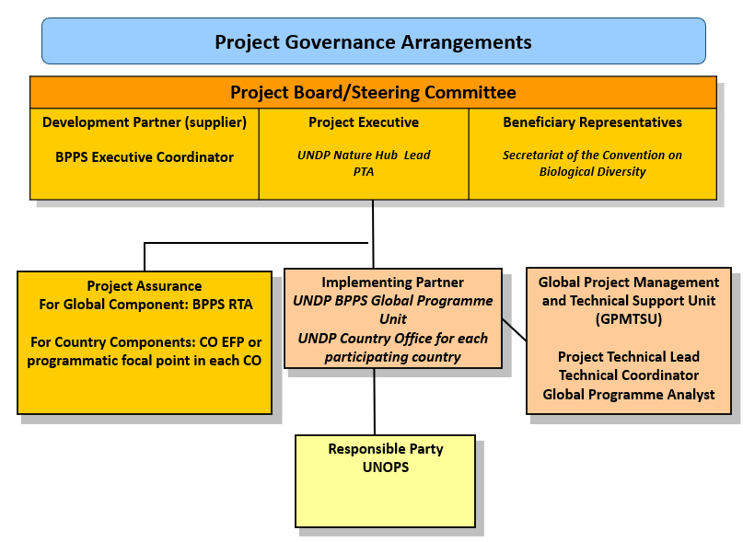

UNDP BPPS Nature Hub assumes full responsibility and accountability for oversight and quality assurance of this Project and ensures its timely implementation in compliance with the GEF-specific requirements and UNDP’s Programme and Operations Policies and Procedures (POPP), its Financial Regulations and Rules and Internal Control Framework. A UNDP BPPS Nature Hub representative will assume the assurance role and will present assurance findings to the Project Board, and therefore attends Project Board meetings as a non-voting member.

Section 3: Segregation of duties and firewalls vis-à-vis UNDP representation on the project board:

As noted in the Minimum Fiduciary Standards for GEF Partner Agencies, in cases where a GEF Partner Agency (i.e., UNDP) carries out both implementation oversight and execution of a project, the GEF Partner Agency (i.e., UNDP) must separate its project implementation oversight and execution duties, and describe in the relevant project document a: 1) Satisfactory institutional arrangement for the separation of implementation oversight and executing functions in different departments of the GEF Partner Agency; and 2) Clear lines of responsibility, reporting and accountability within the GEF Partner Agency between the project implementation oversight and execution functions.
In this case UNDP’s implementation oversight role in the project – as represented in the project board and via the project assurance function – is performed by Nature Hub lead, Principal technical advisor and Nature Hub, Regional Technical Advisor. UNDP’s execution role in the project is performed by the Global Programme Management Unit under BPPS Nature Hub, with the support of a Global Project Management and Technical Support Unit (GPMTSU).
Annex 19 must be duly completed by the Country Office and signed by the Resident Representative before DOA issuance.
UNOPS will be a Responsible Party through the Nature for Development Programme to deliver Components 3 of the programme.

Section 4: Roles and Responsibilities of the Project Organization Structure:
a) Project Board: All UNDP projects must be governed by a multi-stakeholder board or committee established to review performance based on monitoring and evaluation, and implementation issues to ensure quality delivery of results. The Project Board (also called the Project Steering Committee) is the most senior, dedicated oversight body for a project.
The two main (mandatory) roles of the project board are as follows:
- High-level oversight of the execution of the project by the Implementing Partner (as explained in the “Provide Oversight” section of the POPP). This is the primary function of the project board and includes annual (and as-needed) assessments of any major risks to the project, and decisions/agreements on any management actions or remedial measures to address them effectively. The Project Board reviews evidence of project performance based on monitoring, evaluation, and reporting, including progress reports, evaluations, risk logs and the combined delivery report. The Project Board is responsible for taking corrective action as needed to ensure the project achieves the desired results.

- Approval of strategic project execution decisions of the Implementing Partner with a view to assess and manage risks, monitor and ensure the overall achievement of projected results and impacts and ensure long term sustainability of project execution decisions of the Implementing Partner (as explained in the “Manage Change” section of the POPP).

Requirements to serve on the Project Board:
- Agree to the Terms of Reference of the Board and the rules on protocols, quorum, and minuting.
- Meet annually; at least once.
- Disclose any conflict of interest in performing the functions of a Project Board member and take all measures to avoid any real or perceived conflicts of interest. This disclosure must be documented and kept on record by UNDP.
- Discharge the functions of the Project Board in accordance with UNDP policies and procedures.
- Ensure the highest levels of transparency and ensure Project Board meeting minutes are recorded and shared with project stakeholders.

Responsibilities of the Project Board:
- Consensus decision making:
  - The project board provides overall guidance and direction to the project, ensuring it remains within any specified constraints, and providing overall oversight of the project implementation.
  - Review project performance based on monitoring, evaluation and reporting, including progress reports, risk logs and the combined delivery report.
  - The project board is responsible for making management decisions by consensus.
  - In order to ensure UNDP’s ultimate accountability, Project Board decisions should be made in accordance with standards that shall ensure management for development results, best value money, fairness, integrity, transparency and effective international competition.
  - In case consensus cannot be reached within the Board, the UNDP representative on the board will mediate to find consensus and, if this cannot be found, will take the final decision to ensure project implementation is not unduly delayed.
- Oversee project execution:
  - Agree on project technical lead’s tolerances as required, within the parameters outlined in the project document, and provide direction and advice for exceptional situations when the project technical lead’s tolerances are exceeded.
- Appraise annual work plans prepared by the Implementing Partner for the Project; review combined delivery reports prior to certification by the implementing partner.
- Address any high-level project issues as raised by the project technical lead and project assurance.
- Advise on major and minor amendments to the project within the parameters set by UNDP and the donor and refer such proposed major and minor amendments to the UNDP BPPS Executive Coordinator and Director – Environmental Finance (and the GEF, as required by GEF policies).
- Provide high-level direction and recommendations to the project management unit to ensure that the agreed deliverables are produced satisfactorily and according to plans.
- Track and monitor co-financed activities and realization of co-financing amounts of this project.
- Approve the Inception Report, GEF annual project implementation reports, mid-term review and terminal evaluation reports.
- Ensure commitment of human resources to support project implementation, arbitrating any issues within the project.
- Risk Management:
  - Provide guidance on evolving or materialized project risks and agree on possible mitigation and management actions to address specific risks.
  - Review and update the project risk register and associated management plans based on the information prepared by the Implementing Partner. This includes risks related that can be directly managed by this project, as well as contextual risks that may affect project delivery or continued UNDP compliance and reputation but are outside of the control of the project. For example, social and environmental risks associated with co-financed activities or activities taking place in the project’s area of influence that have implications for the project.
  - Address project-level grievances.
- Coordination:
  - Ensure coordination between various donor and government-funded projects and programmes.
  - Ensure coordination with various government agencies and their participation in project activities.

Composition of the Project Board: The composition of the Project Board must include individuals assigned to the following three roles:
- Project Executive: This is an individual who represents ownership of the project and chairs (or co-chairs) the Project Board. The Executive usually is the senior national counterpart for nationally implemented projects (typically from the same entity as the Implementing Partner), and it must be UNDP for projects that are direct implementation (DIM). In exceptional cases, two individuals from different entities can co-share this role and/or co-chair the Project Board. If the project executive co-chairs the project board with representatives of another category, it typically does so with a development partner representative. The Project Executive is: UNDP Nature Hub Lead, Principal Technical Advisor (PTA) or designated representative.
- Beneficiary Representative(s): Individuals or groups representing the interests of those groups of stakeholders who will ultimately benefit from the project. Their primary function within the board is to ensure the realization of project results from the perspective of project beneficiaries. Often representatives from civil society, industry associations, or other government entities benefiting from the project can fulfil this role. There can be multiple beneficiary representatives in a Project Board. The Beneficiary representative (s) is/are: country representatives will be invited to participate on the Project Board and this will most likely be modeled on the approach taken in the last enabling activity project executed by UNDP namely the 6NR project.
- Development Partner(s): Individuals or groups representing the interests of the parties concerned that provide funding, strategic guidance and/or technical expertise to the project. The Development Partner is the BPPS Executive Coordinator.

b) Project Assurance: Project assurance is the responsibility of each project board member; however, UNDP has a distinct assurance role for all UNDP projects in carrying out objective and independent project oversight and monitoring functions. UNDP performs quality assurance and supports the Project Board (and Project Management Unit) by carrying out objective and independent project oversight and monitoring functions, including compliance with the risk management and social and environmental standards of UNDP. The Project Board cannot delegate any of its quality assurance responsibilities to the Project technical lead. Project assurance is totally independent of project execution.
A designated representative of UNDP playing the project assurance role is expected to attend all board meetings and support board processes as a non-voting representative. It should be noted that while in certain cases UNDP’s project assurance role across the project may encompass activities happening at several levels (e.g., global, regional), at least one UNDP representative playing that function must, as part of their duties, specifically attend board meeting and provide board members with the required documentation required to perform their duties. The UNDP representative playing the main project assurance function is: a Regional Technical Specialist under the Nature Hub.
c) Project Management – Execution of the Project: The Project Technical Lead is the senior most representative of the global project management and technical support unit (GPMTSU) and is responsible for the overall day-to-day management of the project on behalf of the Implementing Partner, including the mobilization of all project inputs, supervision over project staff, responsible parties, consultants and sub-contractors. The project technical lead typically presents key deliverables and documents to the board for their review and approval, including progress reports, annual work plans, adjustments to tolerance levels and risk registers.
The GPMTSU will consist of a Project Technical lead (assigned by UNDP and based as a UNDP FTA), a Technical Coordinator (IPSA-11), Global Programme Analyst (IPSA 9), and other short term technical advisors and experts. The GPMTSU will report to the Operations team under the Nature Hub. Roles and responsibilities of GPMTSU members are detailed in Annex 7. A designated representative of the GPMTSU is expected to attend all board meetings and support board processes as a non-voting representative. UNOPS acting as Responsible Party will provide a team of consultants, under the guidance of the Global Project on Nature for Development and in full coordination with the Project technical lead, to deliver on the technical aspects of the grant, in full collaboration with the Project technical lead.
The primary GPMTSU representative attending board meetings is: the Project technical lead who will be assigned by UNDP.

IX Financial Planning and Management

The total cost of the project is USD 35,600,000. This is financed through a GEF grant of USD 35,600,000 administered by UNDP. UNDP, as the GEF Implementing Agency, is responsible for the oversight of the GEF resources transferred to UNDP bank account only.
Co-financing: There is no co-financing.
Budget Revision and Tolerance: As per UNDP POPP, the project board may agree with the project manager on a tolerance level for each detailed plan under the overall multi-year workplan. The agreed tolerance should be written in the project document or approved project board meeting minutes. It should normally not exceed 10 percent of the agreed annual budget at the activity level, but within the overall approved multi-year workplan at the activity level. Within the agreed tolerances, the project manager can operate without intervention from the project board. Restrictions apply as follows:
Should the following deviations occur, the Project Manager/IP through UNDP Country Office will seek the approval of the BPPS/VF-Hub team to ensure accurate reporting to the GEF. It is strongly encouraged to maintain the expenditures within the approved budget at the budgetary account and at the component level:

- Budget reallocations must prove that the suggested changes in the budget will not lead to material changes in the results to be achieved by the project. A strong justification is required and will be approved on an exceptional basis. Budget re-allocations among the components (including PMC) of the approved Total Budget and Work Plans (TBWP) that represent a value greater than 10% of the total GEF grant.
- Introduction of new outputs/activities (i.e., budget items) that were not part of the agreed project document and TBWP that represent a value greater than 5% of the total GEF grant. The new budget items must be eligible as per the GEF and UNDP policies.
- Project management cost (PMC): budget under PMC component is capped and cannot be increased.

UNDP is not in a position to increase the total budget above the amount approved by the donor, therefore any over-expenditure would have to be absorbed from non-GEF resources by the Implementing Partner (GEF Executing Entity)
Project extensions: No project extensions are allowed, and remaining funds will be returned to the GEF.
Audit: The project will be audited as per UNDP Financial Regulations and Rules and applicable audit policies. Audit cycle and process must be discussed during the Inception workshop. If the Implementing Partner is an UN Agency, the project will be audited according to that Agencies applicable audit policies
Transfer or disposal of assets: In consultation with the Implementing Partner and other parties of the project, UNDP is responsible for deciding on the transfer or other disposal of assets. Transfer or disposal of assets is recommended to be reviewed and endorsed by the project board following UNDP rules and regulations. Assets may be transferred to the government for project activities managed by a national institution at any time during the life of a project however must be done before the operational closure date. In all cases of transfer, a transfer document must be prepared and kept on file. The transfer should be done before Project Management Unit complete their assignments.
Completion Date: The project completion date is the date of Project Document Signature plus project duration. This date can only be extended through a formal extension request. Prior to completion date, all UNDP-financed inputs must be provided and related activities for the Project completed. No activities, except for the final clearance of the Terminal Evaluation Report and the corresponding management response and the end-of-project review Project Board Meeting should take place after the Completion Date.
Project Closure: Project closure will be conducted as per UNDP requirements outlined in the UNDP POPP. All costs incurred to close the project must be included in the project closure budget and reported as final project commitments presented to the Project Board during the final project review. The only costs a project may incur following the final project review are those included in the project closure budget.
- Operational closure: Operational closure must happen within 9 months from project completion date. Prior to operational closure, the Terminal Evaluation must have been submitted and the corresponding TE management response and the end-of-project review Project Board meeting must have been completed. The Implementing Partner through a Project Board decision will notify the UNDP Country Office when operational closure has been completed. Before Operational Closure, the project must have completed the transfer or disposal of any equipment that is still the property of UNDP.
- Financial Closure: Financial closure must happen within 6 months of operational closure or after the date of cancellation. The project will be financially closed when the following conditions have been met: a) the project is operationally completed or has been cancelled; b) the Implementing Partner has reported all financial transactions to UNDP; c) UNDP has closed the accounts for the project; d) UNDP and the Implementing Partner have certified a final Combined Delivery Report (which serves as final budget revision).
Between operational and financial closure, the implementing partner will identify and settle all financial obligations and prepare a final expenditure report. The UNDP Country Office will send the final signed closure documents including confirmation of final cumulative expenditure and unspent balance to BPPS/VF-Hub for confirmation before the project will be financially closed in Quantum by the UNDP Country Office.
Cancellation and Suspension: All projects considering going through cancellation or suspension must follow UNDP and GEF requirements. Guidance can be found in the UNDP POPP (SOPs for management actions of Vertical Fund projects escalated to the Executive Coordinator and Guidance for GEF project revisions).

Refund to GEF: Should a refund of unspent funds to the GEF be necessary, this will be managed directly by the BPPS/VF-Hub Directorate in New York. No action is required by the UNDP Country Office on the actual refund from UNDP project to the GEF Trustee. Unspent project balance is not permited to be transferred to any other projects.

X Total Budget and Work Plan

Total Budget and Work Plan
Quantum Business Unit | UNDP-XXX
Quantum Project ID: | 00XXXXXX | Quantum Project Title: | Umbrella Programme to Support NBSAP Update and the 7th National Reports
Quantum Award ID: | XXXXXXX | Quantum Award Title: | Umbrella Programme to Support NBSAP Update and the 7th National Reports
UNDP-GEF PIMS No. | 9678
Implementing Partner | UNDP

Quantum Outcome (GEF Component) | Quantum Output (GEF Outcome) | Quantum Activity(GEF Output) | Quantum Responsible Party (UNDP, IP, or Responsible Party ) | Quantum Fund ID | Quantum Donor ID | Quantum Budgetary Account Code | Quantum Budget Account Description | Amount Year 2024 (USD) – 10 months | Amount Year 2025 (USD) | Amount Year 2026 (USD) | Amount Year 2027 (USD) - 8 months | Total (USD) | See Budget Note:
1. Revision and updating of National Biodiversity Strategies and Action Plans | 1.1 GBF-aligned NBSAP is developed | 1.1.1 Development and implementation of a comprehensive stakeholder engagement plan, to promote an all-of-society approach to the NBSAP. | UNDP (insert country name CO) | 62000 | 10003 | 71300 | Local Consultants | 862,500 | 431,250 | 215,625 | 159,942 | 1,669,317 | 1
 |  |  |  |  |  | 71400 | Contractual services - Individuals | 345,000 | 129,375 | 86,250 | 86,250 | 646,875 | 2
 |  |  |  |  |  | 71600 | Travel | 172,500 | 172,500 | - | - | 345,000 | 3
 |  |  |  |  |  | 75700 | Training, workshop and conference | 172,500 | 129,375 | - | - | 301,875 | 4
 | 1.1 GBF-aligned NBSAP is developed | Total Output 1.1.1 |  |  |  |  |  | 1,552,500 | 862,500 | 301,875 | 246,192 | 2,963,067
 | 1.1 GBF-aligned NBSAP is developed | 1.1.2 A national gender analysis and action plan developed to ensure gender mainstreaming within consultation processes and within actions to advise the NBSAP updating and revision process. | UNDP (insert country name CO) | 62000 | 10003 | 71300 | Local Consultants | 862,500 | 431,250 | 215,625 | 159,942 | 1,669,317 | 5
 |  |  |  |  |  | 71400 | Contractual services - Individuals | 345,000 | 129,375 | 86,250 | 86,250 | 646,875 | 6
 |  |  |  |  |  | 71600 | Travel | 172,500 | 172,500 | - | - | 345,000 | 7
 |  |  |  |  |  | 75700 | Training, workshop and conference | 172,500 | 129,375 | - | - | 301,875 | 8
 | 1.1 GBF-aligned NBSAP is developed | Total Output 1.1.2 |  |  |  |  |  | 1,552,500 | 862,500 | 301,875 | 246,192 | 2,963,067
 | 1.1 GBF-aligned NBSAP is developed | 1.1.3 Building on the results of the EAS to accelerate early action on NBSAPs, identify and prioritize essential gaps and inconsistencies between the existing NBSAP and changes needed to achieve the Global Biodiversity Framework. | UNDP (insert country name CO) | 62000 | 10003 | 71300 | Local Consultants | 862,500 | 431,250 | 215,625 | 159,942 | 1,669,317 | 9
 |  |  |  |  |  | 71400 | Contractual services - Individuals | 345,000 | 129,375 | 86,250 | 86,250 | 646,875 | 10
 |  |  |  |  |  | 71600 | Travel | 172,500 | 172,500 | - | - | 345,000 | 11
 |  |  |  |  |  | 75700 | Training, workshop and conference | 172,500 | 129,375 | - | - | 301,875 | 12
 | 1.1 GBF-aligned NBSAP is developed | Total Output 1.1.3 |  |  |  |  |  | 1,552,500 | 862,500 | 301,875 | 246,192 | 2,963,067
 | 1.1 GBF-aligned NBSAP is developed | 1.1.4 Building on the results from policy alignment reviews included in the EAS, develop an NBSAP section that addresses policy alignment and coherence, and biodiversity mainstreaming into key sectors within the NBSAP. | UNDP (insert country name CO) | 62000 | 10003 | 71300 | Local Consultants | 862,500 | 431,250 | 215,625 | 159,942 | 1,669,317 | 13
 |  |  |  |  |  | 71400 | Contractual services - Individuals | 345,000 | 129,375 | 86,250 | 86,250 | 646,875 | 14
 |  |  |  |  |  | 71600 | Travel | 172,500 | 172,500 | - | - | 345,000 | 15
 |  |  |  |  |  | 75700 | Training, workshop and conference | 172,500 | 129,375 | - | - | 301,875 | 16
 | 1.1 GBF-aligned NBSAP is developed | Total Output 1.1.4 |  |  |  |  |  | 1,552,500 | 862,500 | 301,875 | 246,192 | 2,963,067
 | 1.1 GBF-aligned NBSAP is developed | 1.1.5 An assessment of the potential environmental and social impacts and potential risks of the implementation of the updated NBSAP. | UNDP (insert country name CO) | 62000 | 10003 | 71300 | Local Consultants | 862,500 | 431,250 | 215,625 | 159,942 | 1,669,317 | 17
 |  |  |  |  |  | 71400 | Contractual services - Individuals | 345,000 | 129,375 | 86,250 | 86,250 | 646,875 | 18
 |  |  |  |  |  | 71600 | Travel | 172,500 | 172,500 | - | - | 345,000 | 19
 |  |  |  |  |  | 75700 | Training, workshop and conference | 172,500 | 129,375 | - | - | 301,875 | 20
 | 1.1 GBF-aligned NBSAP is developed | Total Output 1.1.5 |  |  |  |  |  | 1,552,500 | 862,500 | 301,875 | 246,192 | 2,963,067
 | 1.1 GBF-aligned NBSAP is developed | 1.1.6 Building on nationally and globally available data, develop a first approximation of spatial priorities for Target 1, and develop a spatialized action plan for other area-based targets, including Targets 2, 3, 8, 9, 11 and 12, within the NBSAP. | UNDP (insert country name CO) | 62000 | 10003 | 71300 | Local Consultants | 862,500 | 431,250 | 215,625 | 159,942 | 1,669,317 | 21
 |  |  |  |  |  | 71400 | Contractual services - Individuals | 345,000 | 129,375 | 86,250 | 86,250 | 646,875 | 22
 |  |  |  |  |  | 71600 | Travel | 172,500 | 172,500 | - | - | 345,000 | 23
 |  |  |  |  |  | 75700 | Training, workshop and conference | 172,500 | 129,375 | - | - | 301,875 | 24
 | 1.1 GBF-aligned NBSAP is developed | Total Output 1.1.6 |  |  |  |  |  | 1,552,500 | 862,500 | 301,875 | 246,192 | 2,963,067
 | 1.1 GBF-aligned NBSAP is developed | 1.1.7 Building on the results of the EAS, identify an action plan for eliminating or phasing out harmful subsidies and incentives within the NBSAP | UNDP (insert country name CO) | 62000 | 10003 | 71300 | Local Consultants | 862,500 | 431,250 | 215,625 | 159,942 | 1,669,317 | 25
 |  |  |  |  |  | 71400 | Contractual services - Individuals | 345,000 | 129,375 | 86,250 | 86,250 | 646,875 | 26
 |  |  |  |  |  | 71600 | Travel | 172,500 | 172,500 | - | - | 345,000 | 27
 |  |  |  |  |  | 75700 | Training, workshop and conference | 172,500 | 129,375 | - | - | 301,875 | 28
 | 1.1 GBF-aligned NBSAP is developed | Total Output 1.1.7 |  |  |  |  |  | 1,552,500 | 862,500 | 301,875 | 246,192 | 2,963,067
 | 1.1 GBF-aligned NBSAP is developed | 1.1.8 An assessment of gaps in capacities and resources available undertaken and on that basis, develop plans or strategies for capacity development and resource mobilization, building on the work undertaken under the early support action project, the umbrella program to support development of biodiversity finance plans, and other initiatives such as BIOFIN. | UNDP (insert country name CO) | 62000 | 10003 | 71300 | Local Consultants | 862,500 | 431,250 | 215,625 | 160,149 | 1,669,524 | 29
 |  |  |  |  |  | 71400 | Contractual services - Individuals | 345,000 | 129,375 | 86,250 | 86,250 | 646,875 | 30
 |  |  |  |  |  | 71600 | Travel | 172,500 | 172,500 | - | - | 345,000 | 31
 |  |  |  |  |  | 75700 | Training, workshop and conference | 172,500 | 129,375 | - | - | 301,875 | 32
 | 1.1 GBF-aligned NBSAP is developed | Total Output 1.1.8 |  |  |  |  |  | 1,552,500 | 862,500 | 301,875 | 246,399 | 2,963,274
 | Total Outcome 1.1 |  |  |  |  |  |  | 12,420,000 | 6,900,000 | 2,415,000 | 1,969,743 | 23,704,743
Total Component 1 |  |  |  |  |  |  |  | 12,420,000 | 6,900,000 | 2,415,000 | 1,969,743 | 23,704,743
2. Complete 7th National Reports on Biodiversity | 2.1 National Reports on Biodiversity are completed for each country | 2.1.1 Brief overview of the process of preparation of the report is completed. | UNDP (insert country name CO) | 62000 | 10003 | 71300 | Local Consultants | 207,000 | 207,000 | 690,000 | 69,000 | 1,173,000 | 33
 |  |  |  |  |  | 71400 | Contractual services - Individuals | - | 69,000 | 69,000 | - | 138,000 | 34
 |  |  |  |  |  | 71600 | Travel | 69,000 | - | - | - | 69,000 | 35
2. Complete 7th National Reports on Biodiversity |  | Total Output 2.1.1 |  |  |  |  |  | 276,000 | 276,000 | 759,000 | 69,000 | 1,380,000
2. Complete 7th National Reports on Biodiversity |  | 2.1.2 Status of the revised or updated national biodiversity strategy and action plan (NBSAP) in the light of the Kunming-Montreal Global Biodiversity Framework. | UNDP (insert country name CO) | 62000 | 10003 | 71300 | Local Consultants | 207,000 | 207,000 | 690,000 | 69,000 | 1,173,000 | 36
 |  |  |  |  |  | 71400 | Contractual services - Individuals | - | 69,000 | 69,000 | - | 138,000 | 37
 |  |  |  |  |  | 71600 | Travel | 69,000 | - | - | - | 69,000 | 38
2. Complete 7th National Reports on Biodiversity |  | Total Output 2.1.2 |  |  |  |  |  | 276,000 | 276,000 | 759,000 | 69,000 | 1,380,000
2. Complete 7th National Reports on Biodiversity |  | 2.1.3 Assessment of progress towards national targets are completed; | UNDP (insert country name CO) | 62000 | 10003 | 71300 | Local Consultants | 207,000 | 207,000 | 690,000 | 69,000 | 1,173,000 | 39
 |  |  |  |  |  | 71400 | Contractual services - Individuals | - | 69,000 | 69,000 | - | 138,000 | 40
 |  |  |  |  |  | 71600 | Travel | 69,000 | - | - | - | 69,000 | 41
2. Complete 7th National Reports on Biodiversity |  | Total Output 2.1.3 |  |  |  |  |  | 276,000 | 276,000 | 759,000 | 69,000 | 1,380,000
2. Complete 7th National Reports on Biodiversity |  | 2.1.4. Assessment of progress related to the goals and targets of the Kunming-Montreal Global Biodiversity Framework is completed; | UNDP (insert country name CO) | 62000 | 10003 | 71300 | Local Consultants | 207,000 | 207,000 | 690,000 | 69,000 | 1,173,000 | 42
 |  |  |  |  |  | 71400 | Contractual services - Individuals | - | 69,000 | 69,000 | - | 138,000 | 43
 |  |  |  |  |  | 71600 | Travel | 69,000 | - | - | - | 69,000 | 44
2. Complete 7th National Reports on Biodiversity |  | Total Output 2.1.4 |  |  |  |  |  | 276,000 | 276,000 | 759,000 | 69,000 | 1,380,000
2. Complete 7th National Reports on Biodiversity |  | 2.1.5 Conclusions on the implementation of the Convention and the Kunming-Montreal Global Biodiversity Framework are completed. | UNDP (insert country name CO) | 62000 | 10003 | 71300 | Local Consultants | 207,000 | 207,000 | 690,000 | 69,000 | 1,173,000 | 45
 |  |  |  |  |  | 71400 | Contractual services - Individuals | - | 69,000 | 69,000 | - | 138,000 | 46
 |  |  |  |  |  | 71600 | Travel | 69,000 | - | - | - | 69,000 | 47
2. Complete 7th National Reports on Biodiversity |  | Total Output 2.1.5 |  |  |  |  |  | 276,000 | 276,000 | 759,000 | 69,000 | 1,380,000
2. Complete 7th National Reports on Biodiversity | Total Outcome 2.1 |  |  |  |  |  |  | 1,380,000 | 1,380,000 | 3,795,000 | 345,000 | 6,900,000
Total Component 2 |  |  |  |  |  |  |  | 1,380,000 | 1,380,000 | 3,795,000 | 345,000 | 6,900,000
Global Knowledge and Technical Assistance Platform | 3.1 A global knowledge and technical assistance platform is established to share knowledge and experiences across participating countries and partner organizations. | 3.1.1. A suite of e-learning offerings on a range of GBF-related topics on a demand-driven basis | UNOPS | 62000 | 10003 | 71200 | International Consultants | 83,992 | 104,990 | 32,997 | 29,997 | 251,976 | 48
 |  |  |  |  |  | 71600 | Travel | 2,306 | 2,882 | 906 | 823 | 6,917 | 49
 |  |  |  |  |  | 72100 | Contractual services - Companies | 5,357 | 6,428 | 4,286 | 1,929 | 18,000 | 50
Global Knowledge and Technical Assistance Platform |  |  | Total UNOPS |  |  |  |  | 91,655 | 114,300 | 38,189 | 32,749 | 276,893
Global Knowledge and Technical Assistance Platform |  |  | UNDP | 62000 | 10003 | 61300 | Salary & Post Adj Cst-IP Staff | 26,667 | 32,000 | 32,000 | 21,335 | 112,002 | 51
 |  |  |  |  |  | 71400 | Contractual services - Individual | 11,598 | 13,917 | 13,917 | 9,279 | 48,711 | 52
Global Knowledge and Technical Assistance Platform |  |  | Total UNDP |  |  |  |  | 38,265 | 45,917 | 45,917 | 30,614 | 160,713
Global Knowledge and Technical Assistance Platform |  | Total Output 3.1.1 |  |  |  |  |  | 129,920 | 160,217 | 84,106 | 63,363 | 437,606
Global Knowledge and Technical Assistance Platform |  | 3.1.2. Interactive webinars to highlight best practices. | UNOPS | 62000 | 10003 | 71200 | International Consultants | 83,992 | 104,990 | 32,997 | 29,997 | 251,976 | 53
 |  |  |  |  |  | 71600 | Travel | 2,306 | 2,882 | 906 | 823 | 6,917 | 54
 |  |  |  |  |  | 72100 | Contractual services - Companies | 10,267 | 12,322 | 8,215 | 3,696 | 34,500 | 55
Global Knowledge and Technical Assistance Platform |  | 3.1.2. Interactive webinars to highlight best practices. | Total UNOPS |  |  |  |  | 96,565 | 120,194 | 42,118 | 34,516 | 293,393
Global Knowledge and Technical Assistance Platform |  | 3.1.2. Interactive webinars to highlight best practices. | UNDP | 62000 | 10003 | 61300 | Salary & Post Adj Cst-IP Staff | 26,667 | 32,000 | 32,000 | 21,335 | 112,002 | 56
 |  |  |  |  |  | 71400 | Contractual services - Individual | 11,598 | 13,917 | 13,917 | 9,279 | 48,711 | 57
Global Knowledge and Technical Assistance Platform |  | 3.1.2. Interactive webinars to highlight best practices. | Total UNDP |  |  |  |  | 38,265 | 45,917 | 45,917 | 30,614 | 160,713
Global Knowledge and Technical Assistance Platform |  | Total Output 3.1.2 |  |  |  |  |  | 134,830 | 166,111 | 88,035 | 65,130 | 454,106
Global Knowledge and Technical Assistance Platform |  | 3.1.3 Global catalogue of best practices related to NBSAPs across the 23 GBF targets, including documentation of emerging lessons and best practices captured by dedicated knowledge products, technical publications, videos, websites, articles, and podcast episodes. | UNOPS | 62000 | 10003 | 71200 | International Consultants | 83,992 | 104,990 | 32,997 | 29,997 | 251,976 | 58
 |  |  |  |  |  | 71600 | Travel | 2,306 | 2,882 | 907 | 823 | 6,918 | 59
 |  |  |  |  |  | 72100 | Contractual services - Companies | 5,357 | 6,428 | 4,286 | 1,929 | 18,000 | 60
Global Knowledge and Technical Assistance Platform |  |  | Total UNOPS |  |  |  |  | 91,655 | 114,300 | 38,190 | 32,749 | 276,894
Global Knowledge and Technical Assistance Platform |  |  | UNDP | 62000 | 10003 | 61300 | Salary & Post Adj Cst-IP Staff | 26,667 | 32,000 | 32,000 | 21,335 | 112,002 | 61
 |  |  |  |  |  | 71400 | Contractual services - Individual | 11,598 | 13,917 | 13,917 | 9,279 | 48,711 | 62
Global Knowledge and Technical Assistance Platform |  |  | Total UNDP |  |  |  |  | 38,265 | 45,917 | 45,917 | 30,614 | 160,713
Global Knowledge and Technical Assistance Platform |  | Total Output 3.1.3 |  |  |  |  |  | 129,920 | 160,217 | 84,107 | 63,363 | 437,607
Global Knowledge and Technical Assistance Platform |  | 3.1.4. In-country implementation processes supported by dedicated technical advice from global experts including technical review of NBSAPs on a demand-driven basis, and peer to peer exchanges. | UNOPS | 62000 | 10003 | 71200 | International Consultants | 83,992 | 104,990 | 32,997 | 29,997 | 251,976 | 63
 |  |  |  |  |  | 71600 | Travel | 2,306 | 2,882 | 906 | 823 | 6,917 | 64
 |  |  |  |  |  | 72100 | Contractual services - Companies | 5,357 | 6,428 | 4,286 | 1,929 | 18,000 | 65
Global Knowledge and Technical Assistance Platform |  |  | Total UNOPS |  |  |  |  | 91,655 | 114,300 | 38,189 | 32,749 | 276,893
Global Knowledge and Technical Assistance Platform |  |  | UNDP | 62000 | 10003 | 61300 | Salary & Post Adj Cst-IP Staff | 26,667 | 32,000 | 32,000 | 21,335 | 112,002 | 66
 |  |  |  |  |  | 71400 | Contractual services - Individual | 11,598 | 13,917 | 13,917 | 9,279 | 48,711 | 67
Global Knowledge and Technical Assistance Platform |  |  | Total UNDP |  |  |  |  | 38,265 | 45,917 | 45,917 | 30,614 | 160,713
Global Knowledge and Technical Assistance Platform |  | Total Output 3.1.4 |  |  |  |  |  | 129,920 | 160,217 | 84,106 | 63,363 | 437,606
Global Knowledge and Technical Assistance Platform |  | 3.1.5. Dedicated support to global efforts to raise awareness of the value of biodiversity, and the importance of NBSAPs, at global levels, including through online events that help to mobilize political will and ambition. | UNOPS | 62000 | 10003 | 71200 | International Consultants | 83,992 | 104,990 | 32,997 | 29,997 | 251,976 | 68
 |  |  |  |  |  | 71600 | Travel | 2,306 | 2,882 | 906 | 823 | 6,917 | 69
 |  |  |  |  |  | 72100 | Contractual services - Companies | 5,357 | 6,428 | 4,286 | 1,929 | 18,000 | 70
Global Knowledge and Technical Assistance Platform |  |  | Total UNOPS |  |  |  |  | 91,655 | 114,300 | 38,189 | 32,749 | 276,893
Global Knowledge and Technical Assistance Platform |  |  | UNDP | 62000 | 10003 | 61300 | Salary & Post Adj Cst-IP Staff | 26,667 | 32,000 | 32,000 | 21,335 | 112,002 | 71
 |  |  |  |  |  | 71400 | Contractual services - Individual | 11,598 | 13,917 | 13,917 | 9,279 | 48,711 | 72
Global Knowledge and Technical Assistance Platform |  |  | Total UNDP |  |  |  |  | 38,265 | 45,917 | 45,917 | 30,614 | 160,713
Global Knowledge and Technical Assistance Platform |  | Total Output 3.1.5 |  |  |  |  |  | 129,920 | 160,217 | 84,106 | 63,363 | 437,606
Global Knowledge and Technical Assistance Platform |  | 3.1.6 Communication and outreach activities to facilitate exchange of experiences and best practices amongst countries and promote international cooperation, including regional and global in-person annual meetings, best practice workshops and CBD side events. | UNOPS | 62000 | 10003 | 71200 | International Consultants | 83,992 | 104,990 | 32,997 | 29,997 | 251,976 | 73
 |  |  |  |  |  | 71600 | Travel | 2,306 | 2,882 | 906 | 823 | 6,917 | 74
 |  |  |  |  |  | 72100 | Contractual services - Companies | 5,357 | 6,428 | 4,286 | 1,929 | 18,000 | 75
Global Knowledge and Technical Assistance Platform |  |  | Total UNOPS |  |  |  |  | 91,655 | 114,300 | 38,189 | 32,749 | 276,893
Global Knowledge and Technical Assistance Platform |  |  | UNDP | 62000 | 10003 | 61300 | Salary & Post Adj Cst-IP Staff | 26,667 | 32,000 | 32,000 | 21,335 | 112,002 | 76
 |  |  |  |  |  | 71400 | Contractual services - Individual | 11,598 | 13,917 | 13,917 | 9,279 | 48,711 | 77
Global Knowledge and Technical Assistance Platform |  |  | Total UNDP |  |  |  |  | 38,265 | 45,917 | 45,917 | 30,614 | 160,713
Global Knowledge and Technical Assistance Platform |  | Total Output 3.1.6 |  |  |  |  |  | 129,920 | 160,217 | 84,106 | 63,363 | 437,606
Global Knowledge and Technical Assistance Platform |  | 3.1.7 Flagship summary reports highlighting key issues, including a Global NBSAP Gender Report, a Global NBSAP Ambition Report, and a Global Spatial Report | UNOPS | 62000 | 10003 | 71200 | International Consultants | 57,409 | 71,762 | 22,554 | 20,503 | 172,228 | 78
 |  |  |  |  |  | 71600 | Travel | 2,306 | 2,882 | 906 | 828 | 6,922 | 79
 |  |  |  |  |  | 72100 | Contractual services - Companies | 5,357 | 6,428 | 4,286 | 1,929 | 18,000 | 80
Global Knowledge and Technical Assistance Platform |  |  | Total UNOPS |  |  |  |  | 65,072 | 81,072 | 27,746 | 23,260 | 197,150
Global Knowledge and Technical Assistance Platform |  |  | UNDP | 62000 | 10003 | 61300 | Salary & Post Adj Cst-IP Staff | 26,667 | 32,000 | 32,000 | 21,335 | 112,002 | 81
 |  |  |  |  |  | 71400 | Contractual services - Individual | 11,598 | 13,917 | 13,917 | 9,279 | 48,711 | 82
Global Knowledge and Technical Assistance Platform |  |  | Total UNDP |  |  |  |  | 38,265 | 45,917 | 45,917 | 30,614 | 160,713
Global Knowledge and Technical Assistance Platform |  | Total Output 3.1.7 |  |  |  |  |  | 103,337 | 126,989 | 73,663 | 53,874 | 357,863
Global Knowledge and Technical Assistance Platform | Total Outcome 3.1 |  |  |  |  |  |  | 887,767 | 1,094,185 | 582,229 | 435,819 | 3,000,000
Total Component 3 |  |  |  |  |  |  |  | 887,767 | 1,094,185 | 582,229 | 435,819 | 3,000,000
Monitoring and Evaluation (M&E) | 4.1 Programme M&E meets UNDP and GEF standards. | 4.1 Programme M&E meets UNDP and GEF standards. | UNDP | 62000 | 10003 | 71200 | International Consultants | 9,857 | 11,829 | 7,886 | 34,348 | 63,920 | 83
 |  |  |  |  |  | 71400 | Contractual services - Individual | 53,442 | 64,131 | 64,131 | 42,754 | 224,458 | 84
 |  |  |  |  |  | 75700 | Training, workshop, conference | 11,641 | - | - | - | 11,641 | 85
Monitoring and Evaluation (M&E) | 4.1 Programme M&E meets UNDP and GEF standards. | 4.1 Programme M&E meets UNDP and GEF standards. | Total UNDP |  |  |  |  | 74,940 | 75,960 | 72,017 | 77,102 | 300,019
Monitoring and Evaluation (M&E) | Total Outcome 4.1 |  |  |  |  |  |  | 74,940 | 75,960 | 72,017 | 77,102 | 300,019
Total M&E |  |  |  |  |  |  |  | 74,940 | 75,960 | 72,017 | 77,102 | 300,019
Project Management Cost (PMC) | PMC | PMC | UNDP | 62000 | 10003 | 71400 | Contractual services - Individual | 64,523 | 77,427 | 77,427 | 51,619 | 270,996 | 86
 |  |  |  |  |  | 74100 | Professional Services | - | 3,000 | 3,000 | - | 6,000 | 87
 |  |  |  |  |  | 74596 | Services to projects - GOE for CO | 337,677 | 405,212 | 405,212 | 270,141 | 1,418,242 | 88
Total Project Management Cost |  |  |  |  |  |  |  | 402,200 | 485,639 | 485,639 | 321,760 | 1,695,238
Total Project Grant |  |  |  |  |  |  |  | 15,164,907 | 9,935,784 | 7,349,885 | 3,149,424 | 35,600,000

Budget notes for TBWP

# | Description
1 | Cost of Local Consultants for Development and implementation of a comprehensive stakeholder engagement plan, to promote an all-of-society approach to the NBSAP. Estimated total for 69 countries: 1,669,317 (24,193 per country)
2 | Contractor services for technical research as well as revision and editing of technical documentation. Estimated total for 69 countries: 646,875 (9,375 per country)
3 | Travel costs for national stakeholder consultation, working meetings, costs of data gathering and verification among other purposes. Estimated total for 69 countries: 345,000 (5,000 per country)
4 | Training, workshop and conference costs for GBF-aligned NBSAP development, training can include south-south training workshops, and in-country training and conference costs. Estimated total for 69 countries: 301,875 (4,375 per country)
5 | Cost of Local Consultants for Development of national gender analysis and action plan to ensure gender mainstreaming. Estimated total for 69 countries: 1,669,317 (24,193 per country)
6 | Contractor services for technical research as well as revision and editing of technical documentation. Estimated total for 69 countries: 646,875 (9,375 per country)
7 | Travel costs for national stakeholder consultation, working meetings, costs of data gathering and verification among other purposes. Estimated total for 69 countries: 345,000 (5,000 per country)
8 | Training, workshop and conference costs for GBF-aligned NBSAP development, training can include south-south training workshops, and in-country training and conference costs. Estimated total for 69 countries: 301,875 (4,375 per country)
9 | Cost of Local Consultants to identify and prioritize essential gaps and inconsistencies between the existing NBSAP and changes needed to achieve the Global Biodiversity Framework Estimated total for 69 countries: 1,669,317 (24,193 per country)
10 | Contractor services for technical research as well as revision and editing of technical documentation. Estimated total for 69 countries: 646,875 (9,375 per country)
11 | Travel costs for national stakeholder consultation, working meetings, costs of data gathering and verification among other purposes. Estimated total for 69 countries: 345,000 (5,000 per country)
12 | Training, workshop and conference costs for GBF-aligned NBSAP development, training can include south-south training workshops, and in-country training and conference costs. Estimated total for 69 countries: 301,875 (4,375 per country)
13 | Cost of Local Consultants for Development of NBSAP section that addresses policy alignment and coherence, and biodiversity mainstreaming into key sectors within the NBSAP. Estimated total for 69 countries: 1,669,317 (24,193 per country)
14 | Contractor services for technical research as well as revision and editing of technical documentation. Estimated total for 69 countries: 646,875 (9,375 per country)
15 | Travel costs for national stakeholder consultation, working meetings, costs of data gathering and verification among other purposes. Estimated total for 69 countries: 345,000 (5,000 per country)
16 | Training, workshop and conference costs for GBF-aligned NBSAP development, training can include south-south training workshops, and in-country training and conference costs. Estimated total for 69 countries: 301,875 (4,375 per country)
17 | Cost of Local Consultants for assessment of the potential environmental and social impacts and potential risks of the implementation of the updated NBSAP. Estimated total for 69 countries: 1,669,317 (24,193 per country)
18 | Contractor services for technical research as well as revision and editing of technical documentation. Estimated total for 69 countries: 646,875 (9,375 per country)
19 | Travel costs for national stakeholder consultation, working meetings, costs of data gathering and verification among other purposes. Estimated total for 69 countries: 345,000 (5,000 per country)
20 | Training, workshop and conference costs for GBF-aligned NBSAP development, training can include south-south training workshops, and in-country training and conference costs. Estimated total for 69 countries: 301,875 (4,375 per country)
21 | Cost of Local Consultants for development of a first approximation of spatial priorities for Target 1, and develop a spatialized action plan for other area-based targets. Estimated total for 69 countries: 1,669,317 (24,193 per country)
22 | Contractor services for technical research as well as revision and editing of technical documentation. Estimated total for 69 countries: 646,875 (9,375 per country)
23 | Travel costs for national stakeholder consultation, working meetings, costs of data gathering and verification among other purposes. Estimated total for 69 countries: 345,000 (5,000 per country)
24 | Training, workshop and conference costs for GBF-aligned NBSAP development, training can include south-south training workshops, and in-country training and conference costs. Estimated total for 69 countries: 301,875 (4,375 per country)
25 | Cost of Local Consultants for identification of an action plan for eliminating or phasing out harmful subsidies and incentives within the NBSAP. Estimated total for 69 countries: 1,669,317 (24,193 per country)
26 | Contractor services for technical research as well as revision and editing of technical documentation. Estimated total for 69 countries: 646,875 (9,375 per country)
27 | Travel costs for national stakeholder consultation, working meetings, costs of data gathering and verification among other purposes. Estimated total for 69 countries: 345,000 (5,000 per country)
28 | Training, workshop and conference costs for GBF-aligned NBSAP development, training can include south-south training workshops, and in-country training and conference costs. Estimated total for 69 countries: 301,875 (4,375 per country)
29 | Cost of Local Consultants for assessment of gaps in capacities and resources available undertaken and on that basis, develop plans or strategies for capacity development and resource mobilization. Estimated total for 69 countries: 1,669,524 (24,196 per country)
30 | Contractor services for technical research as well as revision and editing of technical documentation. Estimated total for 69 countries: 646,875 (9,375 per country)
31 | Travel costs for national stakeholder consultation, working meetings, costs of data gathering and verification among other purposes. Estimated total for 69 countries: 345,000 (5,000 per country)
32 | Training, workshop and conference costs for GBF-aligned NBSAP development, training can include south-south training workshops, and in-country training and conference costs. Estimated total for 69 countries: 301,875 (4,375 per country)
33 | Cost of Local Consultants for Brief overview of the process of preparation of the report. Estimated total for 69 countries: 1,173,000 (17,000 per country)
34 | Contractor services for technical research as well as revision and editing of technical documentation. Estimated total for 69 countries: 138,000 (2,000 per country)
35 | Travel costs for national stakeholder consultation, working meetings, costs of data gathering and verification among other purposes. Estimated total for 69 countries: 69,000 (1,000 per country)
36 | Cost of Local Consultants for Status of the revised or updated national biodiversity strategy and action plan (NBSAP) in the light of the Kunming-Montreal Global Biodiversity Framework. Estimated total for 69 countries: 1,173,000 (17,000 per country)
37 | Contractor services for technical research as well as revision and editing of technical documentation. Estimated total for 69 countries: 138,000 (2,000 per country)
38 | Travel costs for national stakeholder consultation, working meetings, costs of data gathering and verification among other purposes. Estimated total for 69 countries: 69,000 (1,000 per country)
39 | Cost of Local Consultants for Assessment of progress towards national targets. Estimated total for 69 countries: 1,173,000 (17,000 per country)
40 | Contractor services for technical research as well as revision and editing of technical documentation. Estimated total for 69 countries: 138,000 (2,000 per country)
41 | Travel costs for national stakeholder consultation, working meetings, costs of data gathering and verification among other purposes. Estimated total for 69 countries: 69,000 (1,000 per country)
42 | Cost of Local Consultants for Assessment of progress related to the goals and targets of the Kunming-Montreal Global Biodiversity Framework. Estimated total for 69 countries: 1,173,000 (17,000 per country)
43 | Contractor services for technical research as well as revision and editing of technical documentation. Estimated total for 69 countries: 138,000 (2,000 per country)
44 | Travel costs for national stakeholder consultation, working meetings, costs of data gathering and verification among other purposes. Estimated total for 69 countries: 69,000 (1,000 per country)
45 | Cost of Local Consultants for completion of Conclusions on the implementation of the Convention and the Kunming-Montreal Global Biodiversity Framework. Estimated total for 69 countries: 1,173,000 (17,000 per country)
46 | Contractor services for technical research as well as revision and editing of technical documentation. Estimated total for 69 countries: 138,000 (2,000 per country)
47 | Travel costs for national stakeholder consultation, working meetings, costs of data gathering and verification among other purposes. Estimated total for 69 countries: 69,000 (1,000 per country)

48 | Cost of international consultants that will need to be engaged for providing learning, knowledge, global advocacy, and specialized technical support for a suite of e-learning offerings on a range of GBF-related topics on a demand-driven basis. Total 251,976
48 |  | Cost ($) | Weeks | Total Cost
48 | 1 Senior Technical Advisor | 8,290 | 4.00 | 33,160
48 | The Senior Technical Manager will provide senior review and quality assurance for all technical guidance (except guidance related to UNDP SES, which will be the responsibility of the SES specialist) prepared under Global technical support | 8,290 | 4.00 | 33,160
48 | 1 GIS Specialist | 2,760 | 5.00 | 13,800
48 | GIS Specialist will provide customized GIS support as required by the project and will also support UN Biodiversity Lab development and maintenance | 2,760 | 5.00 | 13,800
48 | 1 Technical Specialist NBSAPs and Targets | 2,486 | 5.00 | 12,430
48 | The consultant will develop guidance on NBSAPs and National Biodiversity Targets; Provide customized support to countries on NBSAPs and NBTs as required; Develop and execute training materials, webinars and other forms of support; Provide review and quality assurance services on draft documents | 2,486 | 5.00 | 12,430
48 | 1 Technical Specialist Policy | 2,486 | 5.00 | 12,430
48 | The consultant will guidance on policy coherence and alignment; Provide customized support to countries on policy coherence and alignment as required; Develop and execute training materials, webinars and other forms of support; Provide review and quality assurance services on draft documents | 2,486 | 5.00 | 12,430
48 | 1 Knowledge Management & Communication Specialist | 2,180 | 11.00 | 23,980
48 | The consultant will manage and oversee the development of learning resources, in partnership with the Senior Technical Advisor and the technical support lead; Organize and roll out the enrolment, design, execution and delivery of all learning materials | 2,180 | 11.00 | 23,980
48 | 2 Spatial Planning Consultants | 2,486 | 8.00 | 39,776
48 | The two consultants will provide customized support for all materials related to spatial analyses; Support the development and maintenance of the UN Biodiversity Lab functions and collections to achieve elements of Component 3 | 2,486 | 8.00 | 39,776
48 | 1 Policy Coherence Specialist | 2,760 | 9.00 | 24,840
48 | The consultant will provide: customized support for all materials related to policy coherence assessments, development of framework for conducting a policy coherence assessment & provision of technical backstopping for the development policy coherence assessments | 2,760 | 9.00 | 24,840
48 | 1 Senior Web Designer | 2,180 | 8.00 | 17,440
48 | The consultant will support the development of relevant web interfaces and will support the global team in developing and executing MOOCs | 2,180 | 8.00 | 17,440
48 | 1 Senior eLearning Specialist | 2,180 | 8.00 | 17,440
48 | The consultant will: provide customized support for all materials related to elearning, support the development and maintenance of e-learning materials & develop and manage a work flow for e-learning deliverables | 2,180 | 8.00 | 17,440
48 | 2 Junior Consultants | 2,180 | 13.00 | 56,680
48 | The two consultants will maintain key data and information systems required to execute the project, organize and manage communications systems, support the Senior eLearning specialist in developing and executing MOOCs | 2,180 | 13.00 | 56,680
48 |  |  | Total | 251,976
49 | Cost of Travel for Missions to provide dedicated technical advice including support in the design of NBSAPs and engagement with relevant stakeholders Total 6,917
50 | Cost of contractual services associated with translation services and interpretation services. Total 18,000  Translation: 500/day; 10 days, 3 languages = 15,000  Interpretation: 500/day; 2 days, 3 languages= 3,000
51 | Project Technical Lead FT-P4 Total 112,002  The Project Technical Lead will lead the project at a global scale, working to maximise and showcase impacts and to strengthen relationships with stakeholders at all levels and will be responsible for the overall management of the project.
52 | Technical Coordinator – IPSA11 (11%) 48,711 Approximately  The Technical Coordinator will support the project manager to ensure smooth functioning of all elements of Component 3 & 4, ensuring adherence to workplan for delivery of technical deliverables within the allocated timelines, production of regular progress reports and facilitation of technical support as required by the participating UNDP COs.
53 | Cost of international consultants that will need to be engaged for providing learning, knowledge, global advocacy, and specialized technical support for a suite of e-learning offerings on a range of GBF-related topics on a demand-driven basis. Total 251,976
53 |  | Cost ($) | Weeks | Total Cost
53 | 1 Senior Technical Advisor | 8,290 | 4.00 | 33,160
53 | The Senior Technical Manager will provide senior review and quality assurance for all technical guidance (except guidance related to UNDP SES, which will be the responsibility of the SES specialist) prepared under Global technical support | 8,290 | 4.00 | 33,160
53 | 1 GIS Specialist | 2,760 | 5.00 | 13,800
53 | GIS Specialist will provide customized GIS support as required by the project and will also support UN Biodiversity Lab development and maintenance | 2,760 | 5.00 | 13,800
53 | 1 Technical Specialist NBSAPs and Targets | 2,486 | 5.00 | 12,430
53 | The consultant will develop guidance on NBSAPs and National Biodiversity Targets; Provide customized support to countries on NBSAPs and NBTs as required; Develop and execute training materials, webinars and other forms of support; Provide review and quality assurance services on draft documents | 2,486 | 5.00 | 12,430
53 | 1 Technical Specialist Policy | 2,486 | 5.00 | 12,430
53 | The consultant will guidance on policy coherence and alignment; Provide customized support to countries on policy coherence and alignment as required; Develop and execute training materials, webinars and other forms of support; Provide review and quality assurance services on draft documents | 2,486 | 5.00 | 12,430
53 | 1 Knowledge Management & Communication Specialist | 2,180 | 11.00 | 23,980
53 | The consultant will manage and oversee the development of learning resources, in partnership with the Senior Technical Advisor and the technical support lead; Organize and roll out the enrolment, design, execution and delivery of all learning materials | 2,180 | 11.00 | 23,980
53 | 2 Spatial Planning Consultants | 2,486 | 8.00 | 39,776
53 | The two consultants will provide customized support for all materials related to spatial analyses; Support the development and maintenance of the UN Biodiversity Lab functions and collections to achieve elements of Component 3 | 2,486 | 8.00 | 39,776
53 | 1 Policy Coherence Specialist | 2,760 | 9.00 | 24,840
53 | The consultant will provide: customized support for all materials related to policy coherence assessments, development of framework for conducting a policy coherence assessment & provision of technical backstopping for the development policy coherence assessments | 2,760 | 9.00 | 24,840
53 | 1 Senior Web Designer | 2,180 | 8.00 | 17,440
53 | The consultant will support the development of relevant web interfaces and will support the global team in developing and executing MOOCs | 2,180 | 8.00 | 17,440
53 | 1 Senior eLearning Specialist | 2,180 | 8.00 | 17,440
53 | The consultant will: provide customized support for all materials related to elearning, support the development and maintenance of e-learning materials & develop and manage a work flow for e-learning deliverables | 2,180 | 8.00 | 17,440
53 | 2 Junior Consultants | 2,180 | 13.00 | 56,680
53 | The two consultants will maintain key data and information systems required to execute the project, organize and manage communications systems, support the Senior eLearning specialist in developing and executing MOOCs | 2,180 | 13.00 | 56,680
53 |  |  | Total | 251,976
54 | Cost of Travel for Missions to provide dedicated technical advice including support in the design of NBSAPs and engagement with relevant stakeholders Total 6,917
55 | Cost of contractual services associated with translation services and interpretation services. Total 34,500  Translation: 500/day; 20 days, 3 languages = 30,000  Interpretation: 500/day; 3 days, 3 languages= 4,500
56 | Project Technical Lead FT-P4 Total 112,002  The Project Technical Lead will lead the project at a global scale, working to maximise and showcase impacts and to strengthen relationships with stakeholders at all levels and will be responsible for the overall management of the project.
57 | Technical Coordinator – IPSA11 (11%) 48,711 approximately  The Technical Coordinator will support the project manager to ensure smooth functioning of all elements of Component 3 & 4, ensuring adherence to workplan for delivery of technical deliverables within the allocated timelines, production of regular progress reports and facilitation of technical support as required by the participating UNDP COs.
58 | Cost of international consultants that will need to be engaged for providing learning, knowledge, global advocacy, and specialized technical support for a suite of e-learning offerings on a range of GBF-related topics on a demand-driven basis. Total 251,976
58 |  | Cost ($) | Weeks | Total Cost
58 | 1 Senior Technical Advisor | 8,290 | 4.00 | 33,160
58 | The Senior Technical Manager will provide senior review and quality assurance for all technical guidance (except guidance related to UNDP SES, which will be the responsibility of the SES specialist) prepared under Global technical support | 8,290 | 4.00 | 33,160
58 | 1 GIS Specialist | 2,760 | 5.00 | 13,800
58 | GIS Specialist will provide customized GIS support as required by the project and will also support UN Biodiversity Lab development and maintenance | 2,760 | 5.00 | 13,800
58 | 1 Technical Specialist NBSAPs and Targets | 2,486 | 5.00 | 12,430
58 | The consultant will develop guidance on NBSAPs and National Biodiversity Targets; Provide customized support to countries on NBSAPs and NBTs as required; Develop and execute training materials, webinars and other forms of support; Provide review and quality assurance services on draft documents | 2,486 | 5.00 | 12,430
58 | 1 Technical Specialist Policy | 2,486 | 5.00 | 12,430
58 | The consultant will guidance on policy coherence and alignment; Provide customized support to countries on policy coherence and alignment as required; Develop and execute training materials, webinars and other forms of support; Provide review and quality assurance services on draft documents | 2,486 | 5.00 | 12,430
58 | 1 Knowledge Management & Communication Specialist | 2,180 | 11.00 | 23,980
58 | The consultant will manage and oversee the development of learning resources, in partnership with the Senior Technical Advisor and the technical support lead; Organize and roll out the enrolment, design, execution and delivery of all learning materials | 2,180 | 11.00 | 23,980
58 | 2 Spatial Planning Consultants | 2,486 | 8.00 | 39,776
58 | The two consultants will provide customized support for all materials related to spatial analyses; Support the development and maintenance of the UN Biodiversity Lab functions and collections to achieve elements of Component 3 | 2,486 | 8.00 | 39,776
58 | 1 Policy Coherence Specialist | 2,760 | 9.00 | 24,840
58 | The consultant will provide: customized support for all materials related to policy coherence assessments, development of framework for conducting a policy coherence assessment & provision of technical backstopping for the development policy coherence assessments | 2,760 | 9.00 | 24,840
58 | 1 Senior Web Designer | 2,180 | 8.00 | 17,440
58 | The consultant will support the development of relevant web interfaces and will support the global team in developing and executing MOOCs | 2,180 | 8.00 | 17,440
58 | 1 Senior eLearning Specialist | 2,180 | 8.00 | 17,440
58 | The consultant will: provide customized support for all materials related to elearning, support the development and maintenance of e-learning materials & develop and manage a work flow for e-learning deliverables | 2,180 | 8.00 | 17,440
58 | 2 Junior Consultants | 2,180 | 13.00 | 56,680
58 | The two consultants will maintain key data and information systems required to execute the project, organize and manage communications systems, support the Senior eLearning specialist in developing and executing MOOCs | 2,180 | 13.00 | 56,680
58 |  |  | Total | 251,976
59 | Cost of Travel for Missions to provide dedicated technical advice including support in the design of NBSAPs and engagement with relevant stakeholders Total 6,918
60 | Cost of contractual services associated with translation services and interpretation services. Total 18,000  Translation: 500/day; 10 days, 3 languages = 15,000  Interpretation: 500/day; 2 days, 3 languages= 3,000
61 | Project Technical Lead FT-P4 Total 112,002  The Project Technical Lead will lead the project at a global scale, working to maximise and showcase impacts and to strengthen relationships with stakeholders at all levels and will be responsible for the overall management of the project.
62 | Technical Coordinator – IPSA11 (11%) 48,711 Approximately  The Technical Coordinator will support the project manager to ensure smooth functioning of all elements of Component 3 & 4, ensuring adherence to workplan for delivery of technical deliverables within the allocated timelines, production of regular progress reports and facilitation of technical support as required by the participating UNDP COs.
63 | Cost of international consultants that will need to be engaged for providing learning, knowledge, global advocacy, and specialized technical support for a suite of e-learning offerings on a range of GBF-related topics on a demand-driven basis. Total 251,976
63 |  | Cost ($) | Weeks | Total Cost
63 | 1 Senior Technical Advisor | 8,290 | 4.00 | 33,160
63 | The Senior Technical Manager will provide senior review and quality assurance for all technical guidance (except guidance related to UNDP SES, which will be the responsibility of the SES specialist) prepared under Global technical support | 8,290 | 4.00 | 33,160
63 | 1 GIS Specialist | 2,760 | 5.00 | 13,800
63 | GIS Specialist will provide customized GIS support as required by the project and will also support UN Biodiversity Lab development and maintenance | 2,760 | 5.00 | 13,800
63 | 1 Technical Specialist NBSAPs and Targets | 2,486 | 5.00 | 12,430
63 | The consultant will develop guidance on NBSAPs and National Biodiversity Targets; Provide customized support to countries on NBSAPs and NBTs as required; Develop and execute training materials, webinars and other forms of support; Provide review and quality assurance services on draft documents | 2,486 | 5.00 | 12,430
63 | 1 Technical Specialist Policy | 2,486 | 5.00 | 12,430
63 | The consultant will guidance on policy coherence and alignment; Provide customized support to countries on policy coherence and alignment as required; Develop and execute training materials, webinars and other forms of support; Provide review and quality assurance services on draft documents | 2,486 | 5.00 | 12,430
63 | 1 Knowledge Management & Communication Specialist | 2,180 | 11.00 | 23,980
63 | The consultant will manage and oversee the development of learning resources, in partnership with the Senior Technical Advisor and the technical support lead; Organize and roll out the enrolment, design, execution and delivery of all learning materials | 2,180 | 11.00 | 23,980
63 | 2 Spatial Planning Consultants | 2,486 | 8.00 | 39,776
63 | The two consultants will provide customized support for all materials related to spatial analyses; Support the development and maintenance of the UN Biodiversity Lab functions and collections to achieve elements of Component 3 | 2,486 | 8.00 | 39,776
63 | 1 Policy Coherence Specialist | 2,760 | 9.00 | 24,840
63 | The consultant will provide: customized support for all materials related to policy coherence assessments, development of framework for conducting a policy coherence assessment & provision of technical backstopping for the development policy coherence assessments | 2,760 | 9.00 | 24,840
63 | 1 Senior Web Designer | 2,180 | 8.00 | 17,440
63 | The consultant will support the development of relevant web interfaces and will support the global team in developing and executing MOOCs | 2,180 | 8.00 | 17,440
63 | 1 Senior eLearning Specialist | 2,180 | 8.00 | 17,440
63 | The consultant will: provide customized support for all materials related to elearning, support the development and maintenance of e-learning materials & develop and manage a work flow for e-learning deliverables | 2,180 | 8.00 | 17,440
63 | 2 Junior Consultants | 2,180 | 13.00 | 56,680
63 | The two consultants will maintain key data and information systems required to execute the project, organize and manage communications systems, support the Senior eLearning specialist in developing and executing MOOCs | 2,180 | 13.00 | 56,680
63 |  |  | Total | 251,976
64 | Cost of Travel for Missions to provide dedicated technical advice including support in the design of NBSAPs and engagement with relevant stakeholders Total 6,917
65 | Cost of contractual services associated with translation services and interpretation services. Total 18,000  Translation: 500/day; 10 days, 3 languages = 15,000  Interpretation: 500/day; 2 days, 3 languages= 3,000
66 | Project Technical Lead FT-P4 Total 112,002  The Project Technical Lead will lead the project at a global scale, working to maximise and showcase impacts and to strengthen relationships with stakeholders at all levels and will be responsible for the overall management of the project.
67 | Technical Coordinator – IPSA11 (11%) 48,711 Approximately  The Technical Coordinator will support the project manager to ensure smooth functioning of all elements of Component 3 & 4, ensuring adherence to workplan for delivery of technical deliverables within the allocated timelines, production of regular progress reports and facilitation of technical support as required by the participating UNDP COs.
68 | Cost of international consultants that will need to be engaged for providing learning, knowledge, global advocacy, and specialized technical support for a suite of e-learning offerings on a range of GBF-related topics on a demand-driven basis. Total 251,976
68 |  | Cost ($) | Weeks | Total Cost
68 | 1 Senior Technical Advisor | 8,290 | 4.00 | 33,160
68 | The Senior Technical Manager will provide senior review and quality assurance for all technical guidance (except guidance related to UNDP SES, which will be the responsibility of the SES specialist) prepared under Global technical support | 8,290 | 4.00 | 33,160
68 | 1 GIS Specialist | 2,760 | 5.00 | 13,800
68 | GIS Specialist will provide customized GIS support as required by the project and will also support UN Biodiversity Lab development and maintenance | 2,760 | 5.00 | 13,800
68 | 1 Technical Specialist NBSAPs and Targets | 2,486 | 5.00 | 12,430
68 | The consultant will develop guidance on NBSAPs and National Biodiversity Targets; Provide customized support to countries on NBSAPs and NBTs as required; Develop and execute training materials, webinars and other forms of support; Provide review and quality assurance services on draft documents | 2,486 | 5.00 | 12,430
68 | 1 Technical Specialist Policy | 2,486 | 5.00 | 12,430
68 | The consultant will guidance on policy coherence and alignment; Provide customized support to countries on policy coherence and alignment as required; Develop and execute training materials, webinars and other forms of support; Provide review and quality assurance services on draft documents | 2,486 | 5.00 | 12,430
68 | 1 Knowledge Management & Communication Specialist | 2,180 | 11.00 | 23,980
68 | The consultant will manage and oversee the development of learning resources, in partnership with the Senior Technical Advisor and the technical support lead; Organize and roll out the enrolment, design, execution and delivery of all learning materials | 2,180 | 11.00 | 23,980
68 | 2 Spatial Planning Consultants | 2,486 | 8.00 | 39,776
68 | The two consultants will provide customized support for all materials related to spatial analyses; Support the development and maintenance of the UN Biodiversity Lab functions and collections to achieve elements of Component 3 | 2,486 | 8.00 | 39,776
68 | 1 Policy Coherence Specialist | 2,760 | 9.00 | 24,840
68 | The consultant will provide: customized support for all materials related to policy coherence assessments, development of framework for conducting a policy coherence assessment & provision of technical backstopping for the development policy coherence assessments | 2,760 | 9.00 | 24,840
68 | 1 Senior Web Designer | 2,180 | 8.00 | 17,440
68 | The consultant will support the development of relevant web interfaces and will support the global team in developing and executing MOOCs | 2,180 | 8.00 | 17,440
68 | 1 Senior eLearning Specialist | 2,180 | 8.00 | 17,440
68 | The consultant will: provide customized support for all materials related to elearning, support the development and maintenance of e-learning materials & develop and manage a work flow for e-learning deliverables | 2,180 | 8.00 | 17,440
68 | 2 Junior Consultants | 2,180 | 13.00 | 56,680
68 | The two consultants will maintain key data and information systems required to execute the project, organize and manage communications systems, support the Senior eLearning specialist in developing and executing MOOCs | 2,180 | 13.00 | 56,680
68 |  |  | Total | 251,976
69 | Cost of Travel for Missions to provide dedicated technical advice including support in the design of NBSAPs and engagement with relevant stakeholders Total 6,917
70 | Cost of contractual services associated with translation services and interpretation services. Total 18,000  Translation: 500/day; 10 days, 3 languages = 15,000  Interpretation: 500/day; 2 days, 3 languages= 3,000
71 | Project Technical Lead FT-P4 Total 112,002  The Project Technical Lead will lead the project at a global scale, working to maximise and showcase impacts and to strengthen relationships with stakeholders at all levels and will be responsible for the overall management of the project.
72 | Technical Coordinator – IPSA11 (11%) 48,711 Approximately  The Technical Coordinator will support the project manager to ensure smooth functioning of all elements of Component 3 & 4, ensuring adherence to workplan for delivery of technical deliverables within the allocated timelines, production of regular progress reports and facilitation of technical support as required by the participating UNDP COs.
73 | Cost of international consultants that will need to be engaged for providing learning, knowledge, global advocacy, and specialized technical support for a suite of e-learning offerings on a range of GBF-related topics on a demand-driven basis. Total 251,976
73 |  | Cost ($) | Weeks | Total Cost
73 | 1 Senior Technical Advisor | 8,290 | 4.00 | 33,160
73 | The Senior Technical Manager will provide senior review and quality assurance for all technical guidance (except guidance related to UNDP SES, which will be the responsibility of the SES specialist) prepared under Global technical support | 8,290 | 4.00 | 33,160
73 | 1 GIS Specialist | 2,760 | 5.00 | 13,800
73 | GIS Specialist will provide customized GIS support as required by the project and will also support UN Biodiversity Lab development and maintenance | 2,760 | 5.00 | 13,800
73 | 1 Technical Specialist NBSAPs and Targets | 2,486 | 5.00 | 12,430
73 | The consultant will develop guidance on NBSAPs and National Biodiversity Targets; Provide customized support to countries on NBSAPs and NBTs as required; Develop and execute training materials, webinars and other forms of support; Provide review and quality assurance services on draft documents | 2,486 | 5.00 | 12,430
73 | 1 Technical Specialist Policy | 2,486 | 5.00 | 12,430
73 | The consultant will guidance on policy coherence and alignment; Provide customized support to countries on policy coherence and alignment as required; Develop and execute training materials, webinars and other forms of support; Provide review and quality assurance services on draft documents | 2,486 | 5.00 | 12,430
73 | 1 Knowledge Management & Communication Specialist | 2,180 | 11.00 | 23,980
73 | The consultant will manage and oversee the development of learning resources, in partnership with the Senior Technical Advisor and the technical support lead; Organize and roll out the enrolment, design, execution and delivery of all learning materials | 2,180 | 11.00 | 23,980
73 | 2 Spatial Planning Consultants | 2,486 | 8.00 | 39,776
73 | The two consultants will provide customized support for all materials related to spatial analyses; Support the development and maintenance of the UN Biodiversity Lab functions and collections to achieve elements of Component 3 | 2,486 | 8.00 | 39,776
73 | 1 Policy Coherence Specialist | 2,760 | 9.00 | 24,840
73 | The consultant will provide: customized support for all materials related to policy coherence assessments, development of framework for conducting a policy coherence assessment & provision of technical backstopping for the development policy coherence assessments | 2,760 | 9.00 | 24,840
73 | 1 Senior Web Designer | 2,180 | 8.00 | 17,440
73 | The consultant will support the development of relevant web interfaces and will support the global team in developing and executing MOOCs | 2,180 | 8.00 | 17,440
73 | 1 Senior eLearning Specialist | 2,180 | 8.00 | 17,440
73 | The consultant will: provide customized support for all materials related to elearning, support the development and maintenance of e-learning materials & develop and manage a work flow for e-learning deliverables | 2,180 | 8.00 | 17,440
73 | 2 Junior Consultants | 2,180 | 13.00 | 56,680
73 | The two consultants will maintain key data and information systems required to execute the project, organize and manage communications systems, support the Senior eLearning specialist in developing and executing MOOCs | 2,180 | 13.00 | 56,680
73 |  |  | Total | 251,976
74 | Cost of Travel for Missions to provide dedicated technical advice including support in the design of NBSAPs and engagement with relevant stakeholders Total 6,917
75 | Cost of contractual services associated with translation services and interpretation services. Total 18,000  Translation: 500/day; 10 days, 3 languages = 15,000  Interpretation: 500/day; 2 days, 3 languages= 3,000
76 | Project Technical Lead FT-P4 Total 112,002  The Project Technical Lead will lead the project at a global scale, working to maximise and showcase impacts and to strengthen relationships with stakeholders at all levels and will be responsible for the overall management of the project.
77 | Technical Coordinator – IPSA11 (11%) 48,711 Approximately  The Technical Coordinator will support the project manager to ensure smooth functioning of all elements of Component 3 & 4, ensuring adherence to workplan for delivery of technical deliverables within the allocated timelines, production of regular progress reports and facilitation of technical support as required by the participating UNDP COs.
78 | Cost of international consultants that will need to be engaged for providing learning, knowledge, global advocacy, and specialized technical support for flagship summary reports highlighting key issues, including a Global NBSAP Gender Report, a Global NBSAP Ambition Report, and a Global Spatial Report Total 172,228
78 |  | Cost ($) | Weeks | Total Cost
78 | 1 Senior Technical Advisor | 8,290 | 6.00 | 49,740
78 | The Senior Technical Manager will provide senior review and quality assurance for all technical guidance (except guidance related to UNDP SES, which will be the responsibility of the SES specialist) prepared under Global technical support | 8,290 | 6.00 | 49,740
78 | 1 GIS Specialist | 2,760 | 5.00 | 13,800
78 | GIS Specialist will provide customized GIS support as required by the project and will also support UN Biodiversity Lab development and maintenance | 2,760 | 5.00 | 13,800
78 | 1 Technical Specialist NBSAPs and Targets | 2,486 | 5.00 | 12,430
78 | The consultant will develop guidance on NBSAPs and National Biodiversity Targets; Provide customized support to countries on NBSAPs and NBTs as required; Develop and execute training materials, webinars and other forms of support; Provide review and quality assurance services on draft documents | 2,486 | 5.00 | 12,430
78 | 1 Technical Specialist Policy | 2,486 | 5.00 | 12,430
78 | The consultant will guidance on policy coherence and alignment; Provide customized support to countries on policy coherence and alignment as required; Develop and execute training materials, webinars and other forms of support; Provide review and quality assurance services on draft documents | 2,486 | 5.00 | 12,430
78 | 1 Knowledge Management & Communication Specialist | 2,180 | 5.00 | 10,900
78 | The consultant will manage and oversee the development of learning resources, in partnership with the Senior Technical Advisor and the technical support lead; Organize and roll out the enrolment, design, execution and delivery of all learning materials | 2,180 | 5.00 | 10,900
78 | 2 Spatial Planning Consultants | 2,486 | 4.00 | 19,888
78 | The two consultants will provide customized support for all materials related to spatial analyses; Support the development and maintenance of the UN Biodiversity Lab functions and collections to achieve elements of Component 3 | 2,486 | 4.00 | 19,888
78 | 1 Policy Coherence Specialist | 2,760 | 5.00 | 13,800
78 | The consultant will provide: customized support for all materials related to policy coherence assessments, development of framework for conducting a policy coherence assessment & provision of technical backstopping for the development policy coherence assessments | 2,760 | 5.00 | 13,800
78 | 1 Senior Web Designer | 2,180 | 7.00 | 15,260
78 | The consultant will support the development of relevant web interfaces and will support the global team in developing and executing MOOCs | 2,180 | 7.00 | 15,260
78 | 1 Senior eLearning Specialist | 2,180 | 7.00 | 15,260
78 | The consultant will: provide customized support for all materials related to elearning, support the development and maintenance of e-learning materials & develop and manage a work flow for e-learning deliverables | 2,180 | 7.00 | 15,260
78 | 2 Junior Consultants | 2,180 | 2.00 | 8,720
78 | The three consultants will maintain key data and information systems required to execute the project, organize and manage communications systems, support the Senior eLearning specialist in developing and executing MOOCs | 2,180 | 2.00 | 8,720
78 |  |  | Total | 172,228
79 | Cost of Travel for Missions to provide dedicated technical advice including support in the design of NBSAPs and engagement with relevant stakeholders Total 6,922
80 | Cost of contractual services associated with translation services and interpretation services. Total 18,000  Translation: 500/day; 10 days, 3 languages = 15,000  Interpretation: 500/day; 2 days, 3 languages= 3,000
81 | Project Technical Lead FT-P4 Total 112,002  The Project Technical Lead will lead the project at a global scale, working to maximise and showcase impacts and to strengthen relationships with stakeholders at all levels and will be responsible for the overall management of the project.
82 | Technical Coordinator – IPSA11 (11%) 48,711 Approximately  The Technical Coordinator will support the project manager to ensure smooth functioning of all elements of Component 3 & 4, ensuring adherence to workplan for delivery of technical deliverables within the allocated timelines, production of regular progress reports and facilitation of technical support as required by the participating UNDP COs.
83 | Cost of Two International Consultants Total 63,920  Terminal Evaluation Consultant - Total 30,800  Consultant who will deliver terminal evaluation report.  Social & Environmental Safeguards Consultant- Total 33,120  International consultant that will monitor progress to ensure UNDP SES policy is fully met and reporting requirements fulfilled. Also he/she will be be engaged for development of guidance on integrating social and environmental safeguards in NBSAP updates and to provide dedicated technical advice, including technical review of NBSAPs on a demand-driven basis.
84 | Cost of Technical Coordinator and Global Programme Analyst. Total 224,458  Tehnical Coordinator - IPSA11 (23%) 98,630 Approximately  Technical coordinator will be responsible for the monitoring and evaluation of progress against stated results for participating countries and against global objectives, analysis of Work Plan implementation and objectives, including activities linking planning with regular progress reviews and resource allocations.  Global Programme Analyst – IPSA09 (32%) 125,828 Approximately  GPA will support and facilitate results-based programme development and management throughout the different stages of projects/programme implementation; provide support for projects' monitoring and reporting and participate in the production of progress reports.
85 | Cost of Inception Workshop Total 11,641
86 | Cost of Global Programme Analyst – IPSA09 (68%) 270,996 Approximately  Serves as point of contact on administrative and operational issues between the UNDP Country Offices, RTA, Project Management and Global Technical Support Team, UNDP Oversight and Finance teams, other support staff and national implementation teams to provide support in implementing various project activities. Other tasks include support in programmatic management of the project and support in procurement processes
87 | Cost of Two audits Total 6,000
88 | Cost of direct project services provided by UNDP country offices. 1,380,000 Average US$20,000 per CO for 69 countries  Cost of direct project services provided by the Global support team: 38,242.  Total cost: 1,418,242

XI Legal Context
This project forms part of an overall programmatic framework under which several separate associated country level activities will be implemented. When assistance and support services are provided from this Project to the associated country level activities, this document shall be the “Project Document” instrument referred to in: (i) the respective signed SBAAs for the specific countries; or (ii) in the Supplemental Provisions to the Project Document attached to the Project Document in cases where the recipient country has not signed an SBAA with UNDP, attached hereto and forming an integral part hereof. All references in the SBAA to “Executing Agency” shall be deemed to refer to “Implementing Partner.”

This project will be implemented by Global Programme Management Unit within the BPPS Nature Hub (“Implementing Partner”) in accordance with its financial regulations, rules, practices and procedures only to the extent that they do not contravene the principles of the Financial Regulations and Rules of UNDP. Where the financial governance of an Implementing Partner does not provide the required guidance to ensure best value for money, fairness, integrity, transparency, and effective international competition, the financial governance of UNDP shall apply.

XII Risk Management

- UNDP as the Implementing Partner will comply with the policies, procedures and practices of the United Nations Security Management System (UNSMS.)

- UNDP as the Implementing Partner will undertake all reasonable efforts to ensure that none of the project funds are used to provide support to individuals or entities associated with terrorism and that the recipients of any amounts provided by UNDP hereunder do not appear on the list maintained by the Security Council Committee established pursuant to resolution 1267 (1999). The United Nations Security Council Consolidated Sanctions List, and that no UNDP funds received pursuant to the Project Document are used for money laundering activities. The United Nations Security Council Consolidated Sanctions List can be accessed via https://www.un.org/securitycouncil/content/un-sc-consolidated-list. This provision must be included in all sub-contracts or sub-agreements entered into under this Project Document.
- Social and environmental sustainability will be enhanced through application of the UNDP Social and Environmental Standards (http://www.undp.org/ses) and related Accountability Mechanism (http://www.undp.org/secu-srm).
- UNDP as the Implementing Partner will: (a) conduct project and programme-related activities in a manner consistent with the UNDP Social and Environmental Standards, (b) implement any management or mitigation plan prepared for the project or programme to comply with such standards, and (c) engage in a constructive and timely manner to address any concerns and complaints raised through the Accountability Mechanism. UNDP will seek to ensure that communities and other project stakeholders are informed of and have access to the Accountability Mechanism.

- In the implementation of the activities under this Project Document, UNDP as the Implementing Partner will handle any sexual exploitation and abuse (“SEA”) and sexual harassment (“SH”) allegations in accordance with its regulations, rules, policies and procedures.
- All signatories to the Project Document shall cooperate in good faith with any exercise to evaluate any programme or project-related commitments or compliance with the UNDP Social and Environmental Standards. This includes providing access to project sites, relevant personnel, information, and documentation.
- UNDP as the Implementing Partner will ensure that the following obligations are binding on each responsible party, subcontractor and sub-recipient:

  - Consistent with the Article III of the SBAA [or the Supplemental Provisions to the Project Document], the responsibility for the safety and security of each responsible party, subcontractor and sub-recipient and its personnel and property, and of UNDP’s property in such responsible party’s, subcontractor’s and sub-recipient’s custody, rests with such responsible party, subcontractor and sub-recipient. To this end, each responsible party, subcontractor and sub-recipient shall:
    - put in place an appropriate security plan and maintain the security plan, taking into account the security situation in the country where the project is being carried;
    - assume all risks and liabilities related to such responsible party’s, subcontractor’s and sub-recipient’s security, and the full implementation of the security plan.

  - UNDP reserves the right to verify whether such a plan is in place, and to suggest modifications to the plan when necessary. Failure to maintain and implement an appropriate security plan as required hereunder shall be deemed a breach of the responsible party’s, subcontractor’s and sub-recipient’s obligations under this Project Document.

  - Each responsible party, subcontractor and sub-recipient (each a “sub-party” and together “sub-parties”) acknowledges and agrees that UNDP will not tolerate sexual harassment and sexual exploitation and abuse of anyone by the sub-parties, and other entities involved in Project implementation, either as contractors or subcontractors and their personnel, and any individuals performing services for them under the Project Document.
(a) In the implementation of the activities under this Project Document, each sub-party shall comply with the standards of conduct set forth in the Secretary General’s Bulletin ST/SGB/2003/13 of 9 October 2003, concerning “Special measures for protection from sexual exploitation and sexual abuse” (“SEA”).
(b) Moreover, and without limitation to the application of other regulations, rules, policies and procedures bearing upon the performance of the activities under this Project Document, in the implementation of activities, each sub-party, shall not engage in any form of sexual harassment (“SH”). SH is defined as any unwelcome conduct of a sexual nature that might reasonably be expected or be perceived to cause offense or humiliation, when such conduct interferes with work, is made a condition of employment or creates an intimidating, hostile or offensive work environment. SH may occur in the workplace or in connection with work. While typically involving a pattern of conduct, SH may take the form of a single incident. In assessing the reasonableness of expectations or perceptions, the perspective of the person who is the target of the conduct shall be considered.

  - In the performance of the activities under this Project, each sub-party shall (with respect to its own activities) and shall require from its sub-parties (with respect to their activities) that they, have minimum standards and procedures in place, or a plan to develop and/or improve such standards and procedures in order to be able to take effective preventive and investigative action. These should include: policies on sexual harassment and sexual exploitation and abuse; policies on whistleblowing/protection against retaliation; and complaints, disciplinary and investigative mechanisms. In line with this, sub-parties will and will require that their respective sub-parties will take all appropriate measures to:
(i) Prevent its employees, agents or any other persons engaged to perform any services under this Project Document, from engaging in SH or SEA;
(ii) Offer employees and associated personnel training on prevention and response to SH and SEA, where sub-parties have not put in place its own training regarding the prevention of SH and SEA, sub-parties may use the training material available at UNDP;
(iii) Report and monitor allegations of SH and SEA of which any of the sub-parties have been informed or have otherwise become aware, and status thereof;
(iv) Refer victims/survivors of SH and SEA to safe and confidential victim assistance; and
(v) Promptly and confidentially record and investigate any allegations credible enough to warrant an investigation of SH or SEA. Each sub-party shall advise UNDP of any such allegations received and investigations being conducted by itself or any of its sub-parties with respect to their activities under the Project Document, and shall keep UNDP informed during the investigation by it or any of such sub-parties, to the extent that such notification (i) does not jeopardize the conduct of the investigation, including but not limited to the safety or security of persons, and/or (ii) is not in contravention of any laws applicable to it. Following the investigation, the relevant sub-party shall advise UNDP of any actions taken by it or any of the other entities further to the investigation.

  - Each sub-party shall establish that it has complied with the foregoing, to the satisfaction of UNDP, when requested by UNDP or any party acting on its behalf to provide such confirmation. Failure of the relevant sub-party to comply of the foregoing, as determined by UNDP, shall be considered grounds for suspension or termination of the Project.

  - Each responsible party, subcontractor and sub-recipient will ensure that any project activities undertaken by them will be implemented in a manner consistent with the UNDP Social and Environmental Standards and shall ensure that any incidents or issues of non-compliance shall be reported to UNDP in accordance with UNDP Social and Environmental Standards.

  - Each responsible party, subcontractor and sub-recipient will take appropriate steps to prevent misuse of funds, fraud, corruption or other financial irregularities, by its officials, consultants, subcontractors and sub-recipients in implementing the project or programme or using the UNDP funds. It will ensure that its financial management, anti-corruption, anti-fraud and anti-money laundering and countering the financing of terrorism policies are in place and enforced for all funding received from or through UNDP.

  - The requirements of the following documents, then in force at the time of signature of the Project Document, apply to each responsible party, subcontractor and sub-recipient: (a) UNDP Policy on Fraud and other Corrupt Practices (b) UNDP Anti-Money Laundering and Countering the Financing of Terrorism Policy; and (c) UNDP Office of Audit and Investigations Investigation Guidelines. Each responsible party, subcontractor and sub-recipient agrees to the requirements of the above documents, which are an integral part of this Project Document and are available online at www.undp.org.

  - In the event that an investigation is required, UNDP will conduct investigations relating to any aspect of UNDP programmes and projects. Each responsible party, subcontractor and sub-recipient will provide its full cooperation, including making available personnel, relevant documentation, and granting access to its (and its consultants’, subcontractors’ and sub-recipients’) premises, for such purposes at reasonable times and on reasonable conditions as may be required for the purpose of an investigation. Should there be a limitation in meeting this obligation, UNDP shall consult with it to find a solution.

  - Each responsible party, subcontractor and sub-recipient will promptly inform UNDP as the Implementing Partner in case of any incidence of inappropriate use of funds, or credible allegation of fraud or corruption with due confidentiality.

Where it becomes aware that a UNDP project or activity, in whole or in part, is the focus of investigation for alleged fraud/corruption, each responsible party, subcontractor and sub-recipient will inform the UNDP Resident Representative/Head of Office, who will promptly inform UNDP’s Office of Audit and Investigations (OAI). It will provide regular updates to the head of UNDP in the country and OAI of the status of, and actions relating to, such investigation.

  - UNDP will be entitled to a refund from the responsible party, subcontractor or sub-recipient of any funds provided that have been used inappropriately, including through fraud, corruption or other financial irregularities, or otherwise paid other than in accordance with the terms and conditions of this Project Document. Such amount may be deducted by UNDP from any payment due to the responsible party, subcontractor or sub-recipient under this or any other agreement. Recovery of such amount by UNDP shall not diminish or curtail any responsible party’s, subcontractor’s or sub-recipient’s obligations under this Project Document.

Where such funds have not been refunded to UNDP, the responsible party, subcontractor or sub-recipient agrees that donors to UNDP (including the Government) whose funding is the source, in whole or in part, of the funds for the activities under this Project Document, may seek recourse to such responsible party, subcontractor or sub-recipient for the recovery of any funds determined by UNDP to have been used inappropriately, including through fraud, corruption or other financial irregularities, or otherwise paid other than in accordance with the terms and conditions of the Project Document.

Note: The term “Project Document” as used in this clause shall be deemed to include any relevant subsidiary agreement further to the Project Document, including those with responsible parties, subcontractors and sub-recipients.

  - Each contract issued by the responsible party, subcontractor or sub-recipient in connection with this Project Document shall include a provision representing that no fees, gratuities, rebates, gifts, commissions or other payments, other than those shown in the proposal, have been given, received, or promised in connection with the selection process or in contract execution, and that the recipient of funds from it shall cooperate with any and all investigations and post-payment audits.

  - Should UNDP refer to the relevant national authorities for appropriate legal action any alleged wrongdoing relating to the project or programme, the Government will ensure that the relevant national authorities shall actively investigate the same and take appropriate legal action against all individuals found to have participated in the wrongdoing, recover and return any recovered funds to UNDP.

  - Each responsible party, subcontractor and sub-recipient shall ensure that all of its obligations set forth under this section entitled “Risk Management” are passed on to its subcontractors and sub-recipients and that all the clauses under this section entitled “Risk Management Standard Clauses” are adequately reflected, mutatis mutandis, in all its sub-contracts or sub-agreements entered into further to this Project Document.

XIII Mandatory Annexes

- GEF Budget Template
- GEF Execution Support Letter
- Project Map and geospatial coordinates of the project area
- Multiyear Workplan
- Social and Environmental Screening Procedure (SESP), or justification of SESP exemption
- UNDP Risk Register
- Overview of technical consultancies/subcontracts
- Stakeholder Engagement Plan
- Environmental Social Management Framework (ESMF) or other SES frameworks/plans including the Project’s GRM, if required,

- Gender Analysis and Gender Action Plan
- Additional agreements: such as cost sharing agreements, project cooperation agreements signed with NGOs (where the NGO is designated as the “executing entity”), letters of financial commitments etc..
- Signed LOA between UNDP and IP requesting UNDP Support Services (if required on exceptional basis and authorized by the GEF)
- GEF CEO Endorsement/Approval
- On-Granting Provisions Applicable to the Implementing Partner
- Terms of Reference for Project Board and Project Team
- GEF and/or LDCF/SCCF Core indicators (see template below)
- GEF Taxonomy (see template below)
- Results of the Partners Capacity Assessment Tool (PCAT) and HACT Micro Assessment
- UNDP Project Quality Assurance Report (to be completed in UNDP online corporate planning system)

Annex 1: GEF Budget Template
Expenditure Category | Detailed Description | Component (USDeq.) |  |  |  |  |  | Total (USDeq.) | Responsible Entity
Expenditure Category | Detailed Description | Component 1 | Component 2 | Component 3 | Sub-Total | M&E | PMC | Total (USDeq.) | (Executing Entity receiving funds from the GEF Agency)[1]
Expenditure Category | Detailed Description | Sub-components 1 | Sub-component 2 | Sub-component 3
Sub-  contract  to  executing partner | Cost of direct project services provided by UNDP country offices. 1,380,000 Average US$20,000 per CO for 69 countries  Cost of direct project services provided by the Global support team: 38,242. |  |  |  | - |  | 1,418,242 | 1,418,242 | UNDP
Contractual services-Individual | Contractor services for technical research as well as revision and editing of technical documentation. Estimated total for 69 countries: 5,175,000 (75,000 per country) | 5,175,000 |  |  | 5,175,000 |  |  | 5,175,000 | UNDP
Contractual services-Individual | Contractor services for technical research as well as revision and editing of technical documentation. Estimated total for 69 countries: 690,000 (10,000 per country) |  | 690,000 |  | 690,000 |  |  | 690,000 | UNDP
Contractual services-Individual | Cost of Global Programme Analyst – IPSA09 (68%) 270,996 125,828 - Distributed by outcome.  Serves as point of contact on administrative and operational issues between the UNDP Country Offices, RTA, Project Management and Global Technical Support Team, UNDP Oversight and Finance teams, other support staff and national implementation teams to provide support in implementing various project activities. Other tasks include support in programmatic management of the project and support in procurement processes |  |  |  | - |  | 270,996 | 270,996 | UNDP
Contractual services-Individual | Cost of Technical Coordinator (IPSA11) and Global Programme Analyst (IPSA09). Total 224,458  Tehnical Coordinator - IPSA11 (23%) 98,630 Approximately - Distributed by outcome Technical coordinator will be reponsible for the monitoring and evaluation of progress against stated results for participating countries and against global objectives, analysis of Work Plan implementation and objectives, including activities linking planning with regular progress reviews and resource allocations.  Global Programme Analyst – IPSA09 (32%) 125,828 Approximately - Distributed by outcome  Serves as point of contact on administrative and operational issues between the RTA, Project Management and Global Technical Support Team, UNDP Oversight and Finance teams, M&E team and other support staff and national implementation teams to provide support for projects' monitoring and reporting. GPA will support and facilitate results-based programme development and management throughout the different stages of projects/programme implementation; |  |  |  | - | 224,458 |  | 224,458 | UNDP
Contractual services-Individual | Technical Coordinator – IPSA11 (77%) 340,977 Approximately - Distributed by outcome.  The Technical Coordinator will support the project manager to ensure smooth functioning of all elements of Component 3 & 4, ensuring adherence to workplan for delivery of technical deliverables within the allocated timelines, production of regular progress reports and facilitation of technical support as required by the participating UNDP COs. |  |  | 340,977 | 340,977 |  |  | 340,977 | UNDP
Contractual services-Company | Cost of contractual services associated with translation services and interpretation services. Total 142,500  Translation: 500/day; 80 days, 3 languages = 120,000  Interpretation: 500/day; 15 days, 3 languages= 22,500 |  |  | 142,500 | 142,500 |  |  | 142,500 | UNOPS
International Consultants | Cost of international consultants that will need to be engaged for providing learning, knowledge, global advocacy, and specialized technical support for a suite of e-learning offerings on a range of GBF-related topics on a demand-driven basis. Total 1,684,084  1 Senior Technical Advisor  The Senior Technical Manager will provide senior review and quality assurance for all technical guidance (except guidance related to UNDP SES, which will be the responsibility of the SES specialist) prepared under Global technical support. Cost per week (30 weeks) 8,290. Total cost 248,700  1 GIS Specialist  GIS Specialist will provide customized GIS support as required by the project and will also support UN Biodiversity Lab development and maintenance. Cost per week (35 weeks) 2,760. Total cost 96,600.  1 Technical Specialist NBSAPs and Targets  The consultant will develop guidance on NBSAPs and National Biodiversity Targets; Provide customized support to countries on NBSAPs and NBTs as required; Develop and execute training materials, webinars and other forms of support; Provide review and quality assurance services on draft documents. Cost per week (35 weeks) 2,486. Total cost 87,010.  1 Technical Specialist Policy  The consultant will guidance on policy coherence and alignment; Provide customized support to countries on policy coherence and alignment as required; Develop and execute training materials, webinars and other forms of support; Provide review and quality assurance services on draft documents. Cost per week (35 weeks) 2,486. Total cost 87,010.  1 Knowledge Management & Communication Specialist  The consultant will manage and oversee the development of learning resources, in partnership with the Senior Technical Advisor and the technical support lead; Organize and roll out the enrolment, design, execution and delivery of all learning materials. Cost per week (71 weeks) 2,180. Total cost 154,780.  2 Spatial Planning Consultants  The two consultants will provide customized support for all materials related to spatial analyses; Support the development and maintenance of the UN Biodiversity Lab functions and collections to achieve elements of Component 3. Cost per week (52 weeks) 2,486. Total cost 258,544.  1 Policy Coherence Specialist  The consultant will provide: customized support for all materials related to policy coherence assessments, development of framework for conducting a policy coherence assessment & provision of technical backstopping for the development policy coherence assessments. Cost per week (59 weeks) 2,760. Total cost 162,840.  1 Senior Web Designer  The consultant will support the development of relevant web interfaces and will support the global team in developing and executing MOOCs. Cost per week (55 weeks) 2,180. Total cost 119,900  1 Senior eLearning Specialist  The consultant will: provide customized support for all materials related to elearning, support the development and maintenance of e-learning materials & develop and manage a work flow for e-learning deliverables. Cost per week (55 weeks) 2,180. Total cost 119,900  2 Junior Consultants  The two consultants will maintain key data and information systems required to execute the project, organize and manage communications systems, support the Senior eLearning specialist in developing and executing MOOCs. Cost per week (80 weeks) 2,180. Total cost 248,800. |  |  | 1,684,084 | 1,684,084 |  |  | 1,684,084 | UNOPS
International Consultants | Cost of Two International Consultants Total 63,920  1.Terminal Evaluation Consultant - Total 30,800. Consultant who will deliver terminal evaluation report.  2.Social & Environmental Safeguards Consultant- Total 33,120- International consultant that will monitor progress to ensure UNDP SES policy is fully met and reporting requirements fulfilled. Also he/she will be be engaged for development of guidance on integrating social and environmental safeguards in NBSAP updates and to provide dedicated technical advice, including technical review of NBSAPs on a demand-driven basis. |  |  |  | - | 63,920 |  | 63,920 | UNDP
Local Consultants | 1.Cost of Local Consultants for Brief overview of the process of preparation of the report. Estimated total for 69 countries: 1,173,000 (17,000 per country)  2.Cost of Local Consultants for Status of the revised or updated national biodiversity strategy and action plan (NBSAP) in the light of the Kunming-Montreal Global Biodiversity Framework. Estimated total for 69 countries: 1,173,000 (17,000 per country)  3.Cost of Local Consultants for Assessment of progress towards national targets. Estimated total for 69 countries: 1,173,000 (17,000 per country)  4.Cost of Local Consultants for Assessment of progress related to the goals and targets of the Kunming-Montreal Global Biodiversity Framework. Estimated total for 69 countries: 1,173,000 (17,000 per country)  5.Cost of Local Consultants for completion of Conclusions on the implementation of the Convention and the Kunming-Montreal Global Biodiversity Framework. Estimated total for 69 countries: 1,173,000 (17,000 per country)  Estimated total for 69 countries: 5,865,000 (85,000 per country) |  | 5,865,000 |  | 5,865,000 |  |  | 5,865,000 | UNDP
Local Consultants | 1.Cost of Local Consultants for Development and implementation of a comprehensive stakeholder engagement plan, to promote an all-of-society approach to the NBSAP. Estimated total for 69 countries: 1,669,317 (24,193 per country)  2.Cost of Local Consultants for Development of national gender analysis and action plan to ensure gender mainstreaming. Estimated total for 69 countries: 1,669,317 (24,193 per country)  3.Cost of Local Consultants to identify and prioritize essential gaps and inconsistencies between the existing NBSAP and changes needed to achieve the Global Biodiversity Framework Estimated total for 69 countries: 1,669,317 (24,193 per country)  4. Cost of Local Consultants for Development of NBSAP section that addresses policy alignment and coherence, and biodiversity mainstreaming into key sectors within the NBSAP. Estimated total for 69 countries: 1,669,317 (24,193 per country)  5. Cost of Local Consultants for assessment of the potential environmental and social impacts and potential risks of the implementation of the updated NBSAP. Estimated total for 69 countries: 1,669,317 (24,193 per country)  6. Cost of Local Consultants for development of a first approximation of spatial priorities for Target 1, and develop a spatialized action plan for other area-based targets. Estimated total for 69 countries: 1,669,317 (24,193 per country)  7. Cost of Local Consultants for identification of an action plan for eliminating or phasing out harmful subsidies and incentives within the NBSAP. Estimated total for 69 countries: 1,669,317 (24,193 per country)  8. Cost of Local Consultants for assessment of gaps in capacities and resources available undertaken and on that basis, develop plans or strategies for capacity development and resource mobilization. Estimated total for 69 countries: 1,669,524 (24,196 per country)  Estimated total for 69 countries: 13,354,743 (193,547 per country) | 13,354,743 |  |  | 13,354,743 |  |  | 13,354,743 | UNDP
Staff Costs | Project Technical Lead FT-P4 Total 784,014  The Project Technical Lead will lead the project at a global scale, working to maximise and showcase impacts and to strengthen relationships with stakeholders at all levels responsible for the overall management of the project. |  |  | 784,014 | 784,014 |  |  | 784,014 | UNDP
Training, Workshops, Meetings | Cost of Inception Workshop Total 11,641 |  |  |  | - | 11,641 |  | 11,641 | UNDP
Training, Workshops, Meetings | Training, workshop and conference costs for GBF-aligned NBSAP development, training can include south-south training workshops, and in-country training and conference costs. Estimated total for 69 countries: 2,415,000 (35,000 per country) | 2,415,000 |  |  | 2,415,000 |  |  | 2,415,000 | UNDP
Travel | Cost of Travel for Missions to provide dedicated technical advice including support in the design of NBSAPs and engagement with relevant stakeholders Total 48,425 |  |  | 48,425 | 48,425 |  |  | 48,425 | UNOPS
Travel | Travel costs for national stakeholder consultation, working meetings, costs of data gathering and verification among other purposes. Estimated total for 69 countries: 2,760,000 (40,000 per country) | 2,760,000 |  |  | 2,760,000 |  |  | 2,760,000 | UNDP
Travel | Travel costs for national stakeholder consultation, working meetings, costs of data gathering and verification among other purposes. Estimated total for 69 countries: 345,000 (5,000 per country) |  | 345,000 |  | 345,000 |  |  | 345,000 | UNDP
Other Operating Costs | Cost of Two audits Total 6,000 |  |  |  | - |  | 6,000 | 6,000 | UNDP
Grand Total |  | 23,704,743 | 6,900,000 | 3,000,000 | 33,604,743 | 300,019 | 1,695,238 | 35,600,000

Annex 2: GEF execution support letter:
This project will be executed under the Direct Implementation Modality, with UNDP Nature Hub Unit serving as Implementing Partner. The GEF Secretariat has acknowledged the provision of execution support services by UNDP (see communication below).
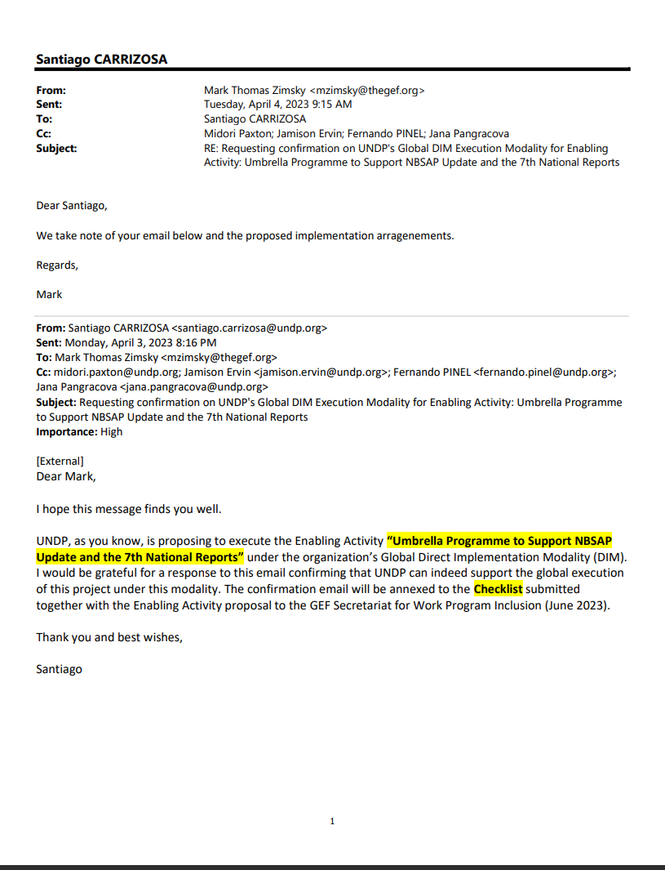

Annex 3: Project map and Geospatial Coordinates of project sites

No spatial maps are required for this project.

Annex 4: Multi Year Work Plan

 | Outcomes | Outputs | Year 1 |  |  |  | Year 2 |  |  |  | Year 3 |  |  |  | Year 4
 | Outcomes | Outputs | Q1 | Q2 | Q3 | Q4 | Q1 | Q2 | Q3 | Q4 | Q1 | Q2 | Q3 | Q4 | Q1 | Q2 | Q3 | Q4
Component 1 | Complete the 7th National Reports on Biodiversity | Stakeholder engagement plan, national gender action plan, national gaps reviewed, National capacity needs assessment | X | X | X | X | X | X
Component 1 | Complete the 7th National Reports on Biodiversity | Policy coherence assessment |  |  |  | x | x | x | x | x
Component 1 | Complete the 7th National Reports on Biodiversity | Spatialized action plan |  |  |  | x | x | x | x | x
Component 1 | Complete the 7th National Reports on Biodiversity | NBSAP submitted |  |  |  |  |  |  | X | X | X | X | X | X
Component 2 | National Reports on Biodiversity (7NR) are completed for each country | Assessment of the revised NBSAP prepared | x | x | x
Component 2 |  | Assessment of progress toward national targets and KM-GBF prepared |  | x | x | x | x
Component 2 |  | Assessment of the implementation of the KM-GBF |  |  | x | x | x | x | x | x
Component 2 |  | National report is submitted |  |  |  |  |  |  |  |  |  | x | x | x | x | x | x
Component 3: | A global knowledge and technical assistance platform is established to share knowledge and experiences across participating countries and partner organizations | E-learning courses |  | X | X | X | X | X | X | X | X | X | X | X
Component 3: |  | Webinars |  |  | X | X | X | X | X | X | X | X | X | X | X | X
Component 3: |  | Case studies | X | X | X | X | X | X | X | X | X | X | X | X | X
Component 3: |  | Dedicated technical advice and data |  | X | X | X | X | X | X | X | X | X | X | X | X | X
Component 3: |  | Global events |  |  | x |  |  |  | x |  |  |  | x |  |  |  | X
Component 3: |  | Communication and outreach, peer to peer exchanges |  |  | X |  | X |  | X |  | X |  | X |  | X |  | X
Component 3: |  | Flagship reports |  |  |  |  | X |  |  | X |  |  |  | X
Component 4:. | Programme M&E meets UNDP and GEF standards | Quarterly reports | x | x | x | x | x | x | x | x | x | x | x | x | x | x | x | X
Component 4:. | Programme M&E meets UNDP and GEF standards | Bi-annual reports |  | X |  | X |  | X |  | X |  | X |  | X |  | x
Component 4:. | Programme M&E meets UNDP and GEF standards | Terminal evaluation |  |  |  |  |  |  |  |  |  |  |  |  |  |  | X | x

Annex 5: UNDP Social and Environmental Screening Procedure (SESP)

Project Information
1. Project Title | Umbrella Programme to Support NBSAP Update and the 7th National Reports
2. Project Number (i.e., Quantum project ID, PIMS+) | 9678
3. Location (Global/Region/Country) | Global
4. Project stage (Design or Implementation) | Design (PPG)
5. Date | September 29, 2023

QUESTION 1: How Does the Project Integrate the Programming Principles in Order to Strengthen Social and Environmental Sustainability?
Briefly describe in the space below how the project mainstreams the human rights-based approach
This is a global programme supported by the GEF, in partnership with UNEP and the CBD Secretariat. This programme is funded by the GEF’s Enabling Activities window, which aims to provide all GEF-eligible countries with the funds required to enable them to fulfil their requirements to the Convention on Biological Diversity (CBD).
The objective of this grant is to enable Parties to the Convention on Biological Diversity to implement two recent commitments: a) revise their National Biodiversity Strategies and Action Plans (NBSAPs) to align with the newly approved Kunming-Montreal Global Biodiversity Framework; and b) complete National Reports on the status of biodiversity and of achieving the goals and targets of this new framework. These activities are closely aligned with those of the Early Action Support Project, which aimed to fast-track readiness and early actions to implement the post-2020 Global Biodiversity Framework by providing financial and technical support to GEF-eligible Parties to the Convention on Biological Diversity (CBD) in their work to align their national targets, NBSAPs, policy frameworks, monitoring frameworks, and finance with the Global Biodiversity Framework. This first project is complementary to the second, and helps Parties continue to accelerate progress.
Parties will update their NBSAPs taking into account the Kunming-Montreal Global Biodiversity Framework (GBF) and national policies. The theory of change for the GBF states that ‘it will be implemented taking a rights-based approach and recognizing the principle of intergenerational equity’.
Aligned with this approach, this project mainstreams the human rights-based approach by providing guidance and capacity building to Parties (through technical support by the project) on gender-sensitive and socially inclusive stakeholder engagement (Outputs 1.1.1 and 1.1.2) , integration of social and environmental screening principles and procedures (Output 1.1.5), and establishing a grievance redress mechanism (GRM) which will be accessible to all stakeholders to voice their concerns about the project. This will help ensure that the process followed by Parties to update NBSAPs is inclusive, free from discrimination and transparent. During the funding of previous enabling activities, GEF-eligible countries conducted stakeholder mapping exercises for biodiversity issues. Participating Parties may re-engage those working groups during this Enabling Activity. Where there are emerging issues, such as gender equality, Indigenous land rights, and sectoral issues, national processes for participation should identify relevant stakeholders to be invited to participate in the process.
The project is structured under 3 main components: (i) National Biodiversity Strategies and Action Plan Updates: to update the National Biodiversity Strategies and Action Plan (NBSAP) to be in full alignment with the Kunming-Montreal Global Biodiversity Framework; (ii)7th National Report: to complete the 7th National Report to the Convention on Biological Diversity, in accordance with COP 15 Decision 15/6; and (iii) Global Knowledge Exchange and Technical Support: to facilitate coordination and exchange of knowledge amongst all parties, building on the global knowledge work supporting the Early Action Grant, and the Biodiversity Finance grants.
As a global programme supporting the implementation of the GBF, this initiative recognizes and upholds the human rights-principles as key elements in achieving development results. In this light, the initiative, through its technical support component will promote equal, non-discriminatory, and active participation of all stakeholders in planning, decision making, implementation and evaluation of its activities and outcomes.
Led by countries, stakeholders will be engaged to participate in the process, and the appropriate procedures such as multistakeholder dialogue platforms and meaningful participation will be recommended at the recipient country level, based on national processes and policy frameworks, ensuring they meet international standards.

With technical support provided through the Global Program and each UNDP Country Office, each country led project will develop a Stakeholder Engagement Plan/Template and a gender analysis and action plan to ensure that their national planning process upholds the principles of equality and non-discrimination, participation and inclusion and accountability to stakeholders (see below).

Briefly describe in the space below how the project is likely to improve gender equality and women’s empowerment
The project provides financial and technical support to Parties to the UN Convention on Biological Diversity (UNCBD) so that they can update their national biodiversity strategy and action plan (NBSAP) in alignment with the post-2020 Global Biodiversity Framework (GBF) and develop their 7th national communication. Gender mainstreaming is an important aspect of CBD implementation and it is enshrined not only in the previous Strategic Plan 2011-2020 (refer to COP 10 Decision X/2, article 8), but also in the new emerging Global Biodiversity Framework, as well as in a number of other COP decisions. The theory of change for the GBF states ‘the need for appropriate recognition of gender equality, women’s empowerment, youth, gender-responsive approaches and the full and effective participation of indigenous peoples and local communities in the implementation of this framework’. The global technical support grant component of the project will provide guidance to Parties on how to ensure a gender responsive and socially inclusive approach, including recommendations for inclusion of women and women’s groups in consultations and specific issues related to gender. The consultation guidelines require that culturally appropriate consultation mechanisms are deployed, including to consider participation access needs for persons with disabilities, and awareness of sociocultural power dynamics (gender norms, informal hierarchies, unpaid care roles) that may impact full participation.
The project will promote gender equality and develop capacities contributing to the national gender equality agenda and globally at SDG 5. The GBF EA as a complementary initiative to this NBSAP Umbrella Programme, will develop a global guidance on gender mainstreaming in support to the implementation of national projects that will benefit this project.
National projects will develop gender analyses and action plans (Output 1.1.2) to ensure gender mainstreaming within consultation processes and integration of gender issues int the NBSAP updates.

Briefly describe in the space below how the project mainstreams sustainability and resilience
This is a key focus of the project insofar as it aims to help Parties update their NBSAPs to align them with the post-2020 GBF, the mission of which is ‘To take urgent action across society to conserve and sustainably use biodiversity and ensure the fair and equitable sharing of benefits from the use of genetics resources, to put biodiversity on a path to recovery by 2030 for the benefit of planet and people’. By providing financial and technical support to Parties to carry out this alignment process, the project will be contributing to the GBF’s long term vision of living in harmony with nature by 2050.
This project will raise awareness during its implementation phase to enhance future application of social and environmental safeguards standards and procedures, especially in the context of potential downstream impacts on Protected Areas or any other regulated areas/territories. that meet international standards.Future projects derived from the NBSAP that may be supported by UNDP or other agencies, will apply relevant SES assessments and mitigation according to the SES Policy and procedures of the implementing agency.
Briefly describe in the space below how the project strengthens accountability to stakeholders
Accountability to stakeholders will be mainstreamed by: (i) enabling meaningful stakeholder engagement and participation (with special attention paid to those at risk of being left behind) – project component 1; (ii) ensuring transparency through provision of timely, accessible and functional information on supported activities, including on potential social and environmental risks, impacts and management measures (Components 1 and 3); (iii) ensuring stakeholders can communicate their concerns and have access to a rights-based grievance resolution mechanism; and (iv) ensuring effective results monitoring (Component 4).
In-country activities implemented under this global umbrella programme will include meaningful stakeholder engagement in the process of updating the NBSAP. In each country a national steering committee will be established to provide strategic direction and review and approve all national level outputs. These will be led by ministries of the environment, supplemented by other key affected stakeholders as per the national context.
Accountability will be ensured by providing guidance (through the global technical support component of the project) to Parties on stakeholder engagement. Parties will also be provided with guidance on establishing a grievance redress mechanism (GRM) to ensure meaningful means for local communities and affected populations to raise concerns and/or grievances including enhancing national stakeholder response mechanisms and informing on UNDP’s Accountability Mechanism (www.undp.org/secu-srm).

QUESTION 2: What are the Potential Social and Environmental Risks?  Note: Complete SESP Attachment 1 before responding to Question 2. | QUESTION 3: What is the level of significance of the potential social and environmental risks?  Note: Respond to Questions 4 and 5below before proceeding to Question 5 |  |  |  | QUESTION 6: Describe the assessment and management measures for each risk rated Moderate, Substantial or High
Risk Description  (broken down by event, cause, impact) | Impact and Likelihood (1-5) | Significance (Low, Moderate Substantial,  High) | Comments (optional) |  |  |  | Description of assessment and management measures for risks rated as Moderate, Substantial or High
Risk 1 Participating governments, may not have the capacity to ensure equitable representation of diverse stakeholder groups, especially Indigenous Peoples and/or Local Communities, and other vulnerable groups, in the process of updating their NBSAP.  Stakeholders may therefore not be afforded meaningful opportunities to share their views during the process.  (P2 to P7 and P13 to P15 of checklist). | L = 3  I = 3 | Moderate | The CBD/GBF recognizes that reaching the 2050 Vision for Biodiversity will require a whole-of-society approach. It is important that the views, perspectives, and experiences of all groups are considered in decision-making processes related to NBSAP planning.  This requires equitable participation in decision-making processes, with a view to ensure that indigenous peoples and local communities, including those most vulnerable, women and girls, elders and youth can effectively shape national policy making processes and that their rights to participation are respected.  The scope of this SESP covers only the potential direct impact from activities implemented by this project, that are related to the implementation of Enabling Activities. The latter activities include capacity support to conducting assessments, creating policy dialogues/multistakeholder round tables, raising awareness via assessments on BD and finance policies, support to policy processes and financial targets and planning processes.  This project will not determine the content of the policy /planning processes because the process is nationally owned, and responds to national agenda setting, lobbying, inter-sector ministerial dialogues and public policy making processes. The project supports these processes, which are nationally owned and determined, and hence does not determine the outcome, which is the updated NBSAP.  Considerations regarding indirect (downstream impacts) are listed under Risk 4 of this SESP. |  |  |  | The Coordination project will provide guidance on socially inclusive stakeholder engagement to Parties (through the global technical support facility) to ensure that stakeholder involvement, including Indigenous Peoples and/or Local Communities representation, is fully embedded in the process of revising NBSAPs (See Component 1) technical support /in the project document). Each country team supported by the project will develop a Stakeholder Engagement Plan to guide the NBSAP update process.  The Global technical support team will also provide guidance to Parties on establishing a GRM associated with their NBSAP. UNDP’s Accountability Mechanism (www.undp.org/secu-srm) will also be available in relation to this UNDP project.
Risk 2 The role of women in accessing environmental goods and services and the differentiated impact on them of meeting NBTs may not be adequately considered in the process of reviewing the NBSAPs and may perpetuate existing discriminations against women that may result from future interventions that are informed by the NBSAP  (P10, P11 of checklist). | L = 3  I = 3 | Moderate | The preamble of the UNCBD recognizes the vital role that women play in the conservation and sustainable use of biological diversity and the need for the full participation of women at all levels of policymaking and implementation for biodiversity conservation. In recognition of this, a first draft of a gender plan of action for the post-2020 period has been prepared for consideration at SBI 3 and for adoption by the COP.  Under this project, countries will be developing new NBSAPs, identifying areas where actions are needed, and gender considerations will need to be assessed and integrated.  Gender analyses will be part of this projects. |  |  |  | The project will provide support to country level projects for gender mainstreaming via the development of a Gender Guidance document at the Global level, focused webinars, and workshop presentations.  In addition, this project, through its capacity support component, will provide gender equality and women’s empowerment guidance to recipient government based on the post-2020 gender plan of action in order to support the targeted integration of gender actions into national biodiversity action plans (https://www.cbd.int/doc/c/7227/c52b/ed7715edecb93033e67c1602/sbi-03-inf-41-en.pdf).  Gender mainstreaming should start early in the national policy consultation processes and gender related criteria should be integrated into the updated NBSAPs.  The project will also provide guidance to Parties through the global technical support component of the project on establishing a gender-sensitive GRM associated with their NBSAP. UNDP’s Accountability Mechanism (www.undp.org/secu-srm) will also be available in relation to this UNDP project.
Risk 3: The updated NBSAPs may not give adequate consideration to potential indirect downstream risks associated with implementation of the National Biodiversity Action Plan recommendations and requirements, including risks associated with:  - Impacts on biodiversity (e.g. through utilization of genetic resources, impacts on habitat, changes to land use) (Standard 1)  - Potential Economic or physical displacement (Standard 5)  - Impacts on cultural heritage such as traditional knowledge (Standard 1 and 4)  - Impact on indigenous peoples (Standard 6)  - Community health and Safety and Labor and Working conditions (Standard 3 and 7) | L = 3  I = 3 | Moderate | The potential post-project downstream risks described under this risk will be attributed to future projects funded by the GEF and other donors and designed to implement the NBSAPs. However, while this project is not supporting implementation, if the NBSAPs are not informed by potential downstream environmental and social impacts then they may ultimately result in unintended impacts during their implementation.  The current project will raise awareness and support knowledge development but will not manage the risks pertaining to future projects. |  |  |  | This global programme will not implement the National Biodiversity Strategy and Action Plans. This will be done by future projects or initiatives, some of which may be supported by UNDP and others by other agencies. If future projects are funded by GEF resources with support by UNDP, UNDP will apply its SES Policy to assess risks and guide the development of mitigation measures. Where the downstream projects are to be implemented with support of other agencies, they will apply their own SES policies.  To support the integration of considerations within the NBSAPs related to potential downstream impacts and unintended environmental and social impacts, this project will provide guidance to participating countries to develop assessments and awareness raising documents (e.g. on potential environmental and social impacts that could result from NBSAP update) and the mainstreaming of social and environmental sustainability aspects within the dialogue processes for biodiversity finance planning, where possible.  In addition, during implementation, the project will support training on the setting up of country level accountability mechanisms (including Grievance and redress mechanisms) within the national interventions, provide guidance on stakeholder response mechanisms, disclosure, public consultation and validation of finance solutions and plans, to support the governments accountability to stakeholders. This will be conducted within the framework of national policies and will focus on enhancing the national processes of public consultation and stakeholder engagement within policy development processes.  In support to the above, this project has integrated assessments within one output (1.1.5):  An assessment of potential socio-economic tradeoffs, including environmental/social impacts derived from the NBSAPs updated through project activities and recommendations to ensure that risks are avoided and managed when projects to implement the NBSAPs are undertaken in the future.  These assessments can shed light on concerns about Indigenous Peoples and special interest groups rights to ABS/genetic resources and/or indigenous knowledge, land and resource rights, and FPIC requirements.  This will provide support to national authorities via information available to integrate in the dialogue safeguards considerations such as respect to the rights of the special interest groups and holders of Genetic Resources (GR) and its associated Traditional Knowledge (TK) under the Nagoya Protocol and other international laws and national legislation and regulations regarding indigenous peoples and special interest groups. Including meaningful and effective consultation with local communities (holders of GR and TK) so that TK is used and or shared only with the consent of the providers of such TK and through the application of FPIC procedures.
 | QUESTION 4: What is the overall project risk categorization?
 | Low Risk |  |  | ☐
 | Moderate Risk |  |  | ý | The overall risk category for this project is moderate.  As the intervention by this global programme is an enabling activity, it will mainly consist of developing studies, assessments, and plans and facilitating policy dialogues. Through project activities, two tangible direct risks to SES programme principles may occur: The risk on Human Rights to meaningful participation in decision making regarding NBSAP policy planning may have an impact on stakeholders via the potential risk of exclusion of vulnerable stakeholders; and, the activities may perpetuate gender inequalities. Both risks may occur while defining NBSAPs if the interests of affected stakeholders are not represented.  With the support and guidance of the Global Technical Support Unit each programme country will develop a simplified stakeholder engagement plan and a gender analysis and action plan and benefit from gender guidance to support gender mainstreaming.  The implementation of the NBSAPs, that may lead to development interventions on the ground, are not within the scope of this project. However, this project takes into account potential downstream social and environmental impacts through components of the project that provide knowledge, awareness raising and technical advice to governments, via technical assessment and capacity building activities, where social and environmental standards and safeguards will be considered.
 | Substantial Risk |  |  | ☐
 | High Risk |  |  | ☐
 | QUESTION 5: Based on the identified risks and risk categorization, what requirements of the SES are triggered? (Check all that apply)
 | Question only required for Moderate, Substantial and High Risk projects
 | Is assessment required? (check if “yes”) |  |  |  |  |  |  | Status? (completed,  planned)
 | if yes, indicate overall type and status |  |  |  | ☐ | Targeted assessment(s)
 |  |  |  |  | ☐ | ESIA (Environmental and Social  Impact Assessment)
 |  |  |  |  | ☐ | SESA (Strategic Environmental and  Social Assessment)
 | Are management plans required? (check if “yes) |  |  | ý
 | If yes, indicate overall type |  |  |  | ý | Targeted management plans (e.g., Gender Action Plan, Emergency Response Plan, Waste Management  Plan, others) |  | The following studies are planned and will be carried out in the countries that are part of this global umbrella programme:  -Simplified stakeholder engagement plan  -Gender Mainstreaming action plan, following the guidance that the global technical support unit will provide to recipient countries

Final Sign Off
Final Screening at the design-stage is not complete until the following signatures are included

Signature | Date | Description
QA Assessor |  | UNDP staff member responsible for the project, typically a UNDP Programme Officer. Final signature confirms  they have “checked” to ensure that the SESP is adequately conducted.
QA Approver |  | UNDP senior manager, typically the UNDP Deputy Country Director (DCD), Country Director (CD), Deputy Resident Representative (DRR), or Resident Representative (RR). The QA Approver cannot also be the QA  Assessor. Final signature confirms they have “cleared” the SESP prior to submittal to the PAC.
PAC Chair |  | UNDP chair of the PAC. In some cases PAC Chair may also be the QA Approver. Final signature confirms that the SESP was considered as part of the project appraisal and considered in recommendations of the PAC.

SESP Attachment 1. Social and Environmental Risk Screening Checklist
Checklist Potential Social and Environmental Risks
INSTRUCTIONS: The risk screening checklist will assist in answering Questions 2-6 of the Screening Template. Answers to the checklist questions help to (1) identify potential risks, (2) determine the overall risk categorization of the project, and (3) determine required level of assessment and management measures. Refer to the SES toolkit
for further guidance on addressing screening questions.
Overarching Principle: Leave No One Behind  Human Rights |  | Answer (Yes/No)
P.1 | Have local communities or individuals raised human rights concerns regarding the project (e.g. during the stakeholder engagement process, grievance processes, public statements)? | No
P.2 | Is there a risk that duty-bearers (e.g. government agencies) do not have the capacity to meet their obligations in the project? | Yes
P.3 | Is there a risk that rights-holders (e.g. project-affected persons) do not have the capacity to claim their rights? | yes
Would the project potentially involve or lead to:
P.4 | adverse impacts on enjoyment of the human rights (civil, political, economic, social or cultural) of the affected population and particularly of marginalized groups? | Yes
P.5 | inequitable or discriminatory impacts on affected populations, particularly people living in poverty or marginalized or excluded individuals or groups, including persons with disabilities? 16 | YEs
P.6 | restrictions in availability, quality of and/or access to resources or basic services, in particular to marginalized individuals or groups, including persons with disabilities? | Yes
P.7 | exacerbation of conflicts among and/or the risk of violence to project-affected communities and individuals? | Yes
Gender Equality and Women’s Empowerment
P.8 | Have women’s groups/leaders raised gender equality concerns regarding the project, (e.g. during the stakeholder engagement process, grievance processes, public statements)? | No
Would the project potentially involve or lead to:
P.9 | adverse impacts on gender equality and/or the situation of women and girls? | Yes
P.10 reproducing discriminations against women based on gender, especially regarding participation in design and implementation or access to opportunities and benefits? |  | Yes
P.11 limitations on women’s ability to use, develop and protect natural resources, taking into account different  roles and positions of women and men in accessing environmental goods and services?  For example, activities that could lead to natural resources degradation or depletion in communities who depend on these resources for their livelihoods and well being |  | Yes
P.12 exacerbation of risks of gender-based violence?  For example, through the influx of workers to a community, changes in community and household power dynamics, increased exposure to unsafe public places and/or transport, etc. |  | Yes

Sustainability and Resilience: Screening questions regarding risks associated with sustainability and resilience are encompassed by the Standard-specific questions below
Accountability
Would the project potentially involve or lead to:
P.13 exclusion of any potentially affected stakeholders, in particular marginalized groups and excluded individuals (including persons with disabilities), from fully participating in decisions that may affect them? | Yes
P.14 grievances or objections from potentially affected stakeholders? | Yes
P.15 risks of retaliation or reprisals against stakeholders who express concerns or grievances, or who seek to participate in or to obtain information on the project? | No
Project-Level Standards
Standard 1: Biodiversity Conservation and Sustainable Natural Resource Management
Would the project potentially involve or lead to:
1.1 adverse impacts to habitats (e.g. modified, natural, and critical habitats) and/or ecosystems and ecosystem services?  For example, through habitat loss, conversion or degradation, fragmentation, hydrological changes | No
1.2 activities within or adjacent to critical habitats and/or environmentally sensitive areas, including (but not limited to) legally protected areas (e.g. nature reserve, national park), areas proposed for protection, or recognized as such by authoritative sources and/or indigenous peoples or local communities? | Yes
1.3 changes to the use of lands and resources that may have adverse impacts on habitats, ecosystems, and/or livelihoods? (Note: if restrictions and/or limitations of access to lands would apply, refer to Standard 5) | Yes
1.4 risks to endangered species (e.g. reduction, encroachment on habitat)? | No
1.5 exacerbation of illegal wildlife trade? | No
1.6 introduction of invasive alien species? | No
1.7 adverse impacts on soils? | No
1.8 harvesting of natural forests, plantation development, or reforestation? | Yes
1.9 significant agricultural production? | No
1.10 animal husbandry or harvesting of fish populations or other aquatic species? | No
1.11 significant extraction, diversion or containment of surface or ground water?  For example, construction of dams, reservoirs, river basin developments, groundwater extraction | No
1.12 handling or utilization of genetically modified organisms/living modified organisms?17 | No
1.13 utilization of genetic resources? (e.g. collection and/or harvesting, commercial development)18 | Yes
1.14 adverse transboundary or global environmental concerns? | No
Standard 2: Climate Change and Disaster Risks
Would the project potentially involve or lead to:

17 See the Convention on Biological Diversity and its Cartagena Protocol on Biosafety.
18 See the Convention on Biological Diversity and its Nagoya Protocol on access and benefit sharing from use of genetic resources.

2.1 areas subject to hazards such as earthquakes, floods, landslides, severe winds, storm surges, tsunami or volcanic eruptions? | Yes
2.2 outputs and outcomes sensitive or vulnerable to potential impacts of climate change or disasters?  For example, through increased precipitation, drought, temperature, salinity, extreme events, earthquakes | Yes
2.3 increases in vulnerability to climate change impacts or disaster risks now or in the future (also known as maladaptive or negative coping practices)?  For example, changes to land use planning may encourage further development of floodplains, potentially  increasing the population’s vulnerability to climate change, specifically flooding | No
2.4 increases of greenhouse gas emissions, black carbon emissions or other drivers of climate change? | No
Standard 3: Community Health, Safety and Security
Would the project potentially involve or lead to:
3.1 construction and/or infrastructure development (e.g. roads, buildings, dams)? (Note: the GEF does not finance projects that would involve the construction or rehabilitation of large or complex dams) | No
3.2 air pollution, noise, vibration, traffic, injuries, physical hazards, poor surface water quality due to runoff, erosion, sanitation? | No
3.3 harm or losses due to failure of structural elements of the project (e.g. collapse of buildings or infrastructure)? | No
3.4 risks of water-borne or other vector-borne diseases (e.g. temporary breeding habitats), communicable and noncommunicable diseases, nutritional disorders, mental health? | Yes
3.5 transport, storage, and use and/or disposal of hazardous or dangerous materials (e.g. explosives, fuel and other chemicals during construction and operation)? | No
3.6 adverse impacts on ecosystems and ecosystem services relevant to communities’ health (e.g. food, surface  water purification, natural buffers from flooding)? | No
3.7 influx of project workers to project areas? | No
3.8 engagement of security personnel to protect facilities and property or to support project activities? | Yes
Standard 4: Cultural Heritage
Would the project potentially involve or lead to:
4.1 activities adjacent to or within a Cultural Heritage site? | Yes
4.2 significant excavations, demolitions, movement of earth, flooding or other environmental changes? | No
4.3 adverse impacts to sites, structures, or objects with historical, cultural, artistic, traditional or religious values or intangible forms of culture (e.g. knowledge, innovations, practices)? (Note: projects intended to protect and conserve Cultural Heritage may also have inadvertent adverse impacts) | Yes
4.4 alterations to landscapes and natural features with cultural significance? | Yes
4.5 utilization of tangible and/or intangible forms (e.g. practices, traditional knowledge) of Cultural Heritage for commercial or other purposes? | Yes
Standard 5: Displacement and Resettlement
Would the project potentially involve or lead to:
5.1 temporary or permanent and full or partial physical displacement (including people without legally recognizable claims to land)? | Yes

5.2 economic displacement (e.g. loss of assets or access to resources due to land acquisition or access restrictions – even in the absence of physical relocation)? | Yes
5.3 risk of forced evictions?19 | Yes
5.4 impacts on or changes to land tenure arrangements and/or community based property rights/customary rights to land, territories and/or resources? | Yes
Standard 6: Indigenous Peoples
Would the project potentially involve or lead to:
6.1 areas where indigenous peoples are present (including project area of influence)? | Yes
6.2 activities located on lands and territories claimed by indigenous peoples? | Yes
6.3 impacts (positive or negative) to the human rights, lands, natural resources, territories, and traditional livelihoods of indigenous peoples (regardless of whether indigenous peoples possess the legal titles to such areas, whether the project is located within or outside of the lands and territories inhabited by the affected peoples, or whether the indigenous peoples are recognized as indigenous peoples by the country in question)?  If the answer to screening question 6.3 is “yes”, then Standard 6 requirements apply, and the potential significance of risks related to impacts on indigenous peoples must be Moderate or above. * | Yes
6.4 the absence of culturally appropriate consultations carried out with the objective of achieving FPIC on matters that may affect the rights and interests, lands, resources, territories and traditional livelihoods of the indigenous peoples concerned? | Yes
6.5 the utilization and/or commercial development of natural resources on lands and territories claimed by indigenous peoples? | Yes
6.6 forced eviction or the whole or partial physical or economic displacement of indigenous peoples, including through access restrictions to lands, territories, and resources?  Consider, and where appropriate ensure, consistency with the answers under Standard 5 above | Yes
6.7 adverse impacts on the development priorities of indigenous peoples as defined by them? | Yes
6.8 risks to the physical and cultural survival of indigenous peoples? | Yes
6.9 impacts on the Cultural Heritage of indigenous peoples, including through the commercialization or use of their traditional knowledge and practices?  Consider, and where appropriate ensure, consistency with the answers under Standard 4 above. | Yes
Standard 7: Labour and Working Conditions
Would the project potentially involve or lead to: (note: applies to project and contractor workers)
7.1 working conditions that do not meet national labour laws and international commitments? | No
7.2 working conditions that may deny freedom of association and collective bargaining? | No
7.3 use of child labour? | No
7.4 use of forced labour? | No
7.5 discriminatory working conditions and/or lack of equal opportunity? | No
7.6 occupational health and safety risks due to physical, chemical, biological and psychosocial hazards (including violence and harassment) throughout the project life-cycle? | Yes

19 Forced eviction is defined here as the permanent or temporary removal against their will of individuals, families or communities from the homes and/or land which they occupy, without the provision of, and access to, appropriate forms of legal or other protection. Forced evictions constitute gross violations of a range of internationally recognized human rights.

Standard 8: Pollution Prevention and Resource Efficiency
Would the project potentially involve or lead to:
8.1 the release of pollutants to the environment due to routine or non-routine circumstances with the potential for adverse local, regional, and/or transboundary impacts? | No
8.2 the generation of waste (both hazardous and non-hazardous)? | No
8.3 the manufacture, trade, release, and/or use of hazardous materials and/or chemicals? | No
8.4 the use of chemicals or materials subject to international bans or phase-outs?  For example, DDT, PCBs and other chemicals listed in international conventions such as the Montreal Protocol, Minamata Convention, Basel Convention, Rotterdam Convention, Stockholm Convention | No
8.5 the application of pesticides that may have a negative effect on the environment or human health? | No
8.6 significant consumption of raw materials, energy, and/or water? | No

Annex 6: UNDP Risk Register
# | Description | Risk Category | Impact & Probability | Risk Treatment / Management Measures | Risk Owner
1 | There is a risk that the development of guidance materials is not sufficiently paced to meet the needs of governments. | Operational | Low  L = 1  I = 3 | UNEP and UNDP will divide key tasks in developing methodologies, tools and guidance, in order to roll out guidance in the most efficient and time-sensitive manner possible | Project Technical Lead
2 | There is a risk that some governments may not have adequate access to avail themselves of online courses and relevant materials | Operational | Low  L = 2  I = 2 | UNEP and UNDP will mitigate the risk of digital inequality and barriers to access by conducting an early survey of barriers to digital access, and will ensure that all countries who are part of the Early Action Grant project will have sufficient access to digital support materials. They will also provide off-line alternatives. | Project Technical Lead
3 | Ongoing COVID-19 – there is a small risk that COVID-19 may disrupt the ability of governments to conduct in-person consultations  Consultations can proceed in spite of prevailing Covid-19 public health measures in different countries | Operational | Low  L = 2  I = 2 | After two years of dealing with Covid-19, countries have developed many different adaptive strategies, and can cope with ongoing lockdowns and restrictions. UNDP and UNEP will mitigate potential risks by ensuring a fully online program of support, to buffer against potential travel disruptions affecting in-person trainings | Project Technical Lead
4 | Countries may not incorporate gender-responsive measures into policies to address gender gaps or promote gender equality and women’s empowerment | Social and Environmental | Low  L = 2  I = 2 | UNDP will build on lessons learned in the 6NR regarding gender mainstreaming to support Parties to more fully consider gender-responsive measures based on readiness levels | Project Technical Lead
5 | (National level assumption) Risk of delays in project implementation due to the national processes involved, such as coordination among relevant sectors.  (Theory of Change assumption) Government counterparts own and actively engage in the consultative process to achieve GBF alignment | Strategic | Moderate  L = 3  I = 3 | Being able to directly influence and speed-up national processes may not be possible for the project. That said, the project will encourage Parties to adhere to agreed work plans, and will troubleshoot on obstacles to the extent possible. Parties will be supported with technical expertise, tools, methodologies, and approaches so that at least these are not factors holding back progress. | Project Technical Lead
6 | (Country MSP assumption) The risk of lack of national approval of updated NBSAPs and political will to implement the results of the project.  (Theory of Change assumption) There is political will to validate GBF-aligned NBSAPs and NBTs | Strategic | Moderate  L = 2  I = 4 | This may be beyond the accountability line of the project given that this is governed by national political processes outside the project’s influence. The CBD processes could greatly help with mitigating this risk by encouraging Parties to sign documents as soon as possible, and boosting political engagement. It is expected that the ground laid by this project will facilitate the identification and development of specific projects to implement GBF-aligned national targets and NBSAPs through funding from GEF and other donors following this project. | Project Technical Lead
7 | Limited oversight and monitoring may have reputational impact on the project | Reputational | Moderate  L = 3  I = 3 | UNDP's role in project governance will ensure that the project is being executed in compliance with UNDP & GEF policies. This is achieved through three main lines of oversight and monitoring. The first line of oversight is provided through the UNDP BPPS Nature Hub Project Assurance responsibilities (fulfilled by the UNDP BPPS VF-Hub EBD RTA and PTA and through UNDP’s direct role on the Project Board/Steering Committee. The project’s second line of oversight is provided by the UNDP BPPS VF Hub , headed by the UNDP VF Executive Coordinator (Pradeep Kurukulasuriya). The third line of oversight is provided by the independent OAI, IEO and other UNDP bodies. | Project Technical Lead
8 | Risk of fraud and corruption | Reputational | Low  L=2  I=2 | Overall, in accordance with the Project Document, the Project Board shall ensure the highest levels of fairness, integrity and transparency and take all measures to avoid any real or perceived conflicts of interest. The pertinent control mechanisms are contained within the UNDP Policy against Fraud and other Corrupt Practices to ensure early identification and management of conflict of interest. UNDP procurement rules based on key principles of procurement enlisted in the UNDP Financial rules and regulations will be implemented. | Project Technical Lead
9 | (Country MSP assumption) Civil society may not be adequately included in the various components, particularly in the setting of national targets, and the alignment of key policies, especially related to land use rights and tenure. | Social & Environmental | Moderate  L = 1  I = 4 | This project will provide technical support related to stakeholder engagement for each of the various components. UNDP and UN Environment will ensure that individual country proposals contain a comprehensive list of the stakeholders that will be engaged in the process. In partnership with the SCBD, experts will be engaged to train country teams on how to facilitate a comprehensive stakeholder engagement process. | Project Technical Lead
10 | (Country MSP assumption) Parties may not have access to the tools, methodologies and approaches required to complete all aspects of the Early Action Grant. | Operational | Low  L = 1  I = 4 | The project will build on existing capacity building programs that SCBD, UNDP and UNEP maintain in order to support parties with development and implementation of their NBSAPs, national targets, policy alignment, monitoring plans and resource mobilization.  UNDP and UNEP will maintain a technical support facility to support countries throughout the project. UNDP and UNEP will support Parties by providing detailed technical guidance, and ensuring south-south exchange and learning. Operational procedures and substantive guidance will also be provided in multiple languages. | Project Technical Lead
11 | (Country MSP assumption) Countries may not review gender issues substantially. | Social & Environmental | Low  L = 3  I = 3 | The global technical support unit will provide guidance to ensure that gender issues are fully mainstreamed into each of the components of this Early Action Grant project. UNDP and UNEP will make available a catalogue of gender-based dimensions, and will include gender dimensions in the technical support and expert review process. | Project Technical Lead
12 | (SESP Risk 1.)  Participating governments, may not have the capacity to ensure equitable representation of diverse stakeholder groups, especially Indigenous Peoples and/or Local Communities, and other vulnerable groups, in the process of updating their NBSAP.  Stakeholders may therefore not be afforded meaningful opportunities to share their views during the process.  (P2 to P7 and P13 to P15 of checklist). | Social & Environmental | Moderate  L = 3  I = 3 | The Coordination project will provide guidance on socially inclusive stakeholder engagement to Parties (through the global technical support facility) to ensure that stakeholder involvement, including Indigenous Peoples and/or Local Communities representation, is fully embedded in the process of revising NBSAPs (See Component 1) technical support /in the project document). Each country team supported by the project will develop a Stakeholder Engagement Plan to guide the NBSAP update process.  The Global technical support team will also provide guidance to Parties on establishing a GRM associated with their NBSAP. UNDP’s Accountability Mechanism (www.undp.org/secu-srm) will also be available in relation to this UNDP project. | Project Technical Lead
13 | (SESP Risk 2.) The role of women in accessing environmental goods and services and the differentiated impact on them of meeting NBTs may not be adequately considered in the process of reviewing the NBSAPs and may perpetuate existing discriminations against women that may result from future interventions that are informed by the NBSAP  (P10, P11 of checklist). | Social & Environmental | Moderate L = 3  I = 3 | The project will provide support to country level projects for gender mainstreaming via the development of a Gender Guidance document at the Global level, focused webinars, and workshop presentations.  In addition, this project, through its capacity support component, will provide gender equality and women’s empowerment guidance to recipient government based on the post-2020 gender plan of action in order to support the targeted integration of gender actions into national biodiversity action plans (https://www.cbd.int/doc/c/7227/c52b/ed7715edecb93033e67c1602/sbi-03-inf-41-en.pdf).  Gender mainstreaming should start early in the national policy consultation processes and gender related criteria should be integrated into the updated NBSAPs.  The project will also provide guidance to Parties through the global technical support component of the project on establishing a gender-sensitive GRM associated with their NBSAP. UNDP’s Accountability Mechanism (www.undp.org/secu-srm) will also be available in relation to this UNDP project. | Project Technical Lead
14 | (SESP Risk 3.) The updated NBSAPs may not give adequate consideration to potential indirect downstream risks associated with implementation of the National Biodiversity Action Plan recommendations and requirements, including risks associated with:  - Impacts on biodiversity (e.g. through utilization of genetic resources, impacts on habitat, changes to land use) (Standard 1)  - Potential Economic or physical displacement (Standard 5)  - Impacts on cultural heritage such as traditional knowledge (Standard 1 and 4)  - Impact on indigenous peoples (Standard 6)  - Community health and Safety and Labor and Working conditions (Standard 3 and 7) | Social & Environmental | Moderate  L = 3  I = 3 | This global programme will not implement the National Biodiversity Strategy and Action Plans. This will be done by future projects or initiatives, some of which may be supported by UNDP and others by other agencies. If future projects are funded by GEF resources with support by UNDP, UNDP will apply its SES Policy to assess risks and guide the development of mitigation measures. Where the downstream projects are to be implemented with support of other agencies, they will apply their own SES policies.  To support the integration of considerations within the NBSAPs related to potential downstream impacts and unintended environmental and social impacts, this project will provide guidance to participating countries to develop assessments and awareness raising documents (e.g. on potential environmental and social impacts that could result from NBSAP update) and the mainstreaming of social and environmental sustainability aspects within the dialogue processes for biodiversity finance planning, where possible.  In addition, during implementation, the project will support training on the setting up of country level accountability mechanisms (including Grievance and redress mechanisms) within the national interventions, provide guidance on stakeholder response mechanisms, disclosure, public consultation and validation of finance solutions and plans, to support the governments accountability to stakeholders. This will be conducted within the framework of national policies and will focus on enhancing the national processes of public consultation and stakeholder engagement within policy development processes.  In support to the above, this project has integrated assessments within one output (1.1.5):  An assessment of potential socio-economic tradeoffs, including environmental/social impacts derived from the NBSAPs updated through project activities and recommendations to ensure that risks are avoided and managed when projects to implement the NBSAPs are undertaken in the future.  These assessments can shed light on concerns about Indigenous Peoples and special interest groups rights to ABS/genetic resources and/or indigenous knowledge, land and resource rights, and FPIC requirements.  This will provide support to national authorities via information available to integrate in the dialogue safeguards considerations such as respect to the rights of the special interest groups and holders of Genetic Resources (GR) and its associated Traditional Knowledge (TK) under the Nagoya Protocol and other international laws and national legislation and regulations regarding indigenous peoples and special interest groups. Including meaningful and effective consultation with local communities (holders of GR and TK) so that TK is used and or shared only with the consent of the providers of such TK and through the application of FPIC procedures. | Project Technical Lead
15 | UNOPS has been affected by Member State scrutiny following the 2020 OAI GEF Portfolio Performance Review. This might pose a political and reputational risk that could affect project oversight and performance. UNOPS is a responsible party through the Nature for Development Programme. | Reputational | Moderate  L = 3  I = 3 | UNOPS is already taking mitigation actions to remedy the situation as indicated in their statement to the annual session of the Executive Board 2022 (Statement Executive Board). UNDP will sign a Letter of Agreement with UNOPS and will monitor implementation ensuring appropriate use of funds. UNDP will monitor implementation of these actions and possible impact on the project. | Project Technical Lead

Annex 7: Overview of Technical Consultancies/Subcontracts
Consultant | Time Input | Tasks, Inputs and Outputs
For Project Management
Global Technical Lead  Rate: $5091/week | 154 weeks / over 4 years | Th Global Technical Lead will be responsible for the overall management of the project. This includes showcasing impacts and strengthening relationships with stakeholders at all levels.  Duties and Responsibilities  - Ensure the management and administrative requirements (technical, financial, communications, audits, evaluations, etc.) of the GEF are met.  - Ensure that UNDP-specific processes (integrated work planning, budgeting, procurement, monitoring and evaluation, SESP, etc.) are met.  - Ensure procedural compliance and timely and quality delivery of outputs by responsible parties.  - Establish and convene meetings of the Project Board.  - Ensure timely implementation/outcomes and outputs/products by providing inputs to, and critically reviewing technical inputs.  - Work with UNDP staff and partner organizations to feed lessons learned from the project implementation.  - Liaise with other relevant UNDP staff including in-country colleagues regarding the project, including to share information about trends and issues in the thematic area.  - Liaise with relevant initiatives and programs in UNDP and with other organizations in support of the execution of the project.  - Manage the overall conduct of the project.  - Plan the activities of the project and monitor progress against the approved workplan.  - Provide support for completion of assessments required by UNDP, spot checks and audits.  - Manage requests for the provision of UNDP financial resources through funding advances, direct payments or reimbursement using the FACE form.  - Monitor financial resources and accounting to ensure the accuracy and reliability of financial reports.  - Monitor progress, watch for plan deviations and make course corrections when needed within project board-agreed tolerances to achieve results.  - Ensure that changes are controlled, and problems addressed.  - Perform regular progress reporting to the project board as agreed with the board, including measures to address challenges and opportunities.  - Prepare and submit financial reports to UNDP on a quarterly basis.  - Manage and monitor the project risks – including social and environmental risks - initially identified and submit new risks to the Project Board for consideration and decision on possible actions if required; update the status of these risks by maintaining the project risks log;  - Capture lessons learned during project implementation.  - Prepare revisions to the multi-year workplan, as needed, as well as annual and quarterly plans if required.  - Prepare the inception report no later than one month after the inception workshop.  - Ensure that the indicators included in the project results framework are monitored annually in advance of the GEF PIR submission deadline so that progress can be reported in the GEF PIR.  - Prepare the GEF PIR;  - Assess major and minor amendments to the project within the parameters set by UNDP-GEF;  - Monitor implementation plans including the gender action plan, stakeholder engagement plan, and any environmental and social management plans;  - Monitor and track progress against the GEF Core indicators.  - Support the Terminal Evaluation process.  - Liaise with the UNOPS Programme Manager and UNOPS technical lead to ensure successful execution of Components 3 and  - Compliance of operations with UN/UNDP rules, regulations and policies, implementation of corporate operational strategies, establishment of management targets and monitoring achievement of results.  - Provision of advice on strategies, policies and plans affecting delivery of policy, advisory and programme support services.  - Contribution to and ensuring compliance with internal Standard Operating Procedures in Finance, Human Resources Management, Procurement, Logistical and ICT services and Results Management.  - Effective formulation and implementation of global programmes and projects through advisory support, focusing especially on execution modalities, management arrangements, implementation capacities, and other operational aspects.  - Establishment of collaborative arrangements with partners in line with applicable UNDP regulations and rules, including but not limited to donor agreements, memoranda of understanding, letters of agreement, grant agreements etc.  - Timely approval of project budgets in Quantum through the commitment control function based on valid supporting documents, proper use of accounts and accurate F&A set up.  - Efficient and effective performance of Manager Level 1 role in Quantum for approval of purchase orders and vouchers.  - Knowledge building and sharing with regard to operational/finance business processes
Global Programme  Analyst (IPSA 9)  Rate: $1,907/week | 208 weeks / over 4 years | Duties and Responsibilities  The incumbent will be responsible for the day-to-day administrative support of up to 3 global projects in the VF-Hub portfolio implemented through DIM modality (including the GBF-EAS). The GPA provides administrative support services, including support to project manager/coordinator and PTA, financial management, documentation management, and support to monitoring and reporting as required for the successful management and achievement of the outcomes of each assigned project, in compliance with the policies, processes and procedures of UNDP and the requirements of the project’s respective donors. The GPA works primarily, but not exclusively, with the respective DIM Project Managers, Principal Technical Advisor (PTA), Senior Technical Advisor (STA) and other thematic leads assigned for project oversight, UNDP country offices (where ground activities are envisaged), HR and Procurement Implementation support teams, representatives of donor organizations, RPs and subcontractors. The following are the specific key functions/results expected:  Support for projects’ administrative services:  - Serves as point of contact on administrative and operational issues between the UNDP Country Offices, Global Technical Support Team, UNDP Oversight and Finance team, RTA, other support staff, national implementation teams (where relevant), RPs and donor agencies;  - Supports the PCs and PTA/STA in monitoring and facilitating compliance with management and administrative requirements from donors, including reviewing financial reports generated in QUANTUM, budget compliance and audit reports, time-sheets;  - Supports the PCs/PTA/STA in monitoring and facilitating compliance with UNDP and donor rules in managing financial resources, monitoring and evaluation;  - On request from PC, assists with the development and output of implementation materials, including project documents, guidance materials, templates, and technical reports;  - Ensures timely and accurate project report submissions to donors;  - Maintains accurate information in PIMS for all milestones;  - Develops and maintains procurement and HR plans  - Submits procurement and HR requests and assists procurement and HR in the selection and recruitment of project consultants and/or personnel ensuring compliance with the applicable UNDP rules & regulations;  - Coordinates project appraisal committee activities for the assigned DIM projects;  - Facilitates and supports the preparation and organization of virtual or hybrid meetings and workshops;  - Facilitates knowledge-building and sharing;  - Supports the PCs / PTA in meetings with key stakeholders as required.  Support to projects’ financial and technical management  - Sets up and maintains document control procedures and a document filing system, including for supporting documentation for financial reviews, continuously integrating relevant new information/data;  - Provide support in managing requests for day-to-day financial administration, using advance of funds, direct payments, or reimbursement using Fund Authorization and Certificate of Expenditures;  - Maintains the internal expenditures control system which ensures that vouchers processed are matched and completed; transactions are correctly recorded and posted in Quantum;  - Takes timely corrective actions on unposted vouchers, including the vouchers with budget check errors, match exceptions, unapproved vouchers;  - Creates requisitions and registers goods receipt in QUANTUM (ERP);  - Carries out budget checks for requisitions, Purchase Orders and vouchers;  Support to projects’ monitoring and reporting  - Supports and facilitates results-based programme development and management throughout the different stages of projects/programme implementation;  - Provide regular reviews by the PCs/PTA regarding project details, schedules, risks, deliverables and budgets to ensure implementation is on track;  - Monitors quality indicators and administers quality review processes and assists PC in arranging for independent evaluations of the Initiative;  - Monitors planning and implementation carried out by RPs, such as by contractors and service providers including in pilot countries, and ensures that they are aligned with key milestones;  - Provides support to resource mobilization, maintaining information/databases on potential and actual donors, providing administrative information and editing support towards funding proposals.
For Technical Assistance
Senior Technical  Advisor  Rate: $8,290/week | 30 weeks / over 3.5 years | This will be a part-time role. The Senior Technical Manager will provide senior review and quality assurance for all technical guidance (except guidance related to UNDP SES, which will be the responsibility of the SES specialist) prepared under Pathway 2: Global technical support. They will provide technical advice to support in oversight of the development and execution of technical guidance.  Tasks:  - Provide technical assurance and backstopping to the project manager on all issues related to the Early Action Grant project  - Provide support and oversight in the development of technical learning materials  Key Deliverables:  - Technical reviews, draft documents, final products related to Component 3  Expertise & Qualifications:  - Master’s degree or higher in natural resources or relevant field highly desired  - Experience with National Biodiversity Strategies and Action Plans and 6th National Reports  - At least 15 years of experience with thematic areas included in National Biodiversity Strategies and Action Plans and 6th National Reports, including protected areas and their status, the conservation status of biodiversity, threats to biodiversity  - Experience with biodiversity finance  - Experience with policy assessments  - Experience with spatial data  - Experience with biodiversity targets and indicators
Social & Environmental Safeguards Specialist  Rate: $2,760/week | 12 weeks/ 3.5 years | Develop guidance on integrating social and environmental safeguards in NBSAP updates. Based on the SESP, this must include the following types of guidance:  - Guidance on how to consider potential social and environmental risks and safeguards in country-led processes to update the NBSAPs;  - stakeholder engagement guidance to Parties to ensure that stakeholder involvement, including IPLC representation, is embedded in the process of updating NBTs and NBSAPs, and that the country-led process is inclusive and gender-responsive;  - guidance on establishing a GRM, including through UNDP’s Accountability Mechanism (www.undp.org/secu-srm);  - guidance on gender equality and women’s empowerment to Parties based on the post-2020 gender plan of action and its linkages with the most directly relevant goals, milestones and targets of the framework, in order to support the targeted integration of gender actions into respective areas of national biodiversity strategies and action plans (https://www.cbd.int/doc/c/7227/c52b/ed7715edecb93033e67c1602/sbi-03-inf-41-en.pdf).  Based on UNDP SES guidance on stakeholder engagement (https://info.undp.org/sites/bpps/SES_Toolkit/SES%20Document%20Library/Uploaded%20October%202016/UNDP%20SES%20Stakeholder%20Engagement%20GN_Final_Dec2020.pdf), develop a simplified template and guidance that can be used by country teams in the inception phase to develop stakeholder engagement plans for their NBSAP process. If required, support specific country teams that may need extra help in developing the Stakeholder Engagement Plan that reflects all the above guidance, or cases where more detailed plans may be needed.
GIS Specialist  Rate: $2,760/week | 35 weeks/ 3.5 years | Duties and Responsibilities  Tasks:  - Provide customized support for all materials related to spatial analyses  - Support the development and maintenance of the UN Biodiversity Lab functions and collections  - Provide technical GIS-related backstopping for the development of Components 1, 2 and 4  Key Deliverables:  - Customized GIS support as required by the project  - UNBL support as needed  Expertise & Qualifications:  - Master’s degree in relevant field highly desired  - At least 10 years of relevant work experience  - Experience in, and familiarity with, natural resources issues  - Experience related to the intersection of GIS and policy  - Experience providing customized GIS support to country focal points
Technical Specialist NBSAPs and Targets  Rate: $2,486/week | 35 weeks/ 3.5 years | Tasks:  - Develop guidance on NBSAPs and National Biodiversity Targets  - Provide customized support to countries on NBSAPs and NBTs as required  - Develop and execute training materials, webinars and other forms of support  - Provide review and quality assurance services on draft documents  Key Deliverables:  - Guidance and materials on NBSAPs and National Biodiversity Targets  - Webinar reports and recordings  Expertise & Qualifications:  - Master’s degree in relevant field highly desired  - At least 5 years of relevant work experience  - Experience in, and familiarity with, natural resources issues  - Experience in providing customized support to national focal points on NBSAPs and National Biodiversity Targets
Technical Specialist Policy  Rate: $2,486/week | 35 weeks/ 3.5 years | Tasks:  - Develop guidance on policy coherence and alignment  - Provide customized support to countries on policy coherence and alignment as required  - Develop and execute training materials, webinars and other forms of support  - Provide review and quality assurance services on draft documents  Key Deliverables:  - Guidance and materials on policy coherence and alignment  - Webinar reports and recordings  Expertise & Qualifications:  - Master’s degree in relevant field highly desired  - At least 5 years of relevant work experience  - Experience in, and familiarity with, natural resources issues  - Experience in providing customized support to national focal points on policy coherence and alignment
Reporting Specialist  Rate: $2,760/week | 36 weeks/ 3.5 years | Tasks:  - Develop guidance on policy reporting  - Provide customized support to countries on reporting as required  - Develop and execute training materials, webinars and other forms of support  - Provide review and quality assurance services on draft documents  Key Deliverables:  - Guidance and materials on reporting  - Webinar reports and recordings  Expertise & Qualifications:  - Master’s degree in relevant field highly desired  - At least 10 years of relevant work experience  - Experience in, and familiarity with, natural resources issues
Knowledge Management & Communication Specialist  Rate: $2,180/week | 71 weeks/ 3.5 years | Tasks:  - Manage and oversee the development learning resources, in partnership with the Senior Technical Specialist and the technical coordinator  - Organize and roll out the enrolment, design, execution and delivery of all learning materials  Key Deliverables:  - Design and execution of learning modality, e-learning modules and MOOCS for the elements of Component 3  - Support the development and collection of 100 case studies  - Support the NBSAP Forum  Expertise & Qualifications:  - Master’s degree in relevant field highly desired  - At least 5 years of relevant work experience in e-learning  - Experience in, and familiarity with, natural resources issues  - Experience managing data and information systems  - Experience running webinars and dialogue platforms  - Experience managing relationships with stakeholders
2 Spatial Planning Consultants  Rate: $2,486/week | 52 weeks/ 3.5 years | Tasks:  - Provide customized support for all materials related to spatial analyses  - Support the development and maintenance of the UN Biodiversity Lab functions and collections to achieve elements of Component 3  - Provide technical GIS-related backstopping for the development of Component 3  Key Deliverables:  - Customized GIS support as required by the project  - Framework for conducting spatialized action plans for area-based targets  Expertise & Qualifications:  - Master’s degree in relevant field highly desired  - At least 10 years of relevant work experience  - Experience in, and familiarity with, natural resources issues  - Experience related to the intersection of GIS and policy  - Experience providing customized GIS support to country focal points
Policy Coherence Consultant  Rate: $2,760/week | 59 weeks/ 3.5 years | Tasks:  - Provide customized support for all materials related to policy coherence assessments  - Develop a framework for conducting a policy coherence assessment  - Provide technical backstopping for the development policy coherence assessments  Key Deliverables:  - Customized GIS support as required by the project  - UNBL  Expertise & Qualifications:  - Master’s degree in relevant field highly desired  - At least 10 years of relevant work experience  - Experience in, and familiarity with, natural resources issues  - Experience related to the intersection of GIS and policy  Experience providing customized GIS support to country focal points
Senior Web Designer  Rate: $2,180/week | 71 weeks/ 3.5 years | Tasks:  - Develop all relevant web interfaces  - Complete all coding and design required for execution of the project, including migration of the NBSAP Forum, the Massive Open Online Course spaces, and any communities of practice and other spaces  - Support the Senior eLearning specialist in developing and executing MOOCs  Key Deliverables:  - Web platforms and portals created, including the NBSAP Forum 2.0, various MOOCs, and communities of practice  Expertise & Qualifications:  - Master’s degree in relevant field highly desired  - At least 5 years of relevant work experience  Experience in the design and execution of web portals and learning portals
Senior eLearning Specialist  Rate: $2,180/week | 71 weeks/ 3.5 years | Tasks:  - Provide customized support for all materials related to e learning  - Support the development and maintenance of e-learning materials  - Develop and manage a work flow for e-learning deliverables, in collaboration with the technical coordinator and the Programme manager  - Report quarterly key analytics  Key Deliverables:  - Customized learning support to countries as required  - Completion of various e-learning courses and materials  Expertise & Qualifications:  - Master’s degree in relevant field highly desired  - At least 10 years of relevant work experience
3 Junior Consultants  Rate: $2,180/week | 80 weeks/ 3.5 years | Tasks:  - Maintain key data and information systems required to execute the project  - Organize and manage communications systems  - Support the Senior eLearning specialist in developing and executing MOOCs  Key Deliverables:  - Technical reviews, draft documents, final products related to each of the elements for component 3 of the project  Expertise & Qualifications:  - Master’s degree in natural resources or relevant field highly desired  - At least 3 years of relevant work experience  - Experience in, and familiarity with, natural resources issues  - Experience managing data and information systems  - Experience running webinars and dialogue platforms  - Experience managing relationships with stakeholders
M&E Specialist  Rate: $2,760/week | 36 weeks/3.5 years | Tasks:  - Manage and provide support to the programme monitoring and evaluation  - Support global team and participating countries to meet and report on their performance targets and indicators  Key Deliverables:  - Lead monitoring of outputs and results as per the results framework for the project.  - Oversee and ensure the implementation of the project’s M&E plan, including periodic appraisal of the project’s results framework with reference to actual and potential project progress and results  Expertise & Qualifications:  - Master’s degree in relevant field highly desired  - At least 5 years of relevant work in monitoring and evaluation on the development of M&E systems and/or performance-based management of international projects.  - Experience in, and familiarity with, natural resources issues  - Experience managing data and information systems  - Experience running webinars and dialogue platforms  - Experience managing relationships with stakeholders

Annex 8: Stakeholder Engagement Plan

National-level stakeholder engagement plan: A stakeholder engagement plan is a key deliverable for all 69 countries, and is included as part of the national deliverables for the project:
“1.1: Development and implementation of a comprehensive stakeholder engagement plan, to promote an all-of-society approach to the NBSAP.”

Annex 9: Environmental Social Management Framework (ESMF) and other SES frameworks/plans

Annex 10: Gender Analysis and Gender Action Plan

Gender Action Plan:
Umbrella Programme to Support NBSAP Update and the 7th National Reports
Project Objective: Project Objective: The objective of this grant is to support countries in revising and updating their National Biodiversity Strategies and Action Plans (NBSAPs) in order to align with the recently agreed upon Kunming-Montreal Global Biodiversity Framework and enable effective implementation of the Convention on Biological Diversity (CBD) and the Kunming Montreal Global Biodiversity Framework at the national level. In addition, this grant supports countries in preparing and submitting their 7th National Report on the implementation of the Convention on Biological Diversity and the Kunming-Montreal Global Biodiversity Framework.
Component 1: Rapid review of NBSAP for alignment with the post-2020 GBF
Outcome 1: GBF-aligned NBSAP is developed.

Output | Gender-responsive output indicator | Target | Timeline
1.1.1 Development and implementation of a comprehensive stakeholder engagement plan, to promote an all-of-society approach to the NBSAP.  1.1.2 A national gender analysis and action plan developed to ensure gender mainstreaming within consultation processes and within actions to advise the NBSAP updating and revision process.  1.1.3 Building on the results of the EAS to accelerate early action on NBSAPs, identify and prioritize essential gaps and inconsistencies between the existing NBSAP and changes needed to achieve the Global Biodiversity Framework.  1.1.4 Building on the results from policy alignment reviews included in the EAS, develop an NBSAP section that addresses policy alignment and coherence, and biodiversity mainstreaming into key sectors within the NBSAP.  1.1.5 An assessment of the potential environmental and social impacts and potential risks of the implementation of the updated NBSAP.  1.1.6 Building on nationally and globally available data, develop a first approximation of spatial priorities for Target 1, and develop a spatialized action plan for other area-based targets, including Targets 2, 3, 8, 9, 11 and 12, within the NBSAP.  1.1.7 Building on the results of the EAS, identify an action plan for eliminating or phasing out harmful subsidies and incentives within the NBSAP  1.1.8 An assessment of gaps in capacities and resources available undertaken and on that basis, develop plans or strategies for capacity development and resource mobilization, building on the work undertaken under the early support action project, the umbrella program to support development of biodiversity finance plans, and other initiatives such as BIOFIN. | Relevant women’s groups and ministries are engaged in the inclusive whole-of-government approach.  Women and gender equality considerations are included in work plans and meeting agendas to help determine gender equality -related entry points during activities to align national biodiversity targets and NBSAPS with the post-2020 GBF and relevant SDG targets.  Number of beneficiaries disaggregated by gender (including national workshops). | An appropriate number of women / women’s groups are engaged in the whole-of-government approach.  Inception and work plan meetings include an agenda item on gender mainstreaming.  40% of key participants have been allocated for discussions on gender equality, women's empowerment, and leadership within the context of NBSAPs. | Initiate at project inception
Component 2: Complete 7th National Reports on Biodiversity
Outcome 2: National Reports on Biodiversity are completed for each country Enhanced and improved monitoring, reporting systems, and transparency frameworks
Output | Gender-responsive output indicator | Target | Timeline
2.1.1 Brief overview of the process of preparation of the report is completed.  2.1.2 Status of the revised or updated national biodiversity strategy and action plan (NBSAP) in the light of the Kunming-Montreal Global Biodiversity Framework.  2.1.3 Assessment of progress towards national targets are completed;  2.1.4. Assessment of progress related to the goals and targets of the Kunming-Montreal Global Biodiversity Framework is completed;  2.1.5 Conclusions on the implementation of the Convention and the Kunming-Montreal Global Biodiversity Framework are completed. | Gaps in gender responsive biodiversity data and monitoring systems are identified.  Opportunities to improve the gender responsiveness of monitoring systems are identified. | Assessments include gaps in sex-disaggregated and gender responsive data for each element.  Plans for enhancing monitoring systems are gender responsive. | Initiate at project inception
Component 3: Global Knowledge and Technical Assistance Platform
Outcome 3: A global knowledge and technical assistance platform is established to share knowledge and experiences across participating countries and partner organizations.
Output | Gender-responsive output indicator | Target | Timeline
3.1.1. A suite of e-learning offerings on a range of GBF-related topics on a demand-driven basis  3.1.2. Interactive webinars to highlight best practices.  3.1.3 Global catalogue of best practices related to NBSAPs across the 23 GBF targets, including documentation of emerging lessons and best practices captured by dedicated knowledge products, technical publications, videos, websites, articles, and podcast episodes.  3.1.4. In-country implementation processes supported by dedicated technical advice from global experts including technical review of NBSAPs on a demand-driven basis, and peer to peer exchanges.  3.1.5. Dedicated support to global efforts to raise awareness of the value of biodiversity, and the importance of NBSAPs, at global levels, including through online events that help to mobilize political will and ambition.  3.1.6 Communication and outreach activities to facilitate exchange of experiences and best practices amongst countries and promote international cooperation, including regional and global in-person annual meetings, best practice workshops and CBD side events.  3.1.7 Flagship summary reports highlighting key issues, including a Global NBSAP Gender Report, a Global NBSAP Ambition Report, and a Global Spatial Report | Relevant women’s groups and ministries, and technical experts on gender mainstreaming, are engaged in the inclusive whole-of-government approach.  Women and gender equality considerations mainstreamed into the policy alignment process.  Global NBSAP Gender report. | An appropriate number of women / women’s groups are engaged in the whole-of-government approach, and focal points with gender mainstreaming technical expertise are involved, where possible.  Rapid review process is gender mainstreamed and actions for policy alignment are gender responsive. | Initiate at project inception
Knowledge Management
Outcome M&E: Programme M&E meets UNDP and GEF standards.
Output | Gender-responsive output indicator | Target | Timeline
Programme M&E meets UNDP and GEF standards. | National gender analysis and action plan with case studies from previous work on supporting gender action plans. | An appropriate number of women / women’s groups and focal points with gender mainstreaming technical expertise are engaged where possible.  Biodiversity finance activities incorporate gender considerations. | Initiate at project inception

Annex 11: Additional agreements

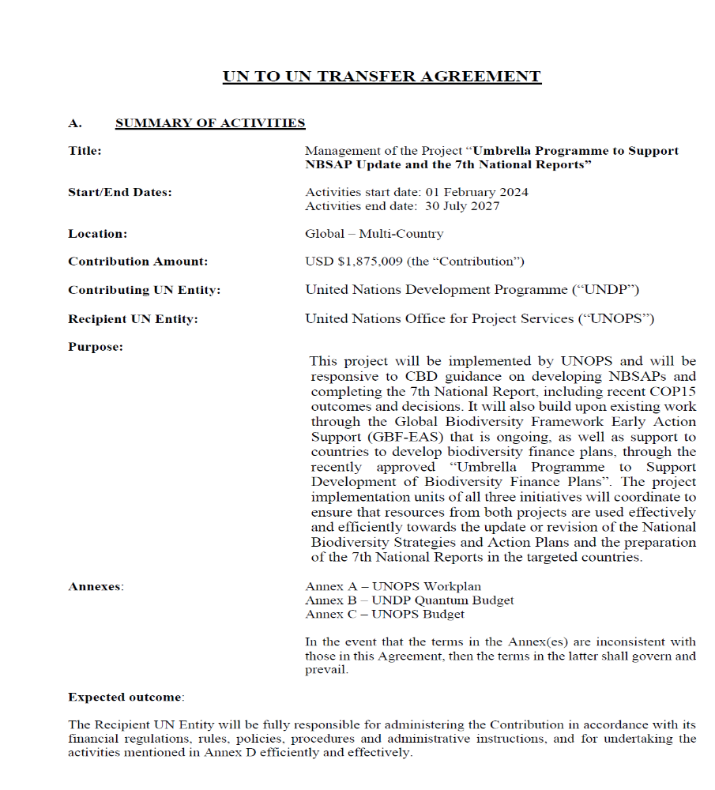

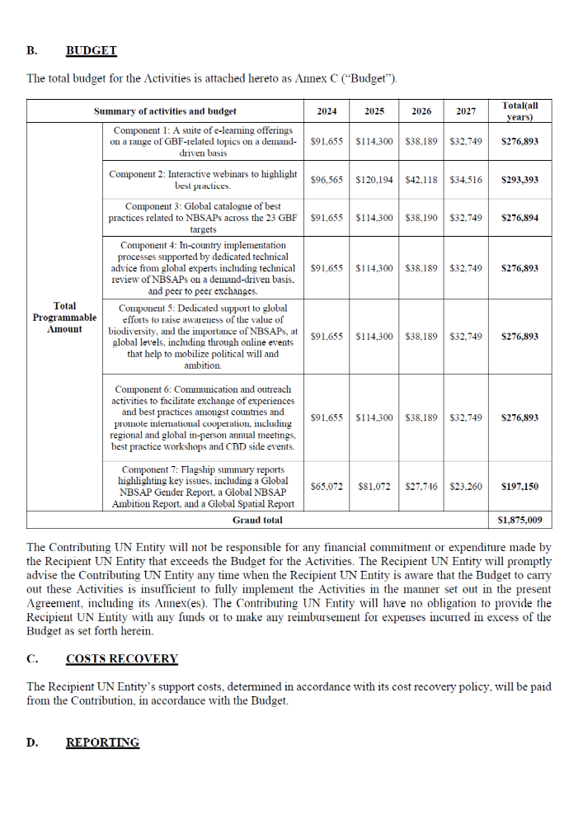
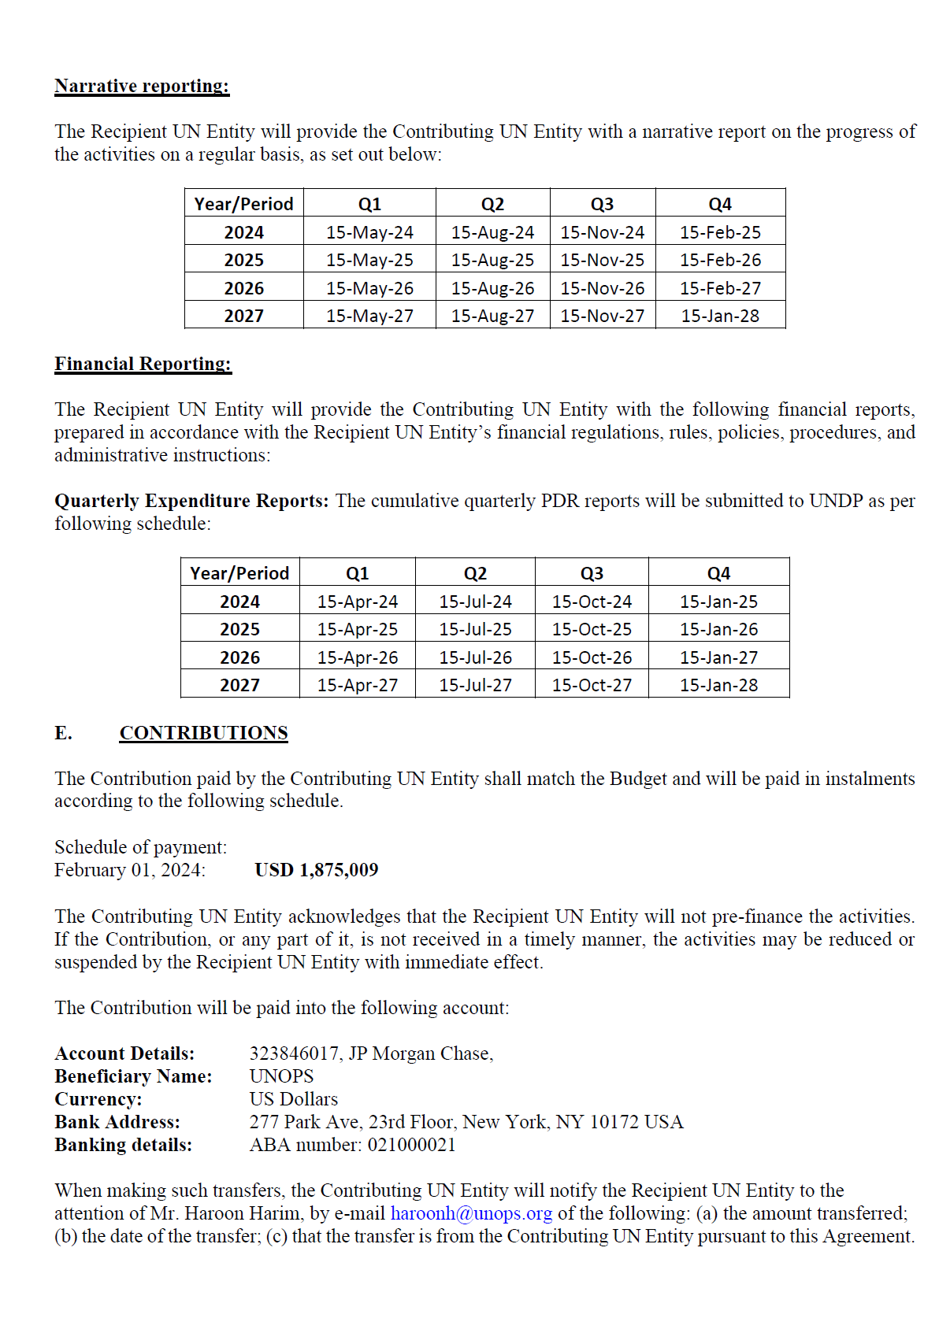 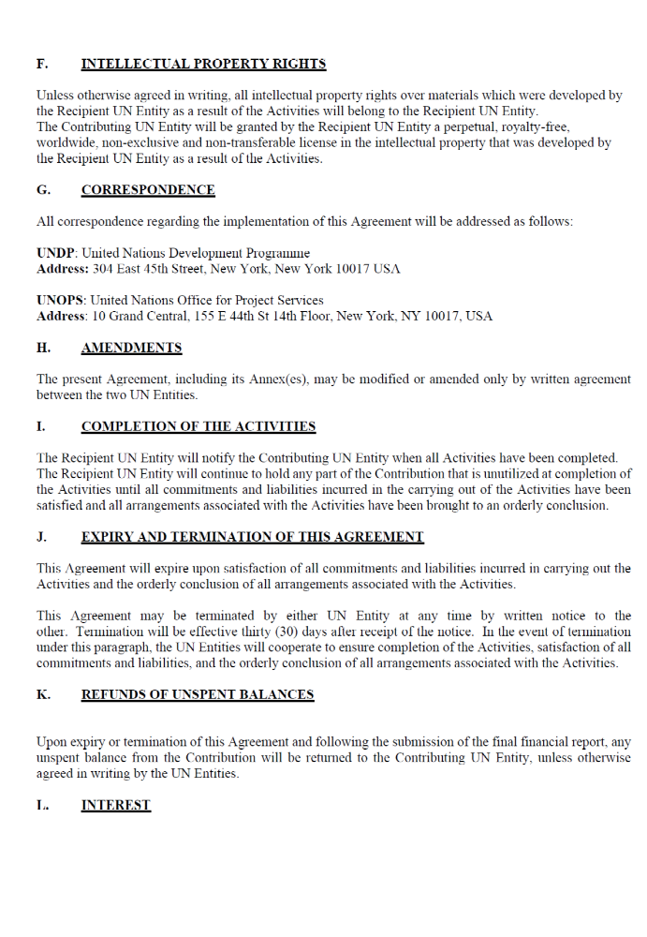 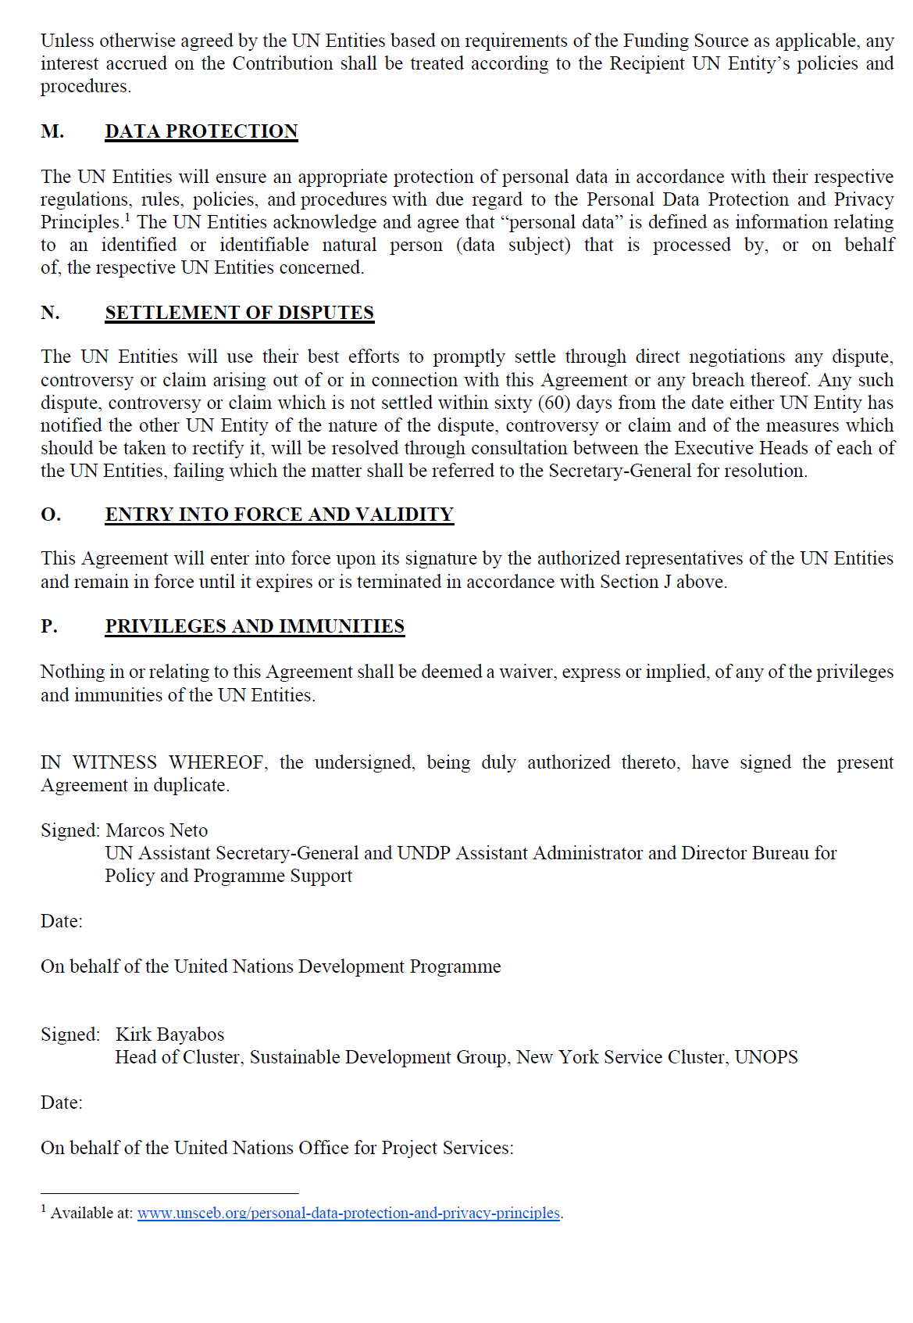 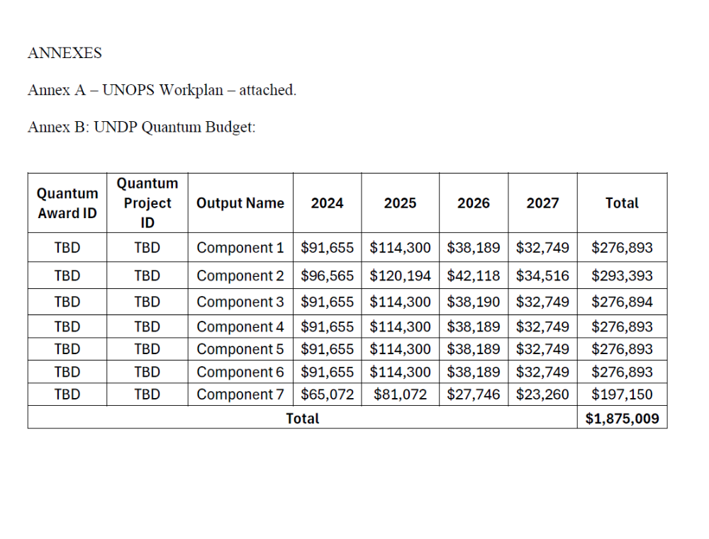 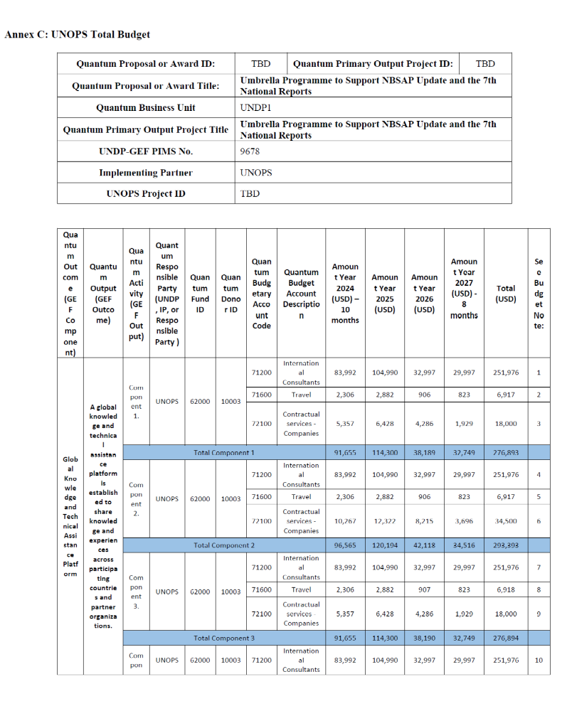 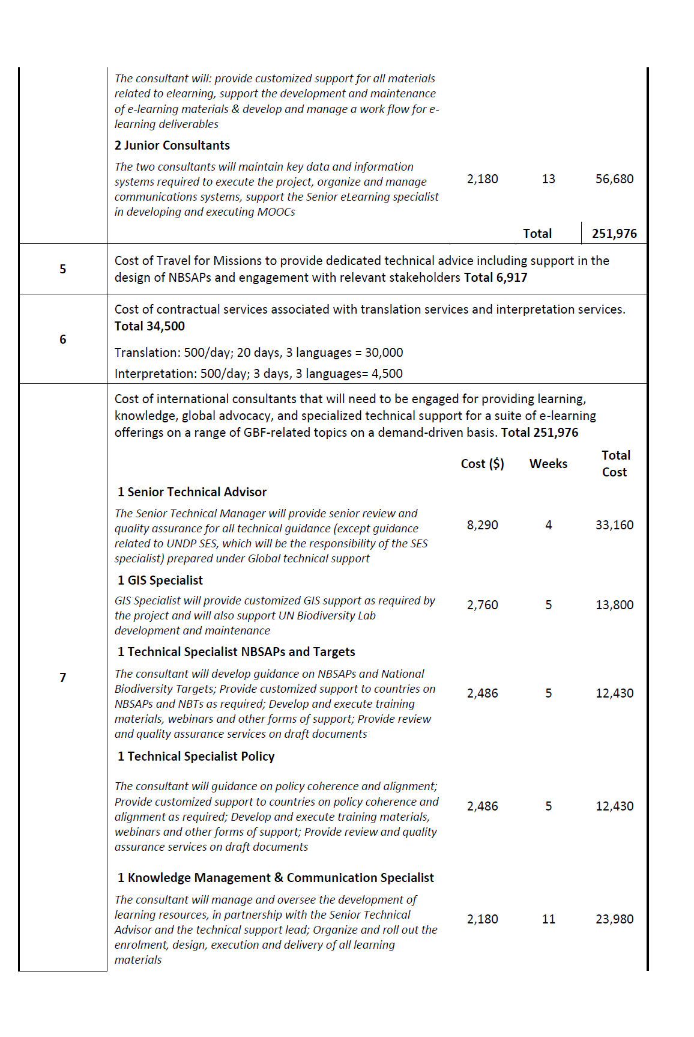 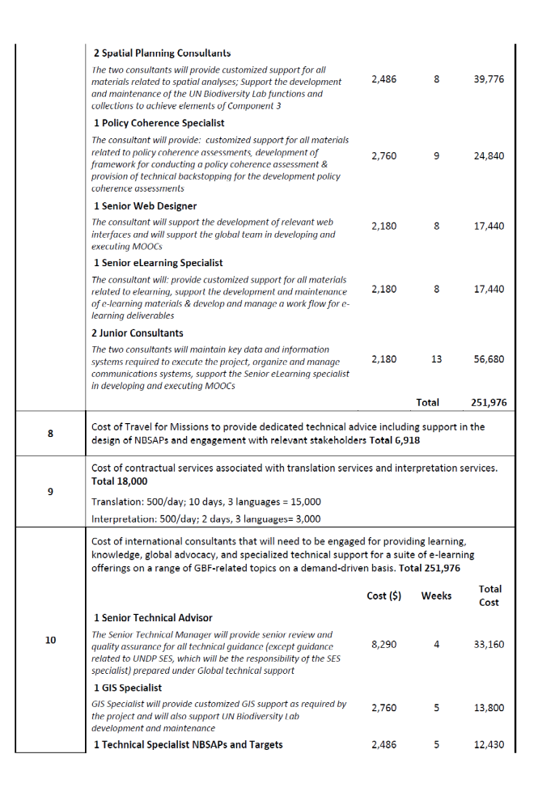 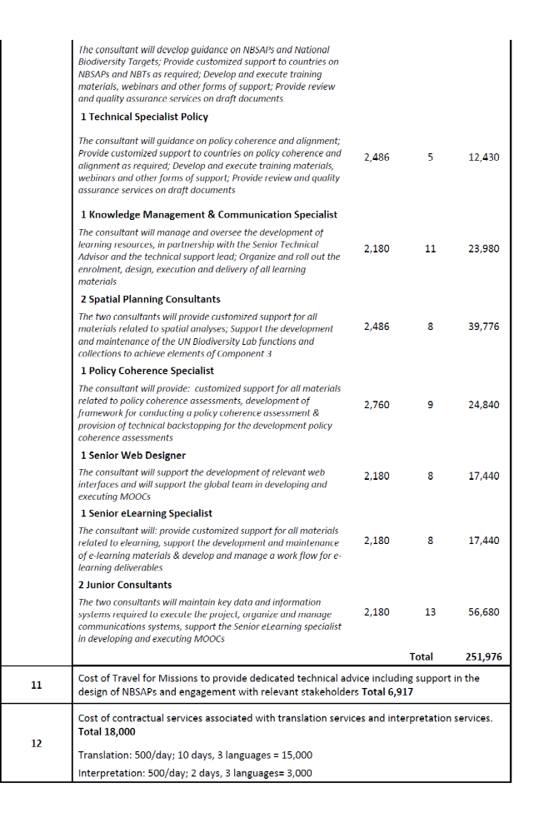 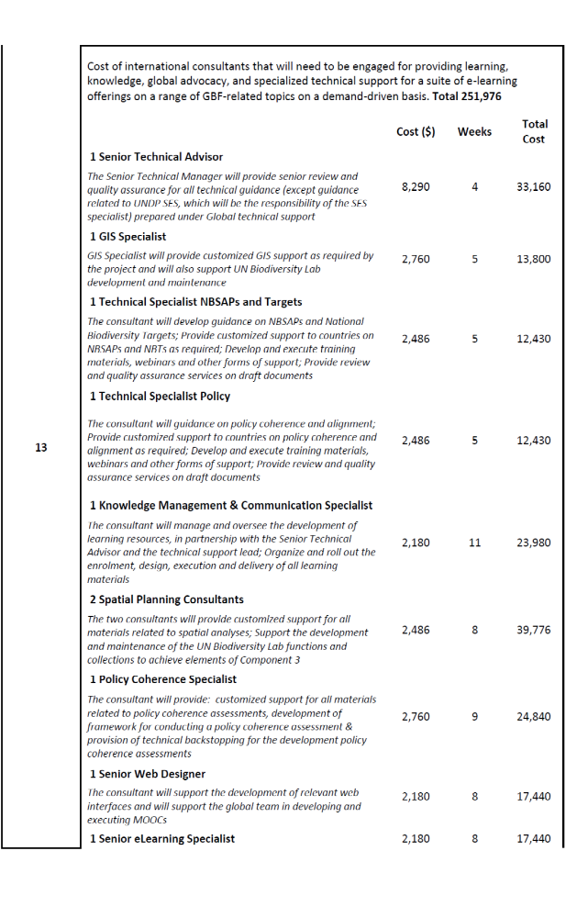 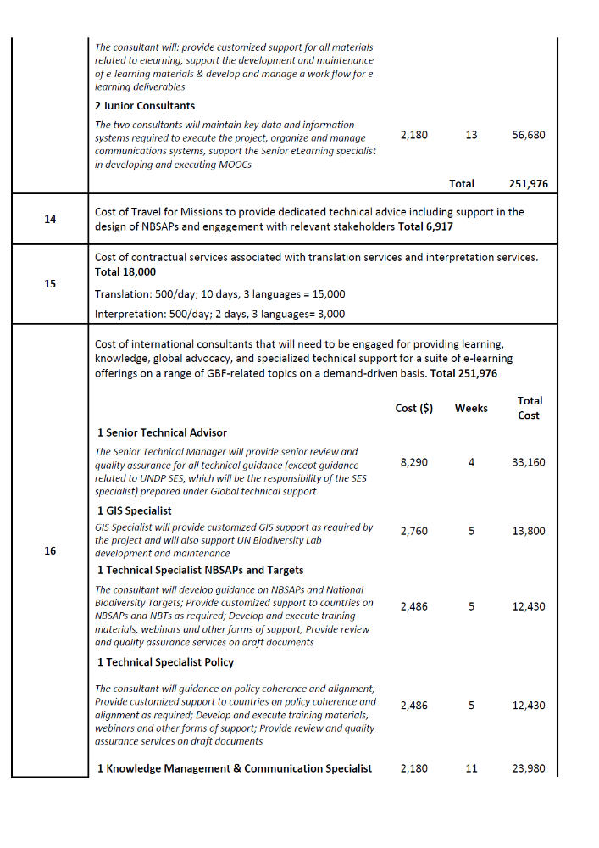 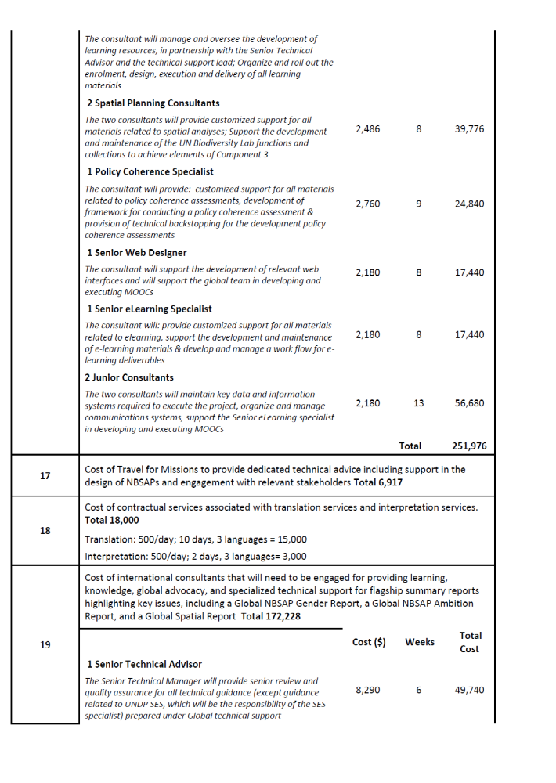 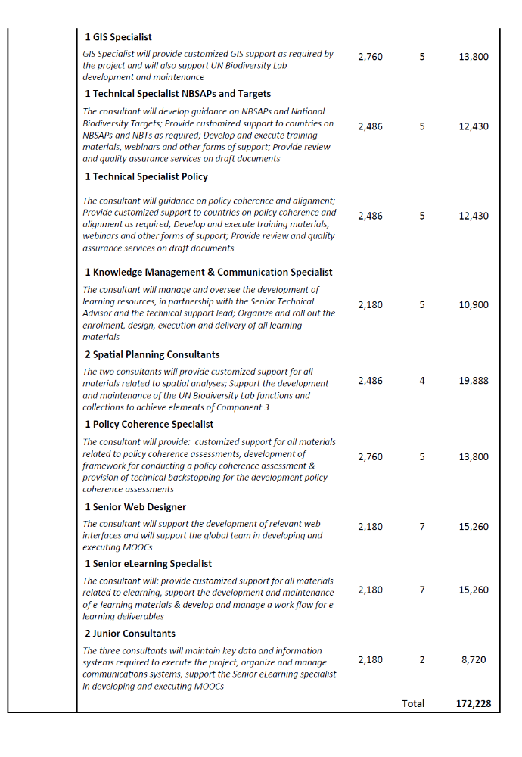 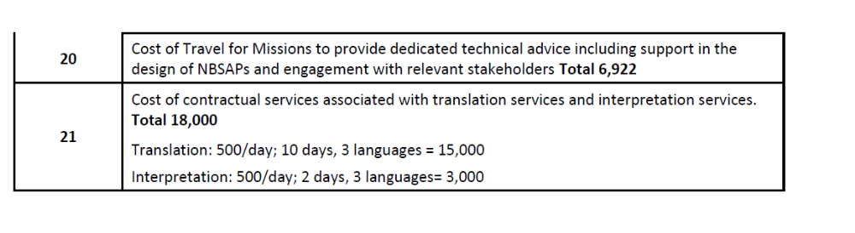
Annex 12: Signed LOA between UNDP and IP requesting UNDP Support Services (if required on exceptional basis and authorized by the GEF)

Annex 13: GEF CEO Endorsement/Approval

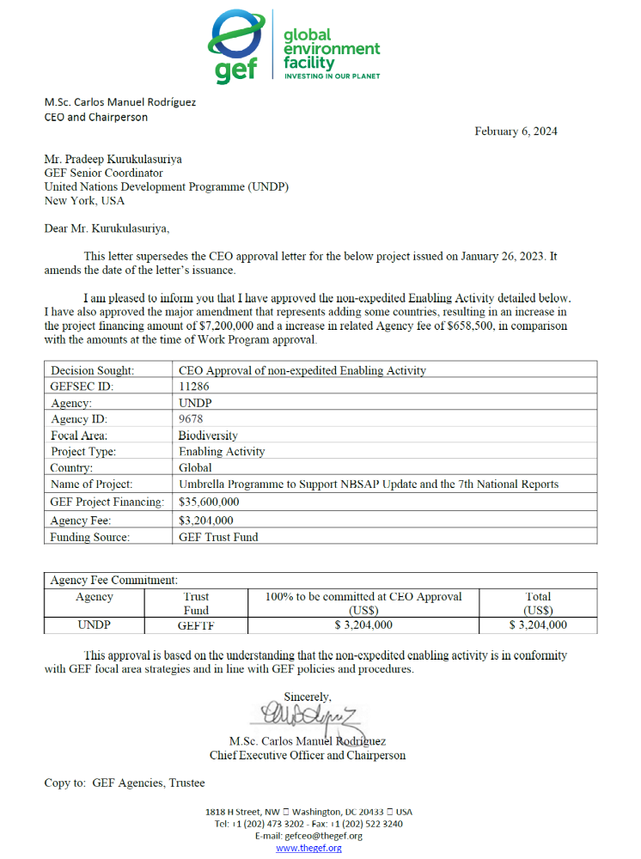

Annex 14: On-Granting Provisions Applicable to the Implementing Partner

On-granting clauses for non-UNDP Implementing Partners can be found here. This applies in cases where on-granting is built into the design and to the extent that it complies with the UNDP Policy on Low Value Grants (LVGs).

Annex 15: Terms of Reference for Project Board and Project Team
The standard Project Board TOR can be found here.

The Project Board will provide overall strategic policy and management direction for the project and play a critical role in reviewing and approving project planning and execution by the Implementing Partner. In line with the adoption of an adaptive management approach, the Project Board will review project progress, make recommendations and adopt the (biennial) project work plans and budget.
Requirements to serve on the Project Board:
- Agree to the Terms of Reference of the Board and the rules on protocols, quorum and minuting.
- Meet annually; at least once.
- Disclose any conflict of interest in performing the functions of a Project Board member and take all measures to avoid any real or perceived conflicts of interest. This disclosure must be documented and kept on record by UNDP.
- Discharge the functions of the Project Board in accordance with UNDP policies and procedures.
- Ensure highest levels of transparency and ensure Project Board meeting minutes are recorded and shared with project stakeholders.

Responsibilities of the Project Board:
- Consensus decision making:
  - The project board provides overall guidance and direction to the project, ensuring it remains within any specified constraints, and providing overall oversight of the project implementation.
  - Review project performance based on monitoring, evaluation and reporting, including progress reports, risk logs and the combined delivery report;
  - The project board is responsible for making management decisions by consensus.
  - In order to ensure UNDP’s ultimate accountability, Project Board decisions should be made in accordance with standards that shall ensure management for development results, best value money, fairness, integrity, transparency and effective international competition.
  - In case consensus cannot be reached within the Board, the UNDP representative on the board will mediate to find consensus and, if this cannot be found, will take the final decision to ensure project implementation is not unduly delayed.
- Oversee project execution:
  - Agree on project manager’s tolerances as required, within the parameters outlined in the project document, and provide direction and advice for exceptional situations when the project manager’s tolerances are exceeded.
- Appraise annual work plans prepared by the Implementing Partner for the Project; review combined delivery reports prior to certification by the implementing partner.
- Address any high-level project issues as raised by the project manager and project assurance;
- Advise on major and minor amendments to the project within the parameters set by UNDP and the donor and refer such proposed major and minor amendments to the UNDP BPPS Nature, Climate and Energy Executive Coordinator (and the GEF, as required by GEF policies);
- Provide high-level direction and recommendations to the project management unit to ensure that the agreed deliverables are produced satisfactorily and according to plans.
- Track and monitor co-financed activities and realization of co-financing amounts of this project.
- Approve the Inception Report, GEF annual project implementation reports, mid-term review and terminal evaluation reports.
- Ensure commitment of human resources to support project implementation, arbitrating any issues within the project.
- Risk management:
  - Provide guidance on evolving or materialized project risks and agree on possible mitigation and management actions to address specific risks.
  - Review and update the project risk register and associated management plans based on the information prepared by the Implementing Partner. This includes risks related that can be directly managed by this project, as well as contextual risks that may affect project delivery or continued UNDP compliance and reputation but are outside of the control of the project. For example, social and environmental risks associated with co-financed activities or activities taking place in the project’s area of influence that have implications for the project.
  - Address project-level grievances.
- Coordination:
  - Ensure coordination between various donor and government-funded projects and programs.
  - Ensure coordination with various government agencies and their participation in project activities.

Membership
(See Section VII Governance and Management Arrangements)
Frequency and Conduct of Meetings
It is anticipated that there will be at least two full meetings of the Project Board to take place at the following times during the duration of the GBF-EAS project: at project inception and project end. Other options such as meetings of representative groupings of the PB, videoconferencing, and e-mail will be explored to allow for additional discussion and review of project matters during project implementation. The Project Manager will be responsible for ensuring close liaison within the Project Board. Formal meetings will be scheduled and arranged by the GPMTSU in consultation with, and at the request of, the other Project Board members.

Annex 16: GEF Core indicators

Annex 17: GEF Taxonomy

Level 1 | Level 2 | Level 3 | Level 4
Influencing models
 | Transform policy and regulatory environments
 | Strengthen institutional capacity and decision-making
 | Convene multi-stakeholder alliances
 | Demonstrate innovative approaches
 | Deploy innovative financial instruments
Stakeholders
 | Indigenous Peoples
 | Private Sector
 |  | Capital providers
 |  | Financial intermediaries and market facilitators
 |  | Large corporations
 |  | SMEs
 |  | Individuals/Entrepreneurs
 |  | Non-Grant Pilot
 |  | Project Reflow
 | Beneficiaries
 | Local Communities
 | Civil Society
 |  | Community Based Organization
 |  | Non-Governmental Organization
 |  | Academia
 |  | Trade Unions and Workers Unions
 | Type of Engagement
 |  | Information Dissemination
 |  | Partnership
 |  | Consultation
 |  | Participation
 | Communications
 |  | Awareness Raising
 |  | Education
 |  | Public Campaigns
 |  | Behavior Change
Capacity, Knowledge and Research
 | Enabling Activities
 | Capacity Development
 | Knowledge Generation and Exchange
 | Targeted Research
 | Learning
 |  | Theory of Change
 |  | Adaptive Management
 |  | Indicators to Measure Change
 | Innovation
 | Knowledge and Learning
 |  | Knowledge Management
 |  | Innovation
 |  | Capacity Development
 |  | Learning
 | Stakeholder Engagement Plan
Gender Equality
 | Gender Mainstreaming
 |  | Beneficiaries
 |  | Women groups
 |  | Sex-disaggregated indicators
 |  | Gender-sensitive indicators
 | Gender results areas
 |  | Access and control over natural resources
 |  | Participation and leadership
 |  | Access to benefits and services
 |  | Capacity development
 |  | Awareness raising
 |  | Knowledge generation
Focal Areas/Theme
 | Integrated Programs
 |  | Commodity Supply Chains (Good Growth Partnership)
 |  |  | Sustainable Commodities Production
 |  |  | Deforestation-free Sourcing
 |  |  | Financial Screening Tools
 |  |  | High Conservation Value Forests
 |  |  | High Carbon Stocks Forests
 |  |  | Soybean Supply Chain
 |  |  | Oil Palm Supply Chain
 |  |  | Beef Supply Chain
 |  |  | Smallholder Farmers
 |  |  | Adaptive Management
 |  | Food Security in Sub-Sahara Africa
 |  |  | Resilience (climate and shocks)
 |  |  | Sustainable Production Systems
 |  |  | Agroecosystems
 |  |  | Land and Soil Health
 |  |  | Diversified Farming
 |  |  | Integrated Land and Water Management
 |  |  | Smallholder Farming
 |  |  | Small and Medium Enterprises
 |  |  | Crop Genetic Diversity
 |  |  | Food Value Chains
 |  |  | Gender Dimensions
 |  |  | Multi-stakeholder Platforms
 |  | Food Systems, Land Use and Restoration
 |  |  | Sustainable Food Systems
 |  |  | Landscape Restoration
 |  |  | Sustainable Commodity Production
 |  |  | Comprehensive Land Use Planning
 |  |  | Integrated Landscapes
 |  |  | Food Value Chains
 |  |  | Deforestation-free Sourcing
 |  |  | Smallholder Farmers
 |  | Sustainable Cities
 |  |  | Integrated urban planning
 |  |  | Urban sustainability framework
 |  |  | Transport and Mobility
 |  |  | Buildings
 |  |  | Municipal waste management
 |  |  | Green space
 |  |  | Urban Biodiversity
 |  |  | Urban Food Systems
 |  |  | Energy efficiency
 |  |  | Municipal Financing
 |  |  | Global Platform for Sustainable Cities
 |  |  | Urban Resilience
 | Biodiversity
 |  | Protected Areas and Landscapes
 |  |  | Terrestrial Protected Areas
 |  |  | Coastal and Marine Protected Areas
 |  |  | Productive Landscapes
 |  |  | Productive Seascapes
 |  |  | Community Based Natural Resource Management
 |  | Mainstreaming
 |  |  | Extractive Industries (oil, gas, mining)
 |  |  | Forestry (Including HCVF and REDD+)
 |  |  | Tourism
 |  |  | Agriculture & agrobiodiversity
 |  |  | Fisheries
 |  |  | Infrastructure
 |  |  | Certification (National Standards)
 |  |  | Certification (International Standards)
 |  | Species
 |  |  | Illegal Wildlife Trade
 |  |  | Threatened Species
 |  |  | Wildlife for Sustainable Development
 |  |  | Crop Wild Relatives
 |  |  | Plant Genetic Resources
 |  |  | Animal Genetic Resources
 |  |  | Livestock Wild Relatives
 |  |  | Invasive Alien Species (IAS)
 |  | Biomes
 |  |  | Mangroves
 |  |  | Coral Reefs
 |  |  | Sea Grasses
 |  |  | Wetlands
 |  |  | Rivers
 |  |  | Lakes
 |  |  | Tropical Rain Forests
 |  |  | Tropical Dry Forests
 |  |  | Temperate Forests
 |  |  | Grasslands
 |  |  | Paramo
 |  |  | Desert
 |  | Financial and Accounting
 |  |  | Payment for Ecosystem Services
 |  |  | Natural Capital Assessment and Accounting
 |  |  | Conservation Trust Funds
 |  |  | Conservation Finance
 |  | Supplementary Protocol to the CBD
 |  |  | Biosafety
 |  |  | Access to Genetic Resources Benefit Sharing
 | Forests
 |  | Forest and Landscape Restoration
 |  |  | REDD/REDD+
 |  | Forest
 |  |  | Amazon
 |  |  | Congo
 |  |  | Drylands
 | Land Degradation
 |  | Sustainable Land Management
 |  |  | Restoration and Rehabilitation of Degraded Lands
 |  |  | Ecosystem Approach
 |  |  | Integrated and Cross-sectoral approach
 |  |  | Community-Based NRM
 |  |  | Sustainable Livelihoods
 |  |  | Income Generating Activities
 |  |  | Sustainable Agriculture
 |  |  | Sustainable Pasture Management
 |  |  | Sustainable Forest/Woodland Management
 |  |  | Improved Soil and Water Management Techniques
 |  |  | Sustainable Fire Management
 |  |  | Drought Mitigation/Early Warning
 |  | Land Degradation Neutrality
 |  |  | Land Productivity
 |  |  | Land Cover and Land cover change
 |  |  | Carbon stocks above or below ground
 |  | Food Security
 | International Waters
 |  | Ship
 |  | Coastal
 |  | Freshwater
 |  |  | Aquifer
 |  |  | River Basin
 |  |  | Lake Basin
 |  | Learning
 |  | Fisheries
 |  | Persistent toxic substances
 |  | SIDS : Small Island Dev States
 |  | Targeted Research
 |  | Pollution
 |  |  | Persistent toxic substances
 |  |  | Plastics
 |  |  | Nutrient pollution from all sectors except wastewater
 |  |  | Nutrient pollution from Wastewater
 |  | Transboundary Diagnostic Analysis and Strategic Action Plan preparation
 |  | Strategic Action Plan Implementation
 |  | Areas Beyond National Jurisdiction
 |  | Large Marine Ecosystems
 |  | Private Sector
 |  | Aquaculture
 |  | Marine Protected Area
 |  | Biomes
 |  |  | Mangrove
 |  |  | Coral Reefs
 |  |  | Seagrasses
 |  |  | Polar Ecosystems
 |  |  | Constructed Wetlands
 | Chemicals and Waste
 |  | Mercury
 |  | Artisanal and Scale Gold Mining
 |  | Coal Fired Power Plants
 |  | Coal Fired Industrial Boilers
 |  | Cement
 |  | Non-Ferrous Metals Production
 |  | Ozone
 |  | Persistent Organic Pollutants
 |  | Unintentional Persistent Organic Pollutants
 |  | Sound Management of chemicals and Waste
 |  | Waste Management
 |  |  | Hazardous Waste Management
 |  |  | Industrial Waste
 |  |  | e-Waste
 |  | Emissions
 |  | Disposal
 |  | New Persistent Organic Pollutants
 |  | Polychlorinated Biphenyls
 |  | Plastics
 |  | Eco-Efficiency
 |  | Pesticides
 |  | DDT - Vector Management
 |  | DDT - Other
 |  | Industrial Emissions
 |  | Open Burning
 |  | Best Available Technology / Best Environmental Practices
 |  | Green Chemistry
 | Climate Change
 |  | Climate Change Adaptation
 |  |  | Climate Finance
 |  |  | Least Developed Countries
 |  |  | Small Island Developing States
 |  |  | Disaster Risk Management
 |  |  | Sea-level rise
 |  |  | Climate Resilience
 |  |  | Climate information
 |  |  | Ecosystem-based Adaptation
 |  |  | Adaptation Tech Transfer
 |  |  | National Adaptation Programme of Action
 |  |  | National Adaptation Plan
 |  |  | Mainstreaming Adaptation
 |  |  | Private Sector
 |  |  | Innovation
 |  |  | Complementarity
 |  |  | Community-based Adaptation
 |  |  | Livelihoods
 |  | Climate Change Mitigation
 |  |  | Agriculture, Forestry, and other Land Use
 |  |  | Energy Efficiency
 |  |  | Sustainable Urban Systems and Transport
 |  |  | Technology Transfer
 |  |  | Renewable Energy
 |  |  | Financing
 |  |  | Enabling Activities
 |  | Technology Transfer
 |  |  | Poznan Strategic Programme on Technology Transfer
 |  |  | Climate Technology Centre & Network (CTCN)
 |  |  | Endogenous technology
 |  |  | Technology Needs Assessment
 |  |  | Adaptation Tech Transfer
 |  | United Nations Framework on Climate Change | Nationally Determined Contribution
 | Rio Markers
 |  | Paris Agreement
 |  | Sustainable Development Goals
 |  | Climate Change Mitigation 0
 |  | Climate Change Mitigation 1
 |  | Climate Change Mitigation 2
 |  | Climate Change Adaptation 0
 |  | Climate Change Adaptation 1
 |  | Climate Change Adaptation 2

Annex 18: Results of the Partners Capacity Assessment Tool (PACT) and HACT Micro Assessment

N/A

Annex 19 - Umbrella Programme to Support NBSAP Update and the 7th National Reports - Country Office Annex

UNDP-GEF PIMS ID number: 9678
Quantum Business Unit (Organization):
Quantum Project ID:
Quantum Award ID:
Execution Modality: UNDP DIM
Background:
The purpose of this annex is to document the management and governance arrangements, the budget and work plan, and the procurement plan for each country participating in the Umbrella Programme to Support NBSAP Update and the 7th National Report. This annex includes the following sections:
- Confirmation of Country Office capacity for oversight and execution support/procurement
- Total Budget and Work Plan (TBWP)
- Procurement Plan
This annex must be duly completed by the Country Office and signed by the Resident Representative before DOA issuance.
Brief Project Description: This global programme will support countries in revising and updating their National Biodiversity Strategies and Action Plans (NBSAPs) in order to align with the recently agreed upon Kunming-Montreal Global Biodiversity Framework, and enable effective implementation of the Convention on Biological Diversity (CBD) and the Kunming Montreal Global Biodiversity Framework at the national level. In addition, this grant supports countries in preparing and submitting their 7th National Report on the implementation of the Convention on Biological Diversity and the Kunming-Montreal Global Biodiversity Framework.
Summary of Key Management Arrangements at the Project Level: At the global level, this global umbrella programme will be supported by a Global Project Management and Technical Support Unit (GPMTSU).
At the national level each country will have consultants that will perform the following activities: development and implementation of a comprehensive stakeholder engagement plan, services for technical research as well as revision and editing of technical documentation, development of national gender analysis and action plan; technical research and editing, identify and prioritize essential gaps and inconsistencies between the existing NBSAP and changes needed to achieve the Global Biodiversity Framework, development of a first approximation of spatial priorities for Target 1, and develop a spatialized action plan for other area-based targets; identification of an action plan for eliminating or phasing out harmful subsidies and incentives within the NBSAP, assessment of gaps in capacities and resources available undertaken and on that basis, develop plans or strategies for capacity development and resource mobilization, provide brief overview of the process of preparation of the report, review status of revised or updated national biodiversity strategy and action plan (NBSAP) in the light of the Kunming-Montreal Global Biodiversity Framework, assessment of progress towards national targets and progress related to the goals and targets of the Kunming-Montreal Global Biodiversity Framework and completion of Conclusions on the implementation of the Convention and the Kunming-Montreal Global Biodiversity Framework.
The GPMTSU will consist of a Project Technical lead (assigned by UNDP and based as a UNDP FTA), a Technical Coordinator (IPSA-11), Global Programme Analyst (IPSA 9), and other short term technical advisors and experts. The GPMTSU will report to the Operations team under the Nature Hub. Roles and responsibilities of GPMTSU members are detailed in Annex 7 of the prodoc.
The Project Technical Lead is the senior most representative of the global project management and technical support unit (GPMTSU) and is responsible for the overall day-to-day management of the project on behalf of the Implementing Partner, including the mobilization of all project inputs, supervision over project staff, responsible parties, consultants and sub-contractors. The project technical lead typically presents key deliverables and documents to the board for their review and approval, including progress reports, annual work plans, adjustments to tolerance levels and risk registers.
Country: add country name
Please provide evidence of Country Office (CO) capacities including the list of subject matter experts to support oversight and provide execution support/procurement.

The Umbrella Programme to Support NBSAP Update and the 7th National Reports will follow the UNDP Direct Implementation Modality (DIM).

The Enabling Activity includes activities to be executed at the global and national levels as follows:

(i) Execution
In terms of execution, country components (components 1-2/national-level activities) will be supported by operational staff based at the UNDP country offices (COs). These operational staff members will be institutionally separate from the CO staff providing oversight over the national components and will maintain a reporting line within the operational unit of the respective COs.
For national-level activities, execution support will be managed by the COs and the overall accountability for the country component execution rests with the Resident Representative (RR). Appropriate technical and operational staff will provide execution support mainly for project management, procurement and financial support and recover the cost through Direct Project Cost (DPC). The DPC for each country is fixed at US $20,000, this is the amount approved by the GEF secretariat and the CO agrees not to go over this DPC limit.
The names and functions of CO staff who will be accountable for the execution of the country components (covered from the project budget) are listed below.

- add name(s) and functional title.
(ii) Oversight
Programmatic oversight over the national level activities (covered from the GEF fee) will be performed by the programmatic unit within the UNDP CO (i.e., CO Environmental Focal Points), in close coordination with the Global oversight unit / UNDP Nature Hub.
The names and functions of CO staff who will provide national level programmatic oversight covered by the GEF Fee are listed below.
- add name(s) and functional title.

(iii) Governance arrangements
A government Project Director and Technical Focal Point(s) have been identified as below.
- Project Director: add name and functional title.
- Technical Focal Point: add name and functional title.
The project activities will be implemented using a highly participatory approach, through active and meaningful participation of stakeholders across the government and beyond, with a lead role for the finance sector. These could include the finance ministry, line environment ministries, sub-national government entities, research and academic bodies, business and industry, indigenous and local community organizations, bodies representing the agricultural, forestry, fishing or other sectors, environmental management bodies, non- governmental organizations, women’s organizations, bodies and agencies addressing sustainable development and poverty eradication, educators, the media, youth, and others emphasizing a whole-of-government and whole-of-society approaches. Each country’s list will be different, but all should be comprehensive. This project will create the means for ensuring that, at the country level, this NBSAP grant complements the previous GBF-EAS to deliver NBSAPs that include the GBF targets and other environmental targets through a widely inclusive and participatory process. The Steering Committee will review all main deliverables produced by the national team. Other relevant governance and/or technical structures can be created (e.g., technical working groups), as needed.
Signature, add name, functional title and signature.

Agreed by UNDP Resident Representative of add country name.
add Date/Month/Year

See National Biodiversity Strategies and Action Plans: Natural Catalysts for Accelerating Action on Sustainable Development Goals, available at https://www.cbd.int/doc/nbsap/NBSAPs-catalysts-SDGs.pdf.
See document CBD/COP/15/9/Add.2 - Analysis of the Contribution of Targets Established by Parties and Progress Towards the Aichi Biodiversity Targets
See http://www.undp.org/content/undp/en/home/operations/transparency/information_disclosurepolicy/
See https://www.thegef.org/gef/policies_guidelines
Please see the Guideline “Embedding Digital in Project Design”.
See https://www.thegef.org/gef/policies_guidelines
See http://www.undp.org/content/undp/en/home/operations/transparency/information_disclosurepolicy/
See https://www.thegef.org/gef/policies_guidelines
Data collection methods should outline specific tools used to collect data and additional information as necessary to support monitoring. The PIR cannot be used as a source of verification.
See https://popp.undp.org/_layouts/15/WopiFrame.aspx?sourcedoc=/UNDP_POPP_DOCUMENT_LIBRARY/Public/PPM_Project%20Management_Closing.docx&action=default.
* Note: revised July 2022 modifying presumption of risk significance from Substantial or higher to Moderate or higher.

